Video: https://www.youtube.com/watch?feature=player_embedded&v=Fpxtenfzr1M

In the Tool and Die Department, frequently soldering is used to manufacture parts and fixtures. The application of solder to a joint requires a specific skill set. It is important to not use too little solder, since the weld might give way. It is also important not to use too much solder, which is wasteful. In this video students will determine the amount of weld material used in a series of “filet welds”.

Common Core Mathematical Content Standards:

7.G Draw, construct, and describe geometrical figures and describe the relationships between them.

3. Describe the two-dimensional figures that result from slicing three-dimensional figures, as in plane sections of … prisms …

7.G Solve real-life and mathematical problems involving angle measure, area, surface area, and volume.

6. Solve real-world and mathematical problems involving area, volume, and surface area of two- and three-dimensional objects composed of triangles, quadrilaterals, polygons, cubes, and right prisms.

Common Core Mathematical Practice Standards:

- Make sense of problems and persevere in solving them.

- Reason abstractly and quantitatively.

6. Attend to precision.

Ariens Company

Ariens Company is a Brillion, Wisconsin-based equipment company which manufactures snow blowers, lawn mowers, and other “chore products” for commercial and high-end consumer markets. This four-generation company has a long history and touts itself as being the “mower of the White House lawn” and “official snow blower of Lambeau Field”.

Video Summary:

Teacher note: Please preview the entire video and pre-work solutions in order to anticipate students’ needs, misconceptions and materials unique to your classroom.
Pre-Activity Discussion | (0:00-0:49) | What do lawnmowers have to do with math?  Why would companies need to ensure that they have an “optimal” amount of weld of weld material when connected two base materials?  Includes Break 1
Information | (0:50-3:32) | How are welds measured? What geometric figures are used to model a weld?  Includes Breaks 2 & 3  What degree of accuracy and what measurement tools are used to measure a weld?  Includes Break 4
Strategies & Solutions | (3:33-5:01) | How would the amount of weld be calculated using the geometric model and given measurements?  Includes Break 5  How is it determined whether a measured weld meets the company’s quality requirements?

Pre-Activity Discussion (0:00-0:49)

- Play Video (0:00-0:09).

- Pause at visual (0:10-0:11) for class discussion.

- Class Discussion: “What do lawnmowers have to do with math?”

Students should brainstorm regarding what mathematics might be involved in the design, production, and assembly of lawn mowers.
It may be helpful to consider:
- What does a lawn mower start as at the beginning of the assembly?
- What jobs do people have who support this “journey”?
(Examples: engineer, tool and die, human resources manager, production technician, product distribution, etc.)
What knowledge and skills might be associated with these fields?

- Play Video (0:12-0:46).

- Pause at prompt (0:47- 0:49) at Break 1 for class discussion.

Why do you think it is important for a manufacturer to ensure that welders are using neither “too little” nor “too much” weld material in a part, as used to join two base pieces of metal together? How do you think mathematics might be used to make sure that there is an “optimal” amount of weld?

Information: (0:50-3:32)

- Play Video (0:50-1:43).

- Pause at prompt (1:44-1:45) at “Break 2” for class discussion.
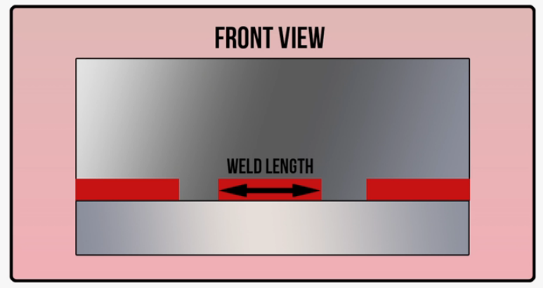
- Class Discussion:
What information is necessary to determine “how much weld” is needed for a part?
  - Weld length
The weld length is measured using a “scale”. (In this case, “scale” refers to a type of ruler.)

  - Weld leg size
    - When a weld is viewed from the side, its cross section can be approximated using an isosceles right triangle. The “leg size” of the weld refers to the length of a leg of this triangular cross section.

    - Discussion question: What three-dimensional figure could be used to model a
weld?
weld length
weld leg length

For the purpose of determining the amount of weld material used, a weld is modeled using a right triangular prism.

- Play Video (1:46-2:22).

- Pause at prompt (2:23-2:25) at “Break 3” for class discussion.

  - Discussion question: How the “vocabulary of a filet weld” compare to the geometric vocabulary used in class discussion?

Examples: “right triangle face presentation” vs. “right triangular cross section”
“point of the triangle” vs. “vertex of the right angle”
“toe of the triangle” vs. “base angle’s vertex”

  - Discussion question: How do you think the “amount of weld” is quantified? What units of measure do you think would be used? What degree of accuracy do you think is necessary in the measurements of weld length and weld leg lengths?

- Play Video (2:26-3:29).

- Pause at prompt (3:30-3:32) at “Break 4” for class discussion.

- Class discussion:

Weld | Weld Length | Weld Leg Length
1 | $1\frac{3}{4}$ inches | $\frac{1}{4}$ inches
2 | $1\frac{1}{2}$ inches | $\frac{1}{4}$ inches
3 | $1\frac{1}{4}$ inches | $\frac{1}{4}$ inches
  - Discussion questions:
    - What measurements and tools were used to measure the three welds?
    - Why would a ruler-like device be able to be used for the weld length but not for the weld leg length?
    - What units of measure were used? What degree of accuracy is used?

Strategies and Solutions: (3:33-5:01)

- Play Video (3:33-3:57).

- Pause at prompt (3:58-4:00) at “Break 5” for class discussion.

- Class discussion:

  - What is the amount of weld material used in each of the three welds?

Solution Strategy:

We have already modeled the welds using right triangular prisms. Based on the information, we can calculate the volume of each of these prisms by find the area of the right triangular base and multiplying it by the “height” of the prism.

The weld leg length of $\frac{1}{4}$ inches was found to be the same for all three welds. This means that the area of the right triangular base of each weld would be the same.

Area of weld cross section = $\frac{1}{2}∙base of triangle∙height of triangle$
= $\frac{1}{2}∙leg length∙leg length$
= $\frac{1}{2}∙(0.25 inches)∙(0.25 inches)$
= $0.03125 square inches$

Weld | Weld Length | Weld Leg Length | Amount of Weld Material
1 | $1\frac{3}{4}$ inches | $\frac{1}{4}$ inches | Volume = $\left(0.03125 {in}^{2}\right)∙(1.75 in)$  = $0.05447 {inches}^{3}$
2 | $1\frac{1}{2}$ inches | $\frac{1}{4}$ inches | Volume = $\left(0.03125 {in}^{2}\right)∙(1.5 in)$  = $0.04688 {inches}^{3}$
3 | $1\frac{1}{4}$ inches | $\frac{1}{4}$ inches | Volume = $\left(0.03125 {in}^{2}\right)∙(1.25 in)$  = $0.039063 {inches}^{3}$

- Play Video (4:01-5:01, end).

- Class discussion:

  - Discussion question: Why do you think percentages are used to compare the weld volume to the intended volume?

Teacher note: This calculation comparison is a “percent error” problem.

  - Why would it never be considered to be ok for a something to be “under-welded”? Why is it undesirable for something to be “over-welded?”

