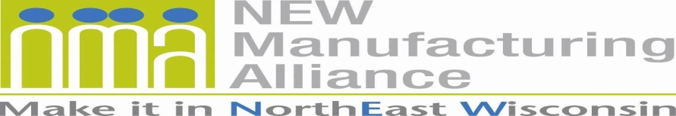

Membership Application

MANUFACTURER ANNUAL DUES STRUCTURE – Based on the total number of northeast Wisconsin employees:
1 to 50 - $600
51 to 250 - $750
251 to 500 - $1,000
501 or Greater - $1,500

ASSOCIATE Member Annual Dues: $1,500
AFFILIATE Member Annual Dues: $0

For membership questions, please contact Ann Franz at ann.franz@nwtc.edu or phone (920) 498-5587.

Today’s Date: Click or tap to enter a date.
Type of Membership: Choose an item.
Number of employees in northeast Wisconsin: Enter text.
Company/Organization Name: Enter text.
Address Line One: Enter text.
Address Line Two: Enter text.
City: Enter text. | State: Enter text. |  |  |  | Zip: Enter text.
Telephone with Area Code: Enter text. |  |  |  | Website Address: Enter text.
Products Manufactured and/or Services Provided: Enter text.
An invoice will be USPS mailed to the primary contact, unless otherwise indicated.
PRIMARY CONTACT’S First & Last Name: Enter text.
Primary Contact’s Title: Enter text. |  | Primary Contact’s Email: Enter text.
HUMAN RESOURCE (HR) CONTACT’S First & Last Name: Enter text.
HR Contact’s Title: Enter text. |  |  | HR Contact’s Email: Enter text.
ADDITIONAL CONTACT’S First & Last Name: Enter text.
Additional Contact’s Title: Enter text. |  |  | Additional Contact’s Email: Enter text.
Describe your business/organization and how it supports manufacturing: Enter text.
☐ I authorize the Alliance to link my company/organization’s website on its ‘Manufacturers’ Outreach’ webpage.
☐ I DO NOT authorize the Alliance to link my company/organization’s website on its ‘Manufacturers’ Outreach’ webpage.
As a means to connect with K-16, the Alliance encourages its members to participate in outreach. Select the K-16 outreach activities you are interested in participating.

☐ Career Speakers
☐ College Internships
☐ Job Shadowing
☐ Mentoring
☐ Plant Tours
☐ Youth Apprenticeship

Below are topics the Alliance is working on. Select any that interest you.

☐ Changing the Image of Manufacturing Careers
☐ Grow Partnerships (connecting with K-16, media and manufacturers)
☐ Workforce Development

My company is interested in a complimentary joint membership in the North Coast Marine Manufacturing Alliance (NCMMA). ☐ YES ☐ NO
Who referred you to join the NEW Manufacturing Alliance? Enter text.

Please email the completed application to
Ann Franz, alliance director, ann.franz@nwtc.edu.
Your company/organization will be contacted within two business days.

Thank you for your interest in joining the
NEW Manufacturing Alliance!

