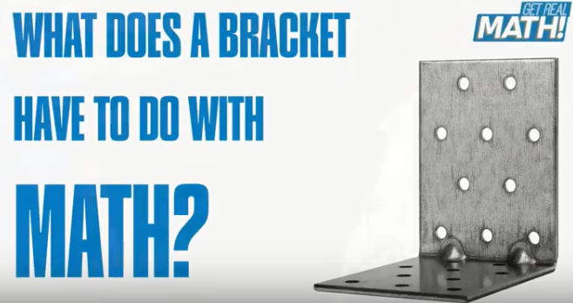

What does a Bracket have to do with Math?
Video: https://youtu.be/4h4FvOuweBs
Lesson Plan
Teacher Note: Please preview the entire video and pre-work the solutions in order to anticipate students’ needs, misconceptions and materials unique to your classroom.
You will also need to determine the background knowledge of your students regarding the following topics, and decide the best method for providing that background in order to support the conceptual understanding of the mathematics shown in the video.
- Measure length with a ruler to 1/16 of an inch
- Understand the relationship between fractions and decimals
- Convert fractions to decimals

Common Core Mathematical Content Standards
- 4.NF Extend understanding of fraction equivalence and ordering, and understand decimal notation for fractions.
- 6.SP Develop an understanding of statistical variability
- 7.RP.3 Use proportional relationships to solve multistep ratio and percent problems.

Common Core Mathematical Practice Standards
1. Make sense of problems and persevere in solving them.
2. Reason abstractly and quantitatively
3. Attend to precision

Company Information: Nercon Eng. & Mfg., Inc. - Biography
Nercon Eng. & Mfg., Inc. has been engineering and manufacturing conveyor and consumer goods packaging equipment for over 38 years. We are known for our expertise in design. Our growing business currently employs about 150 people. With the Nercon Corporate and Engineering office located in Neenah, Wisconsin and the production facility in Oconto, Wisconsin, our local family-owned business has been an active part of both the Fox Valley and Oconto area communities.
Summary
When a customer places an order for a product, the customer expects the product that is delivered to be exactly what they ordered. Due to manufacturing variability there will be unplanned differences in the product. Some differences are so slight that they will not impact the performance of the product. Others will be large enough that the product will no longer work for the customer. This video explores how a manufacturer uses math to check for those differences.

Pre-Activity Discussion:
- Brainstorm possible causes of manufacturing variability in a product.
- What are some consequences of shipping a product to a customer that does not meet the customer’s requirements?
- Vocabulary
  - Product Specifications
  - Variability
  - Tolerance
  - Tolerance Testing

Differentiation:
- The questions on the student handout are scaffolded to meet the needs of students who may need extra support.
- Eliminating some of the added questions and/or the table, and just posing the questions from the video would be a possible differentiation strategy for students who do not need the extra support.
- Students may also benefit by working with others as part of a partner/group investigation.

Information that will be given in the video:
- Bracket tolerance: 7 inches +/- 1/8 inch
- From a 10% sample, the error rate can be no more than 2%
- Initial customer order of 150 brackets
- Note: you will need to print the attached PDF drawings of the brackets and have rulers available for measuring the brackets.

Part 1: (0:00 – 0:40)
- Have students complete Part 1 of the handout.
  - What is the ideal bracket length?
  - What is the allowable amount of variation in bracket length?
  - What is the smallest bracket length that will meet the tolerance specification?
  - What is the largest bracket length that will meet the tolerance specification?

BREAK 1

Part 2: (0:43 – 1:15)
- Discuss why a sample is needed vs. testing all 150 brackets.
- Discuss other real world situations where sampling is used.
- Have students complete Part 2 of the handout.
  - If the initial order is 150 brackets, and 10% of those must be tolerance tested to check for size errors, how many brackets should be randomly selected to test?
  - Using your answer to the question above, if only 2% of our sample can contain size errors, how many sample brackets could be outside of the tolerance range?

BREAK 2

Part 3: ( 1:18 – 1:29)
- Have students complete the first column of the table by measuring the lengths of the 15 brackets in the drawings provided.
- The measurements should be to the nearest 1/16 of an inch

BREAK 3

Part 4: (1:33 – 1:46)
- Students are given the measurements for the 15 sample brackets.
- Discuss and correct student errors and misconceptions
- Have students fill out the second column of the table.
- Discuss whether rounding of decimal places is appropriate.

BREAK 4
Part 5: (1:49 – 1:57)

- Have students complete the third column of the table and use their results to make a decision.

Part 6: (1:59 – end)

- A measuring device called a caliper is introduced.
- Bonus questions are presented.
  - How would a tolerance of +/- 1/1000 be written as a decimal?
  - How many samples would you need to test if the order was for 1000 parts the customer requested that 3% of them be tested for errors?
Extension:
- Discuss ways to “randomly” select a 10% sample to tolerance test. Analyze the pros/cons of each.
  - Simple Random Sampling (SRS)
  - Stratified Sampling
  - Cluster Sampling
  - Systematic Sampling
  - Multistage Sampling (in which some of the methods above are combined in stages)

Student Handout - What do Brackets have to do with Math? Name(s):

Pre-Video Discussion: Notes on important background information.

Problem: Are the sample brackets within the customer’s specification?
Part 1:

- What is the ideal bracket length?

- What is the allowable amount of variation in bracket length?

- What is the smallest bracket length that will meet the tolerance specification?

- What is the largest bracket length that will meet the tolerance specification?

Part 2:

- If the initial order is 150 brackets, and 10% of those must be tolerance tested to check for size errors, how many brackets should be randomly selected to test?

- Using your answer to question 5 above, if only 2% of our sample can contain size errors, how many sample brackets could be outside of the tolerance range?

Bracket Number | Part 3:  Length of bracket written as a fraction to the nearest 1/16 of an inch | Part 4:  Length of bracket written as a decimal | Part 5:  Does this bracket meet the customer’s specifications?
1

2

3

4

5

6

7

8

9

10

11

12

13

14

15

Part 6:
- Bonus Questions–
  - How would a tolerance of +/- 1/1000 be written as a decimal?
  - How many samples would you need to test if the order was for 1000 parts the customer requested that 3% of them be tested for errors?

ANSWER KEY – What do Brackets have to do with Math?

Bracket Number | Length of bracket written as a fraction to the nearest 1/16 of an inch | Length of bracket written as a decimal | Does this bracket meet the customer’s specifications?
1 | 7” | 7.0000
2 | 6 7/8” | 6.8750
3 | 7” | 7.0000
4 | 7 1/8” | 7.1250
5 | 7 ¼” | 7.2500 | no
6 | 7” | 7.0000
7 | 6 7/8” | 6.8750
8 | 7” | 7.0000
9 | 7 1/16” | 7.0625
10 | 6 15/16” | 6.9375
11 | 6 7/8 “ | 6.8750
12 | 7 1/16” | 7.0625
13 | 7” | 7.000
14 | 7 1/8” | 7.1250
15 | 7” | 7.0000

Bonus Questions: +/- 0.001 and 30 samples

