Math Trades 1
Trigonometry (Pythagorean Theorem) Video

Name ___INSTRUCTOR KEY________

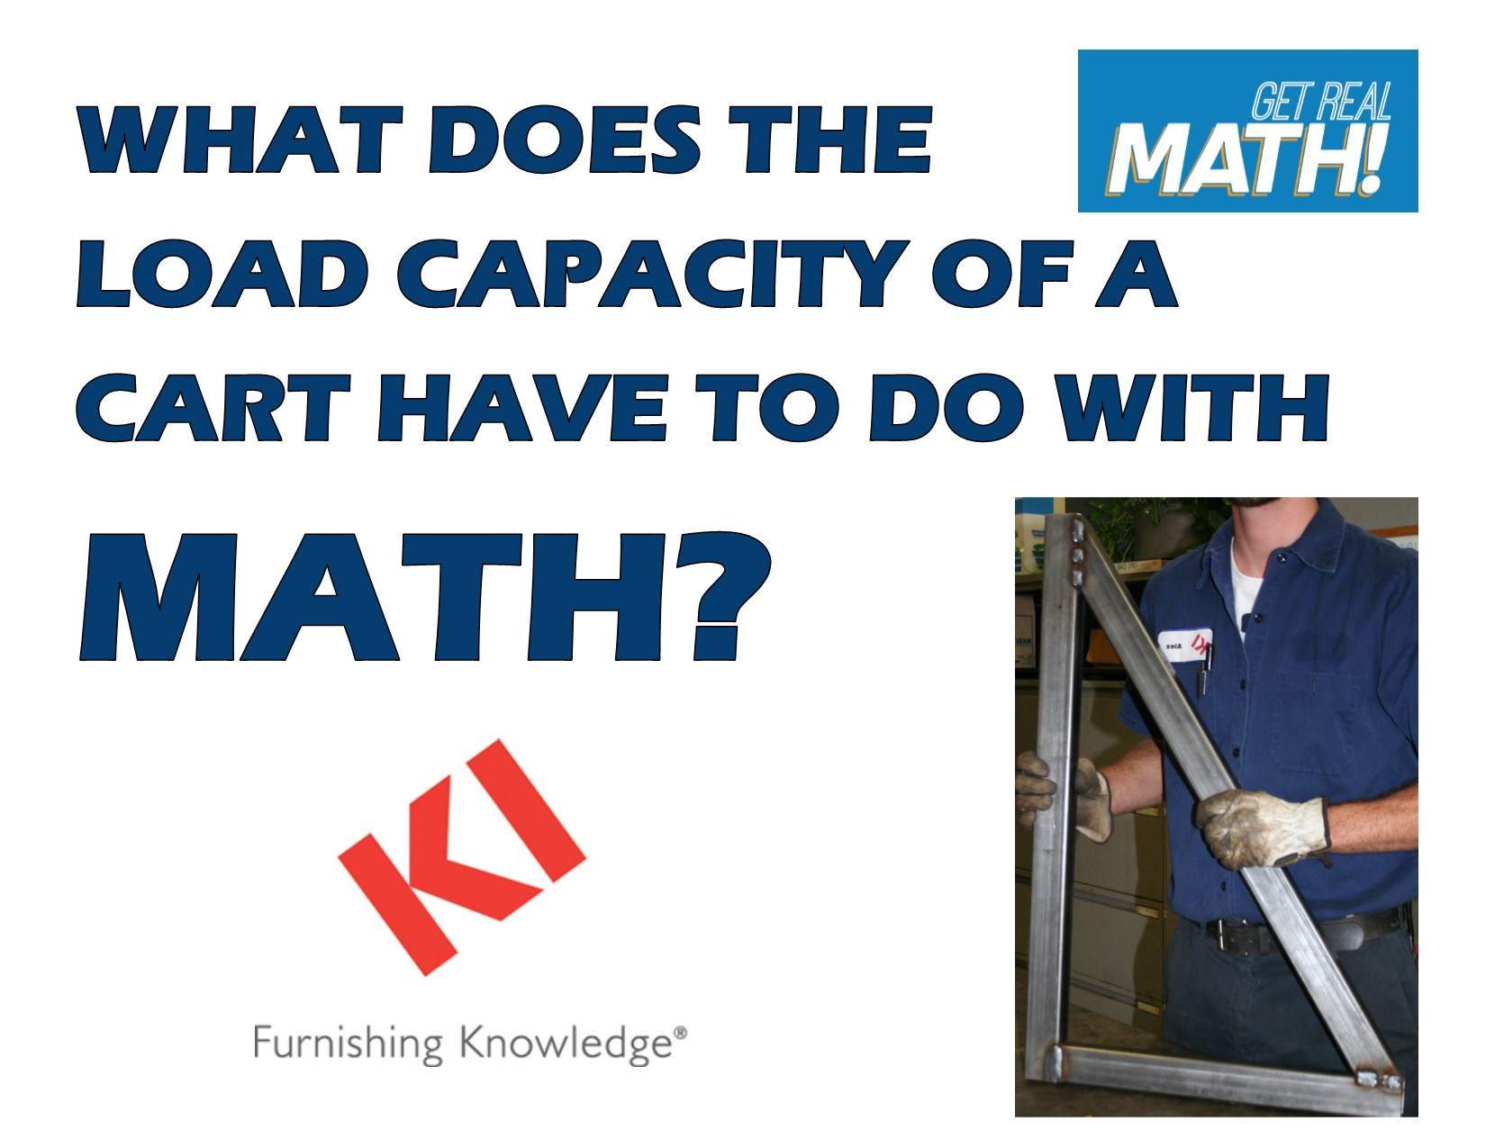
Video Link: https://youtu.be/MAS8htdbH4Y

Summary: In this video, students are challenged to determine the length of a cross brace for a cart. They also need to determine the angle to set the cross brace at. The Pythagorean Theorem and right triangle trigonometry is needed to determine these dimensions. The importance of a strong weld is also discussed as the load the cart may need to carry could be very heavy and a solid cross brace put on securely is necessary.

Company Information: KI is an international manufacturer of office and institutional furniture. KI has ten different manufacturing plants, with its headquarters located in Green Bay, Wisconsin. Each plant focuses on a different aspect of business. At the Green Bay plant the focus is on chairs, desks and tables. The largest part of what KI-Green Bay produces is for educational markets, in both K-12 and post-secondary settings. In 2012, KI shipped about 876,000 combined units total.

Part 1 (0:00-0:48)

- Play video (0:00-0:44), pause at prompt (0:45-0:48) for “Break 1” to answer the discussion questions.

  - What type of product are they talking about making?
    - They are making a cart that will hold heavy loads – it will probably be used in a workplace where heavy materials need to be moved around easily.
  - Why would a cross brace be needed for the cart?
    - Jason said that the load will be up to 1000 pounds. With a potential load this heavy on the cart, a cross brace will need to be added to increase the strength of the cart.
  - Based on the blueprint on the next page, what information is needed and what formulas can be used to determine these missing parts.
    - The length of the cross brace needs to be determined using the Pythagorean Theorem.
    - The angles of where the cross brace meets with each of the legs needs to be determined using one of the trigonometric ratios. It would be best to use tangent based on the original dimensions of the legs given.
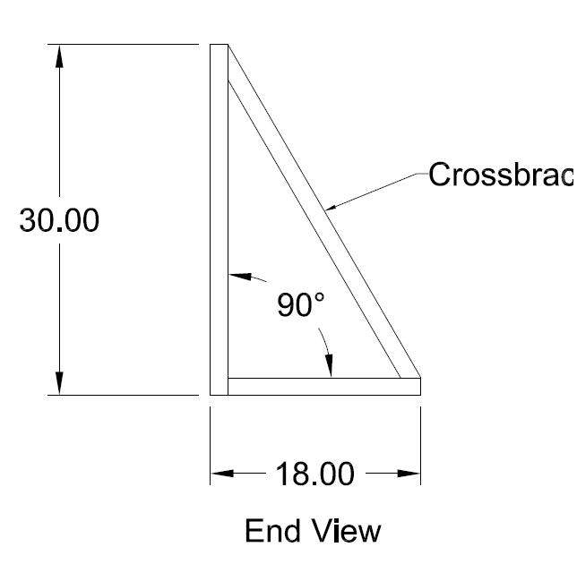
Crossbrace
Part 2 (0:49-1:25)

- Play video (0:49-1:20) verifying that you determined the correct formulas needed to find the missing length and angles, pause at prompt (1:21-1:25) for “Break 2” to answer the discussion question.

- Determine the cross brace length using the Pythagorean Theorem at this point.
- $\sqrt{{30}^{2}+{18}^{2}}=34.99=35"$

Part 3 (1:26-1:44)

- Play video (1:26-1:40) verifying you determined the correct length of the cross brace, pause at prompt (1:41-1:44) for “Break 3” to answer the discussion question.

- Determine the angles the cross brace is set using the tangent function at this point.

- Tan A = 18/30
A= 30.96 31°
- Other angle: 180-90-31 = 59°

Part 4 (1:45-2:14)

- Play video (1:45-2:08) verifying that you determined the correct angles for how the cross brace should be set, pause at prompt (2:08-2:14) for “Break 4” to answer the discussion questions.

  - Did you calculate the angles differently?
    - Discuss if anyone first determined the angle at the bottom being 59.

  - Once one of the angles is determined, is there another way to determine the other missing angle besides taking 180-90-31 = 59.
    - Since this is dealing with a right angle and one angle is definitely 90°, the other two add up to 90°, so we could have just taken 90-31 = 59°.

Part 5 (2:15-3:13)

- Play video (2:15-3:13) and then answer the discussion questions.

  - What material is being used to create this part of the cart?
    - Steel square tubing

  - What does it look like are some of the issues with the weld? (Go back to 2:47 to look closely).
    - The wire feed may have started to feed improperly or Alex may have slipped towards the middle where there is a large gap in the weld.

  - Why is it so important to have a strong weld here?
    - As stated earlier, the load being put onto the cart could be up to 1000 pounds, so the weld needs to be very strong since it will be put under a lot of pressure. If the weld is not strong enough, it could break, regardless of the placement and strength of the initial material. If the cart did not need to hold a load so heavy, the cart would be made out of wood or plastic – the necessity of the strength of the cart is shown by the fact that it is being made out of steel.

  - What other things could be done to make the cart even stronger if a heavier load is needed?
    - Some ideas - additional cross braces could be added to have them on every side, thicker tubing could be used

  - Once this part of the cart is complete, what else will probably be done to complete the cart?
    - This part will be probably be duplicated on at least one other side and they will be attached to the top and bottom bases. Wheels would also need to be attached.

