Math Trades 1
Measurement Video

Name ____INSTRUCTOR KEY_____________
Video Link:
https://youtu.be/BY2nK4B3qtk
Summary: In this video you will look at needing to change dimensions to determine the proper robotic arm to order for a new welding enclosure. A blueprint is provided that you will measure several dimensions which then needs to be turned into a real world dimension using the blueprint scale. The dimensions then need to be converted from inches to millimeters to determine the type of robotic arm to order.

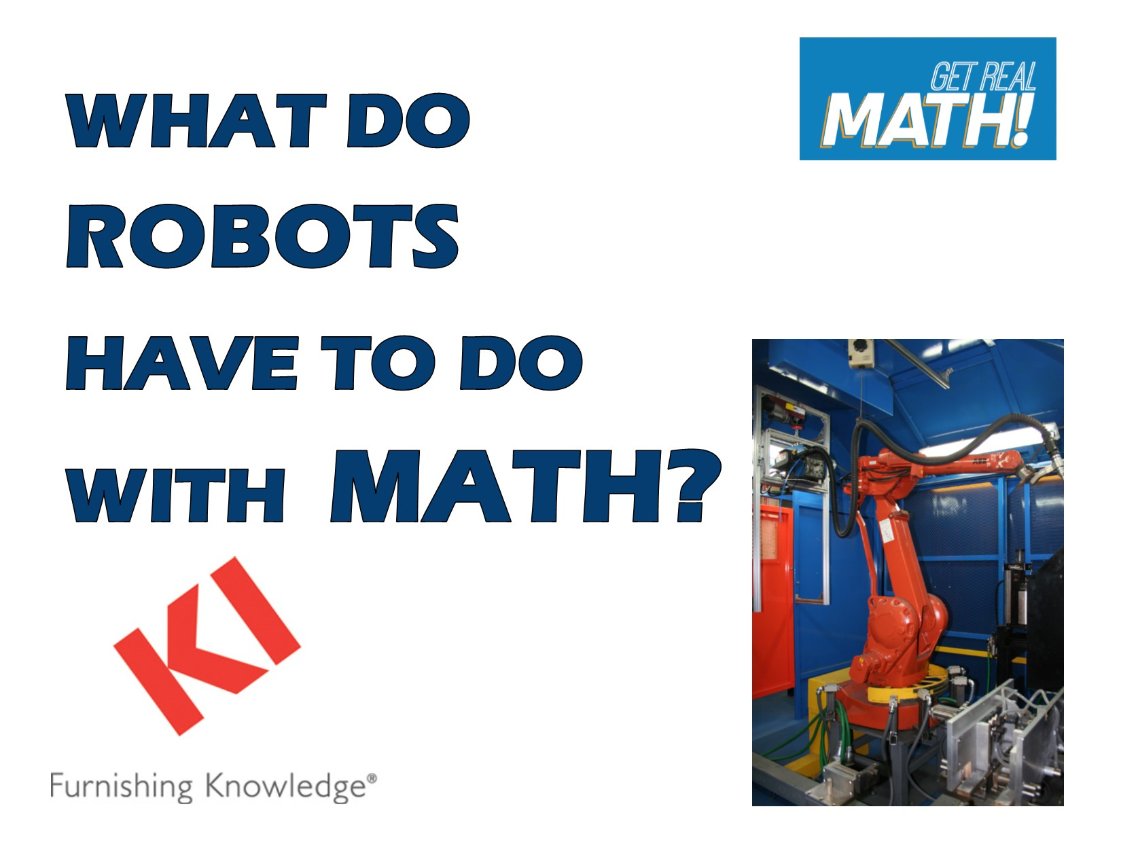
Company Information: KI is an international manufacturer of office and institutional furniture. KI has ten different manufacturing plants, with its headquarters located in Green Bay, Wisconsin. Each plant focuses on a different aspect of business. At the Green Bay plant the focus is on chairs, desks and tables. The largest part of what KI-Green Bay produces is for educational markets, in both K-12 and post-secondary settings. In 2012, KI shipped about 876,000 combined units total.

Part 1 (0:00-1:10)

- Play video (0:00-1:06), pause at prompt (1:07-1:10) at “Break 1” to answer the discussion questions.

- What does this robotic welder look like? What is the purpose of the robotic welder? Joe said that that arm needs to “properly hit all the points that we need.” What does he mean by this?
  - This will be part of an enclosure that has a robotic welder in the middle and several stations that will weld parts, four parts at a time, moving around to each station. The arm needs to be a proper length to reach the stations where the parts will be welded.
- Joe said that the robotic welder will be for dolly production. What do you think this may look like or what might this be?
  - Some KI dollies: http://www.amazon.com/s?rh=n%3A256347011%2Cp_4%3AKI

- Why would it be so important to know the dimension of the robotic arm needed?
  - The correct robotic arm will need to be ordered so that it will fit in the enclosure and reach any job that they may use for this enclosure.
- Now, work in groups to determine the lengths going from the middle of the robot to each of the four stations by measuring the blueprint on the next page in inches and record below. Then determine the real dimension using the blueprint to actual scale of 1 to 15.5:

 | Measured Blueprint Dimension (to nearest 32nd or 16th) | Actual Dimension Based on 1:15.5 scale
Station 1 | 4 ¼” (4.25 in video) | 65.8”
Station 2 | 5” (4.93 in video) | 77.5” or 76.4”
Station 3 | 5” (4.96 in video) | 77.5” or 76.8”
Station 4 | 4 3/8” (4.37 in video) | 67.8”
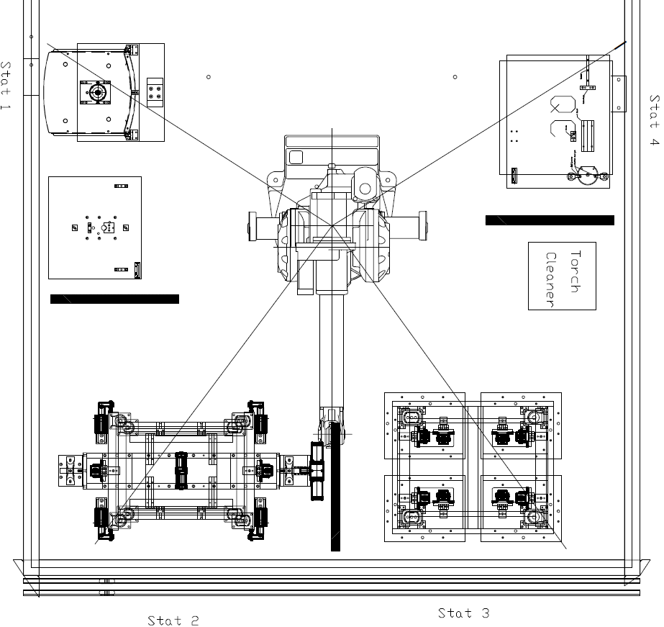

**Note: The blueprint is to scale here so do not adjust the size of the image. Converting the document to a pdf will change the size of the image and will no longer be to scale.
Part 2 (1:11-2:00)

- Play video (1:11-1:55), pause at prompt (1:56-2:00) at “Break 2” to verify that you measured correctly from the blueprint and converted correctly using the appropriate scale. Then answer the discussion questions.

- Did anyone obtain different dimensions? Since we are using a ruler to determine the dimension from the blueprint, is this a precise way to measure?
  - Students may have measured close but not exactly what Jake had measured. Discuss that within a 16th of an inch is pretty accurate.
  - These measurements we are doing are not too accurate without using better measuring tools than a ruler and professionally printed blueprint.
- How did Jake seem to measure?
  - Jake must have measured to the nearest 32nd of an inch and dropped the decimals after the hundredths place.
- For this application do we need to make very precise measurements?
  - For this application precision may not be as important as in other applications since we are determining the type of robotic arm to order and the options probably do not go as accurate as down to the nearest inch even.

Part 3 (2:01-3:43)

- Play video (2:01-2:05),pause at (2:05) to answer the discussion questions

- Are there any ideas of why the dimensions would need to be converted to millimeters?
  - The reason is because the robotic arms that they are to choose from has the dimensions listed in millimeters.
- What is the conversion factor that allows us to convert inches to millimeters?
  - One inch = 25.4 millimeters (mm)
- Why wouldn’t Jake have just measured the blueprint in millimeters initially?
  - He possibly could have but a lot of times the measuring tools handy in a shop like this are all in inches unlike the ruler used in schools which often can be used to measure in inches or millimeters.
  - He possibly could have in reality been looking at some dimensions listed elsewhere on the blueprint that were in inches rather than having measured the blueprint like we did as a class.
- Do you think it is common that millimeters and inches need to be converted in situations like this or industries like manufacturing in general?
  - There are many situations in which US Customary units (like inches) and metric units (like millimeters) need to be converted in the manufacturing industry, especially as industries like this become more and more global.
  - Some examples are dimensions on blueprints are in metric and measuring tools or machines need to be inputted in US Customary or parts that need to be ordered are in one dimension and you need to compare this to a dimension you have that is in the other.
- Now, work in groups to determine the dimensions of the reach of each station in millimeters.
 | Dimension in inches | Dimension in millimeters
Station 1 | 65.8” | 1680 mm
Station 2 | 76.4” | 1950 mm
Station 3 | 76.8” | 1960 mm
Station 4 | 67.8” | 1730 mm

- Play video (2:06-2:31), pause at prompt (2:32) to verify that you converted correctly to the dimensions in millimeters. Then answer the discussion questions.

- Did you have the same calculations as Jake? Jake rounded up to the nearest 10 millimeters. Why do you think he would have done this? Why did he always round up instead of to the nearest ten?
  - He will be comparing the dimensions to what type of robotic arm to order, so at this point, to the nearest 10 mm should be accurate enough. It makes sense for him to always round up because they would want to have a little extra reach if needed, but definitely not be under so that there wouldn’t be a part too far away to weld based on the reach of the arm.

- Play video (2:33-3:08), pause at prompt (3:09) to answer the discussion questions.

- Jake said that the standard robotic arms are series IRB 1400 being 1440 mm and the series IRB 2400 being 1800 mm. He then added 13.5” or 343 mm to each. How did he get 343 mm?
  - 13.5” x 25.4 = 343 mm
  - If students are confused at this point about why they are adding 343 mm due to the welding torch you can cut ahead to 3:50 to see the welding torch on the end of the robotic arm.

- Based on the dimensions we found for the distance of each station, which robotic arm should they order?
  - IRB2400 so that it can reach Stations 2 and 3.

- Play video (3:10-3:39), pause at prompt (3:40-3:43) at “Break 3” to answer the discussion questions

- What were some of the reasons Joe said it is so important that this is correct and the calculations Jake made were accurate?
  - This is a very costly piece of equipment and they are on a tight timeframe to be able to start using this enclosure for production of their dollies. If a mistake was made not only the cost of the part would be in jeopardy but also the products that could not be made due to waiting for the correct part with the correct dimensions.

Part 4 (3:44-4:15)

- Play video (3:44-4:15) and answer the discussion question

- Discuss the importance of the calculations being made in this situation. Summarize what things Jake had to have a confident understanding of in order to be sure he was making correct calculations.
  - Jake needed to be confident in converting units and using blueprint scales. Also, applying when rounding should be done in what way was helpful.

