Math Trades 1
Algebra Video

Name ______INSTRUCTOR KEY___________

Video Link: https://youtu.be/Nrf-47lB-Tw

Summary: Understanding the weight of different things is very important for many reasons – safety being one of the main reasons. In this task, students learn how to calculate the weight of a table in order to determine the appropriate straps to use for rigging the table to move it properly and safely.

NWTC Information: Northeast Wisconsin Technical College is a nationally-ranked, two-year public college where students prepare for high-tech careers and begin their bachelor’s degrees. NWTC is one of 16 colleges in the Wisconsin Technical College System. The College has three campuses in Green Bay, Marinette, and Sturgeon Bay; five regional learning centers in Crivitz, Luxemburg, Niagara, Oconto Falls, and Shawano; and several additional sites.

Part 1 (0:00-0:23)

- Play video (0:00-0:17), pause at prompt (0:18-0:23) for “Break 1” to answer the discussion questions.

- What information will Austin and Wayne need to figure out the weight of the table?
  - Types of material, weights of various materials, dimensions of the parts of the table
- What will be used to lift the table?
  - Austin states that they will use a crane and straps. This is called rigging. The straps will be fed under the table top and connected to a crane and lifted with the crane.
- Why would they need to figure this out? Why not just lift the table to move it themselves?
  - Examples: In many workplaces there is a limit of 50 pounds that employees are allowed to lift. If employees were to lift very heavy items or lift heavy items on a normal basis, then injuries can occur. This can have significant consequences for companies – workers’ compensation, loss of worktime, etc.
- What types of material does it look like are being used for this table?
  - Sheet metal for the top, square tubing for the legs and middle support, and angle iron for the other supports

Part 2 (0:24-1:13)

- Play video (0:24-0:37), pause at (0:38) to answer the discussion question.

- What kind of information does it seem the Ryerson book includes?
- The Ryerson stock list book includes a variety of metals and the weight per unit of a variety of metals.
- To show this via the Ryerson website (seller of metal materials), you can go to www.ryerson.com. If you hover over “Products and Services” and click on Stock List, you can find tables including information that will be shown throughout the lesson plan. For the top of the table, click on Plate and then General Purpose. For the square tubing, click on Tubing & Pipe, Square & Rectangular Tubing, and Square Tubing. For the angle iron, click on Structural Shapes, Angles, and Bar Size.
- Play video (0:39-0:51) filing in the dimensions measured in the chart below, pause at (0:52) to then look up the appropriate weight in the Ryerson Sheet Metal/Steel Plate chart below.

Material | Stock Size | Weight/unit | Quantity/Dimensions | Weight
Sheet Metal | $\frac{3}{8}$” | 15.32 lb/sq ft | 24x48=1152 sq in/144=8 sq ft | 122.56 lbs
Square Tubing | 1$\frac{1}{2}$” x 1$\frac{1}{2}$ “ x $\frac{1}{8}$” | 2.210 lb/ft | 152”/12 = 12.6667’ | 28 lbs
Angle Iron | 1$\frac{1}{2}$” x 1$\frac{1}{2}$ “ x $\frac{1}{8}$” | 1.23 lb/ft | 32”/12=2.6667’ | 3.28 lbs
 |  |  | Total | 153.8 lbs

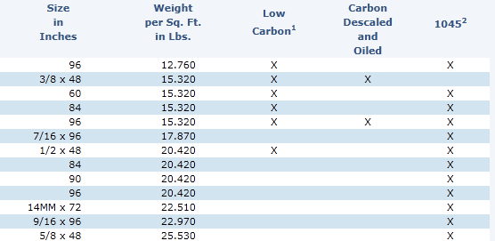

- Did you notice anything about the top of the table that could affect the weight?
  - There are slits in the top of the table. This is so that a clamp can be attached to hold down parts that need to be worked on. This could lower the weight of the table top, but not very significantly since there is not much area missing.

- Play video (0:53-1:08) verifying your weight/unit, pause at prompt (1:09-1:13) for “Break 2” to calculate the weight of the top of the table. Be careful to think about what units you are using and if necessary, convert to an appropriate unit. Record this in the chart above.
Part 3 (1:14-2:32)

- Play video (1:14-1:38) writing the dimensions of square tubing below, pause at (1:39) to determine the total number of inches of square tubing needed and record this in the chart on page 2. Also, look up the appropriate weight in the Ryerson square tubing table below and record in the chart.

  - 4x28 + 40 = 152 inches

***Note: $\frac{\text{1}}{\text{8}}\text{"}$ thickness is 11 Wall Gauge
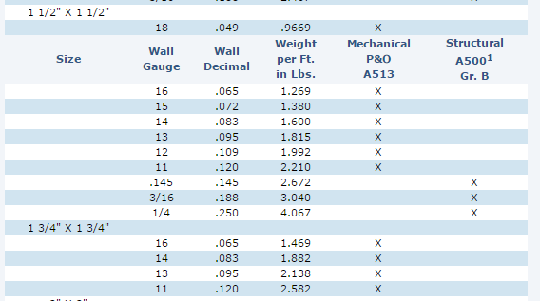

- Play video (1:40-2:15) verifying your weight/unit for square tubing and writing the dimensions of angle iron below, pause at (2:16) to determine the total inches of angle iron needed and record this in the chart on page 2. Also, look up the appropriate weight in the Ryerson angle iron table below and record in the chart.

  - 2x16 = 32 inches

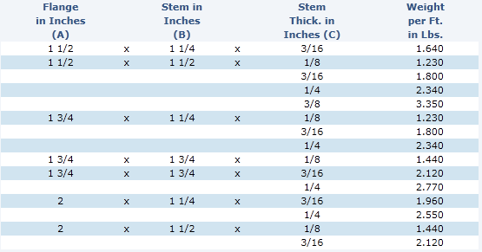
- Play video (2:17-2:25) verifying your weight/unit for angle iron, pause at prompt (2:26-2:32) for “Break 3” to calculate the weight of the square tubing and angle iron. Again, be careful about what the units are. Find the total weight in the chart. Also, answer the discussion question below.

- Why was the sheet metal weight given in pounds per square foot versus the square tubing and angle iron weights given in pounds per foot?
  - The sheet metal is based on an area – square units. The sheet metal can vary in two different dimension – length and width. For the square tubing and angle iron, they come in specific dimensions with only the lengths varying. So, the weights are given as linear standards.

Part 4 (2:33-4:31)

- Play video (2:33-4:26) verifying your weights for each part and total weight, pause at prompt (4:27-4:31) for “Break 4” to answer the discussion questions below.

- Does this weight seem reasonable? Based on earlier discussions, would this table be safe to move by having two people pick it up and move it? What weight should they be looking at the straps being able to handle in order to safely move this table?
  - This is over the 50 pound maximum discussed earlier. The straps should be at least 200 pound straps.

Part 5 (4:32-5:49)

- Play video (4:32-5:49) and then answer the discussion questions

  - The process Austin and Wayne were performing is called rigging. Why is this process so important?

  - The capacity of the strap they were planning to use is 500 pounds. What would happen if the strap only had a capacity of 100 pounds? Or if the table was over 500 pounds? What are possible things that could happen?
    - As discussed earlier, someone could get injured. Things could break which would be very costly – the item trying to be moved or the crane or straps.

  - See some videos of improper rigging and the consequences:
    - https://www.youtube.com/watch?v=ok9DNb2VJY8 – This is very long, but you can skip around and watch several parts
    - https://www.youtube.com/watch?v=axjmK_vjYCM – Watch the first 40 seconds, then skip to watch 1:35-2:00, then skip to 3:00-end

