Math Trades 1
Integer Video

Name _____INSTRUCTOR KEY_____________

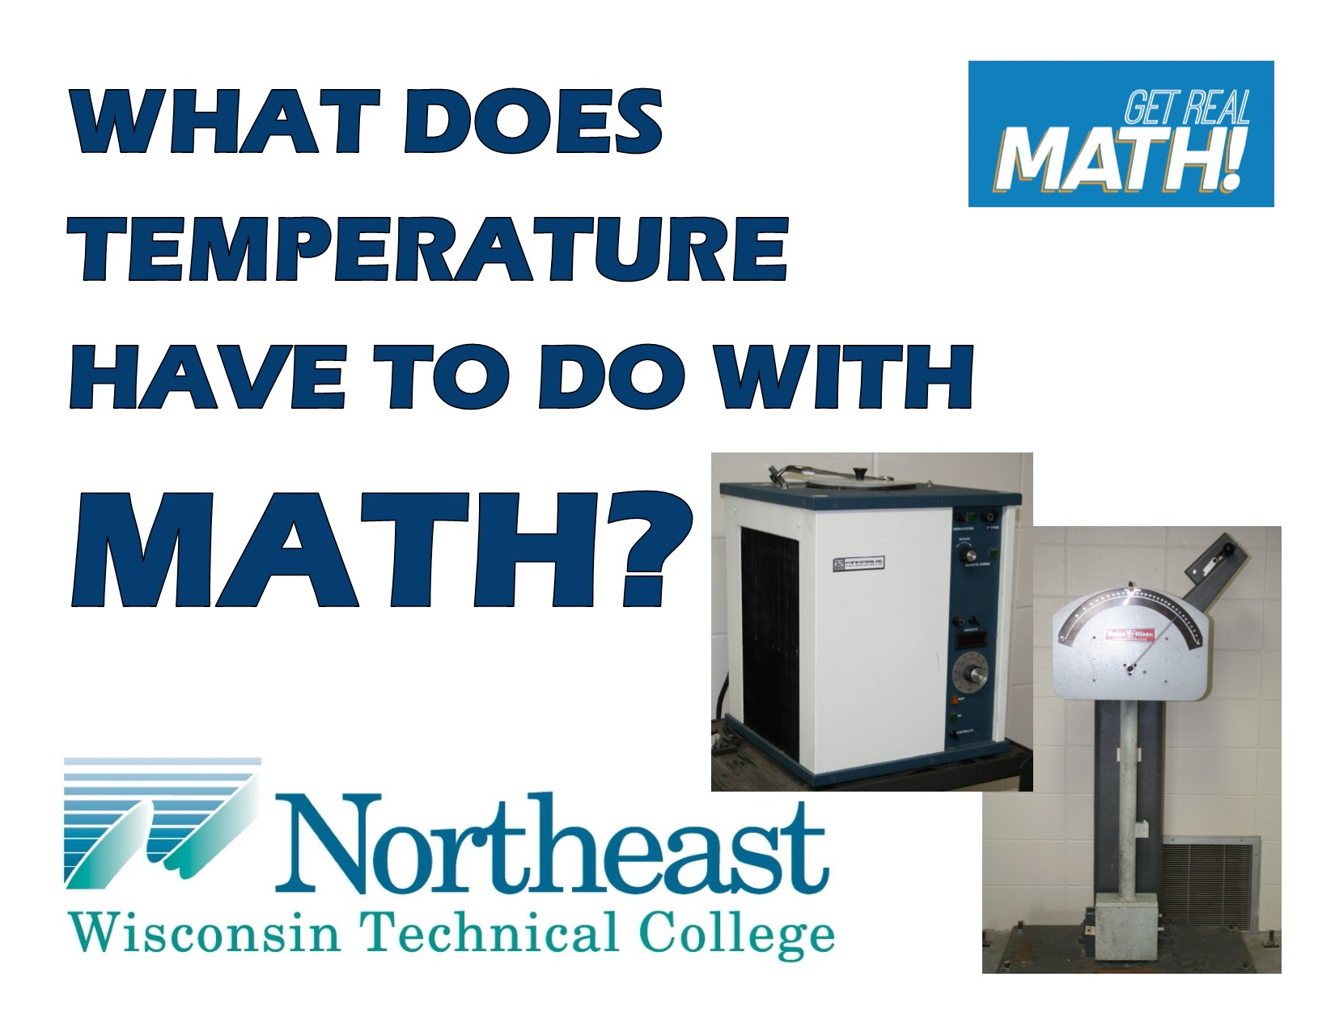
Video Link:
https://youtu.be/IvX0Oncxnss

Summary: In this lesson, you will see a material’s strength being tested using the Charpy Impact Test. In this particular situation, the material is to be tested under very cold temperatures and to do so, the temperature at which the material needs to be tested needs to be converted from Fahrenheit to Celsius.

NWTC Information: Northeast Wisconsin Technical College is a nationally-ranked, two-year public college where students prepare for high-tech careers and begin their bachelor’s degrees. NWTC is one of 16 colleges in the Wisconsin Technical College System. The College has three campuses in Green Bay, Marinette, and Sturgeon Bay; five regional learning centers in Crivitz, Luxemburg, Niagara, Oconto Falls, and Shawano; and several additional sites.

Part 1 (0:00-1:44)

- Play video (0:00-0:36), pause at (0:37) to answer the discussion questions.
  - John says that the Charpy Impact Tester is used for “measuring the actual impact toughness of materials”? What do you think the different materials he is talking about could be?
  - Different metals – steel, aluminum, stainless steel, copper, brass, etc. There are many different variants of each of these types of metals based on the ratio of elements in each of the metals and how the metals are produced. These are all made differently and may need to be tested.
  - Why would something need to be tested at twenty below or forty below?
  - This will be discussed in the video shortly but basically for testing materials that will be used in very cold temperatures. John references the shipping industry and cranes. Other good examples could be bridges or structures in or around the ocean that will be in very cold temperatures.
  - The impact is measured in foot-pounds. What do you think foot-pounds are?
  - According to the Merriam-Webster dictionary, a foot-pound is “a unit of work equal to the work done by a force of one pound acting through a distance of one foot in the direction of the force”. (http://www.merriam-webster.com/dictionary/foot-pound)

- Play video (0:38-1:40), pause at prompt (1:41-1:44) for “Break 1” to answer the discussion questions.
- Why would the dimensions need to be specifically these dimensions with the groove in that specific location?
  - The part needs to have standard dimensions and have the groove in that specific location so that the part can work consistently for the tester it is being placed into. This is also why the particular tool needs to be used to place the part into the tester accurately.
- The notch is to be placed outward from the impact? Why would this be?
- The notch will cause the part to break consistently for each part being tested in the same location each time.
- John stated that three to five specimens will be tested and then an average of the foot-pounds will be taken. How would this be done – how do you find an average?
  - Add up the measurements of foot-pounds and divide by the number of specimens that were tested.
Part 2 (1:45 – 2:31)

- Play video (1:45-2:27), pause at prompt (2:28-2:31) for “Break 2” to answer the discussion questions.
- So, without the specimen the Charpy impact machine read zero foot-pounds of energy. Explain in your own words why and what is going to happen differently once a specimen is there?
- When the hammer has nothing to interfere with its path, there will be no impact. Once there is a specimen (block of metal) in the tester, in the way of the hammer, it will slow down the hammer, absorbing some of the energy.
- How do you think the temperature stipulated on contract documents are determined?
- It would depend on the environment the particular metal will be in. For example, a ship that will be in temperatures in the ocean of thirty below would need to be tested at at least thirty below, if not colder to be safe.
- Since the contract document stipulates the temperature in Fahrenheit and the machine needed to cool the specimen is in Celsius, what will need to be done in order to convert the temperatures?
- Use the formula, C = (F-32)/1.8. Or C = $\frac{5}{9}$(F-32)
- The contract document states that the temperature is listed at -20°F. Determine what this temperature is in Celsius.
Part 3 (2:32 – 3:51)

- Play video (2:32-3:20), pause at (3:21) to answer the discussion question and verify that you have determined the correct temperature in Celsius.
- John shows that -40°F is equal to -40°C. Does this happen at any other temperature?
  - No, only at -40 is this true.
- Play video (3:22-3:51) and answer the discussion questions.
- What does it look like the impact is measured to be? (Go back and pause at 3:39 to look closer.) Looking at the scale, if a stronger material were in the machine, would the foot-pounds be more or less than this?
  - The impact is 70 foot-pounds. The stronger the material, the higher the foot-pounds will be. The pointer would not move as far if there is a part that would slow the hammer down more. The easier it is for the hammer to break through the specimen, the more the pointer will move, showing a lower foot-pounds, a lower impact.
- What may this measurement mean for the material being tested?
  - The value of the impact in foot-pounds tells us the toughness and tensile strength. There are certain requirements a job will have based on the product for that job needing to perform a particular way under certain circumstances. For an example many can understand – think of the Titanic. When it hit an iceberg, the metal that the ship was made of became more and more brittle in the cold environment it was in. For the iceberg to have not damaged the ship, the metal would have had to have been made with a stronger type of steel – a better balance of elements to make the steel stronger in cold temperatures. (Doing a search online of “What metal was the Titanic made of?” will show several articles discussing this.)

