Math Trades 1
Geometry Video

Name _INSTRUCTOR ANSWER KEY____

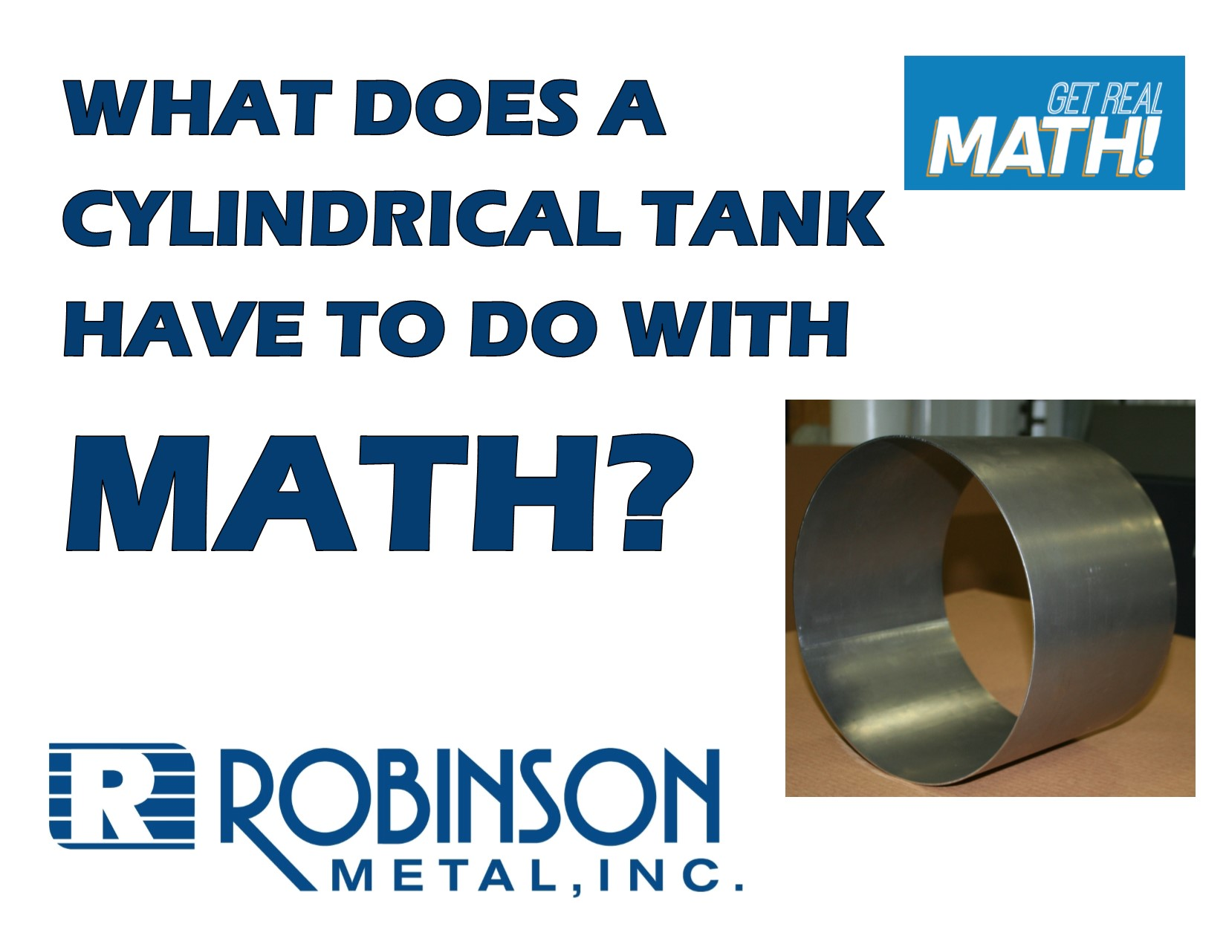
Video Link:
https://youtu.be/-5naDjodNls

Summary:
In this video, specifications for a set of tanks that are ordered are given in regards to the volume in gallons and the diameter of the tank. The height of the tank needs to be determined using some conversions and the formula for volume of a cylinder. The process of how the tank is produced is discussed and shown.

Company Information: Robinson Metal was established in 1975 in Green Bay, WI. RMI now resides in De Pere WI., with a 185,000 sq. ft. manufacturing facility, offering a single comprehensive source, for custom metal fabrication, machining and assembly. RMI has combined the skills and knowledge of our highly trained craftsman with the latest tools and technologies. RMI specializes in stainless steel, aluminum, carbon steel and polycarbonates, resulting in quality finished products, offering a first class customer experience, building products to their designed specifications.

Part 1 (0:00-0:28)

- Play video (0:00-0:24), pause at prompt (0:25-0:28) for “Break 1” to answer the discussion questions.

  - What information is Mark given?
    - Mark is given that the customer wants the tanks to be 4 gallons and the outer diameter (OD) is 12 1/8”. He also is told that they need about 50 tanks.
  - What can he assume based on the information given?
    - Mark is not directly told what the tank will look like but based on the fact that he is given an OD, we can assume the tank is in the shape of a cylinder.
  - What information will he need to determine in order to make these tanks?
    - Mark is asked to come up with the dimensions of the tank. The volume of the tank is given, so instead of the outer diameter, Mark will need to use the inner diameter. Thus, he will need to determine the thickness of the material that will be used to make the tank. Also, he does not know the height of the tank. Other ideas: What type of material is being used, where are openings needed or additional parts attached, will the tank need to be finished off in any way.

  - What formulas or information can he use to determine missing information?
    - Mark can use the volume formula of a cylinder to determine the missing dimension – the height of the tank. Volume of a cylinder is V = πr²h. He will need to use the fact that there are 1 gal = 231 cu in in order to use the formula since we’ll need consistent units to be used with the formula.

  - What may be the process that Robinson will go through in order to go from taking this order to fulfilling the order for the customer?
    - Mark is receiving the specifications requested. He will need to determine the circumference based on the diameter inner diameter and height of the tank. This will give a fabricator the specifications to cut a sheet of metal to appropriate dimensions for the wrap (circular side) and top and bottom. The wrap will then need to be rolled to a circular form. The edge would then need to be joined by being welded and the top and bottom welded on. A tank would probably go through an inspection process to ensure accurate dimensions and the capacity of 4 gallons required of the job is accurate. The tank would then be finished by the welds being ground smooth and the tank being polished or painted.
Part 2 (0:29-0:55)

- Play video (0:29-0:51), pause at prompt (0:52-0:55) for “Break 2” to answer the discussion questions.

  - Mark tells Jesse the material thickness of the “wrap”. What does the wrap denote?
    - The wrap is the side of the cylinder if the cylinder is sitting on one of its circular bases.

  - Now that we are given the thickness of the sheet metal that will used is, determine the inner diameter of the cylinder. Then determine the inner radius.
    - 12.125 – 0.075*2 = 11.975 inner diameter
11.975/2 = 5.9875 inner radius

  - How many cubic inches are in 4 gallons?
    - The volume in cubic inches is 4 gal * 231 = 924 cu inches.

Part 3 (0:56-1:38)

- Play video (0:56-1:33), verifying that you have the correct inner radius and cubic inches, pause at prompt (1:34-1:38) for “Break 3” to answer the discussion questions.

  - Use the information determined so far and the formula for volume of a cylinder to find the missing dimension – the height.
  - 924 = π*5.9875*h² h = 8.204”
Part 4 (1:39-3:07)

- Play video (1:39-3:07), verifying that you calculated the correct height of the tank. They answer the discussion questions below.

  - When Jesse was measuring the height of the tank, he is using a tape measure so the measurement are to fractional inches. What fractional inch measurement would Jesse be measuring if he was measuring to the nearest 16th of an inch? What if he was measuring to the nearest 32nd of an inch?
    - 8 3/16” or 8 7/32” (Obtain by taking .204*16 = 3.264 – rounded to 3/16; .204*32 = 6.528 – rounded to 7/32)

  - This tank was being inspected by Jesse? Why is it important to inspect products?
    - In this situation, they wanted to verify the dimensions being correct before making all 50. In general though, items are inspected on a regular basis to ensure products are being made to their specifications.

  - What things will probably still be done from this point to complete the tank?
    - The seam where the sheet of metal meets will be welded together. The top and bottom bases will probably be welded on and at least one opening will be added. Finishing touches will be done as well.

Extension

- This is not discussed in the video – but the wrap starts as a rectangular sheet of metal, which we can see in the video at (2:31). One side is the height. What is the other side of the rectangle?
  - The circumference of the circles that are the bases.
- What would make the most sense to use for the diameter since we have an outer diameter and inner diameter?
  - It would be the mean (average) diameter.
  - (12.125+11.975)/2 = 12.05”.
  - On the blueprint, it is obtained by taking the diameter – one thickness.
- Determine what the dimensions of the sheet of metal that creates the wrap of the cylinder should be. If time allows, measure out the dimensions on a piece of paper and tape the piece of paper together to replicate making the tank and verify the diameter.
  - C = π*12.05 = 37.856”
  - So, the sheet of metal is 37.856” by 8.204”

- Use the blueprint on the next page which is a supplemental attachment here (by passing around or showing on an overhead) once the students have determined and verified this information.

