Math Trades 1
Decimals Video

Name ___INSTRUCTOR KEY___________

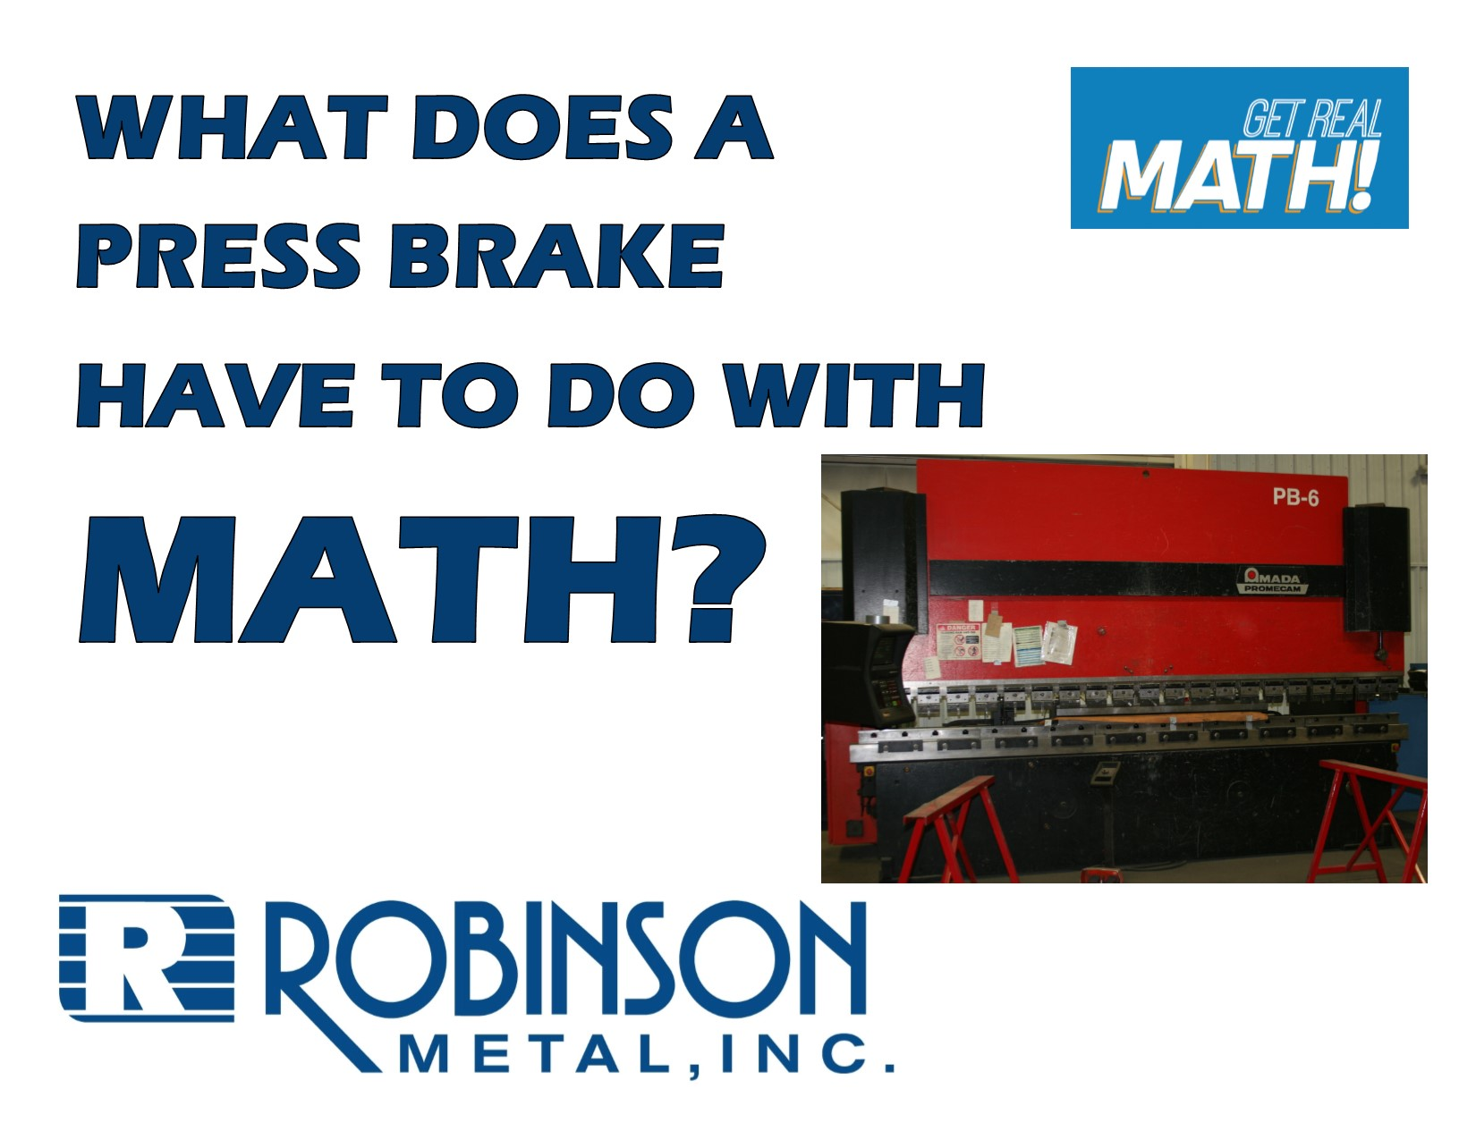
Video Link:
https://youtu.be/e544waetKNA

Summary: In order to operate many machines in the manufacturing industry, dimensions need to be entered a certain way. In this video the dimensions on a blueprint to make a box are in fractions of an inch, but when the sides of the sheet metal are bent using a press brake, the dimensions need to be entered in decimal form. You will need to convert fractional inches into decimals.

Company Information: Robinson Metal was established in 1975 in Green Bay, WI. RMI now resides in De Pere WI., with a 185,000 sq. ft. manufacturing facility, offering a single comprehensive source, for custom metal fabrication, machining and assembly. RMI has combined the skills and knowledge of our highly trained craftsman with the latest tools and technologies. RMI specializes in stainless steel, aluminum, carbon steel and polycarbonates, resulting in quality finished products, offering a first class customer experience, building products to their designed specifications.
Part 1 (0:00-0:31)

- Play video (0:00-0:26), pause at prompt (0:27-0:31) at “Break 1” to answer the discussion questions.
- What do you think a press brake does? How would a box be formed using the sheet of metal we can see on the table?
    - A press brake bends metal. In this situation, a sheet of rectangular metal would have squares cut from each corner so that the sheet is bent along the dotted line as shown below at 90° to make a box with an open top.

- Why would the dimensions need to be entered in decimals versus fractions?
  - While when measuring inches, measuring tools are split into fractions of an inch (8ths, 16ths, 32nds, and 64ths) it is easier to input decimals into a machine. It would be more challenging to need to enter a fraction.
- How do you convert fractions to decimals? Divide the numerator by the denominator.
- You can now work to convert the fractions on the blueprint below to decimals.

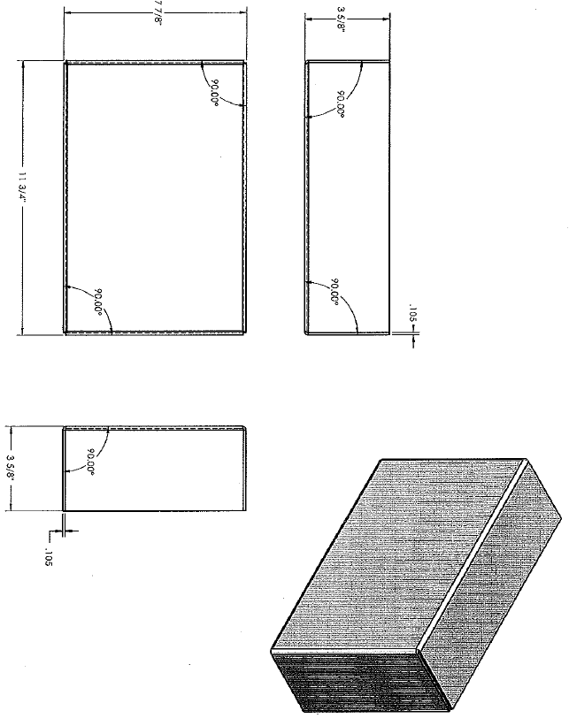
Part 2 (0:32-1:00)

- Play video (0:32-0:56), pause at prompt (0:57-1:00) at “Break 2” to verify your conversions as a class and answer the discussion question below.

- What do you think Jesse means when he says he “knows his decimal-fraction conversions up to the nearest 16th?”
  - Jesse would have memorized what each fractional measurement up to 16ths is in decimal form. By saying up to 16ths, this would include 2nds, 4ths, and 8ths as well since these are reduced versions of 16ths. So, he would have memorized what $\frac{\text{1}}{\text{16}}\text{,}\frac{\text{1}}{\text{8}}\text{,}\frac{\text{3}}{\text{16}}\text{,}\frac{\text{1}}{\text{4}}\text{,}\frac{\text{5}}{\text{16}}\text{,}\frac{\text{3}}{\text{8}}\text{,}\frac{\text{7}}{\text{16}}\text{,}\frac{\text{1}}{\text{2}}\text{,}\frac{\text{9}}{\text{16}}\text{,}\frac{\text{5}}{\text{8}}\text{,}\frac{\text{11}}{\text{16}}\text{,}\frac{\text{3}}{\text{4}}\text{,}\frac{\text{13}}{\text{16}}\text{,}\frac{\text{7}}{\text{8}}\text{,}\frac{\text{15}}{\text{16}}$ are in decimal form. This is typical for those in industry since they are so often converting between fraction and decimal forms of inch measurements. Often also up to 32nds would be known as well.

Part 3 (1:01-1:45)

- Play video (1:01-1:45), verifying remaining conversions and answer the discussion questions below.

- At what angle is the metal being bent to create the box?

  - 90°, go back to 1:13 to view this in the input screen of the press brake.

- What additional things may be done to this box to complete it? What might be the purpose for this box?

  - The corner vertical sides would need to be welded or somehow sealed. Possibly a top would be attached. Answers will vary but some ideas are to hold parts or as part of a larger item.

Extension

- What about converting the other way? What if a blueprint labelled dimensions in decimals but they needed to be converted to the nearest 16th of an inch to be able to use measuring tools that are on a scale of 16^{ths} of an inch or 32nds of an inch? How can this be done?

  - You may want to go through an example if this was not done in class yet. For example, a blueprint may show a dimension to be 3.45”. To convert this to the nearest 16ths on an inch, take .45*16 = 7.2. Round this to 7, so $\text{3}\frac{\text{7}}{\text{16}}\text{"}$. (This can be done because it is like multiplying $\frac{\text{.45}}{\text{1}}\text{*}\frac{\text{16}}{\text{16}}\text{=}\frac{\text{7.2}}{\text{16}}$ and then rounding.)

- If the sheet metal being used on this box needs to be ordered but the dimensions of what you can order are to the nearest 16th, what would you order?

  - … 16th? .105*16 = 1.68 2/16 1/8 (which is .125 – difference of .020)

What about to the nearest 32nd?

- …32nd? .105*32 = 3.36 3/32 (which is .09375 – difference of .01125)

To the nearest 64th?

  - …64th? .105*64 = 6.72 7/64 (which is .109375 – difference of .004375)

