Math Trades 1
Trigonometry (Arc Length) Video

Name _____INSTRUCTOR KEY_________

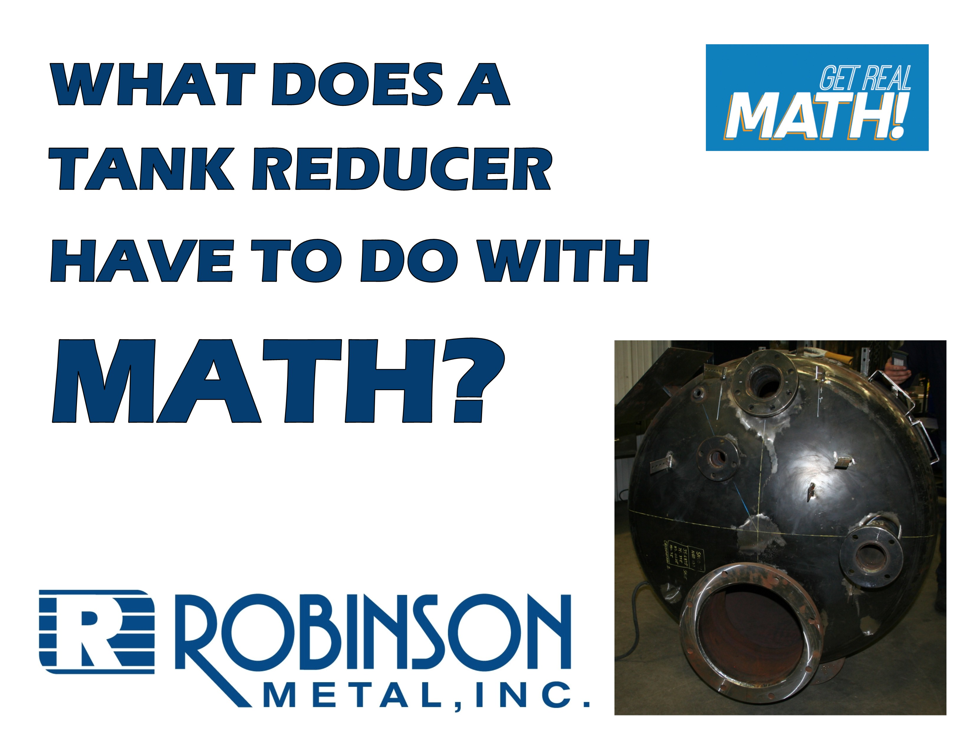
Video Link: https://www.youtube.com/watch?v=zuJqUDkPHO8

Summary: A part needs to be welded onto an exterior part of a tank reducer. Exactly where the part is to be attached needs to be determined first, based on a blueprint. In this activity, students need to determine the correct length from the top of the tank to place the object.

Company Information: Robinson Metal was established in 1975 in Green Bay, WI. RMI now resides in De Pere WI., with a 185,000 sq. ft. manufacturing facility, offering a single comprehensive source, for custom metal fabrication, machining and assembly. RMI has combined the skills and knowledge of our highly trained craftsman with the latest tools and technologies. RMI specializes in stainless steel, aluminum, carbon steel and polycarbonates, resulting in quality finished products, offering a first class customer experience, building products to their designed specifications.

Part 1 (0:00-0:38)

- Play video (0:00-0:22), pause at (0:23) to answer the discussion questions.

- What do you think a “revision” for a job is?
  - The customer who is requesting this job probably realized after submitting the original blueprint that another part needed to be added or the location moved. So, they would send a revision to Robinson with changes needed before the tank is completed. Note that the arrows were added for purposes of this video, they would not typically be on a real blueprint.

- What information in general would be needed to determine where to weld on a piece on the side of a circular tank like the one shown on the first page of the student handout?
  - Students should determine that a portion of the circumference of the tank will need to be determined based on what degree from the top the part needs to be welded. They may add that the diameter or radius would be needed to determine the circumference and that the angle would be needed.

- What tools will Jeremy need to make these calculations and lay out the part?
  - Jeremy will need a calculator for this type of calculation. He will need a soft tape measure (often called pee-wee tape) for once the length (portion of the circumference) is determined and will also need something to mark the tank.
- Play video (0:24-0:33), pause at prompt (0:34-0:38) for “Break 1” to answer the discussion questions.

- Based on the blueprint below, what specific dimensions are needed and why? What is the difference between ID – inner diameter and OD – outer diameter? Why would it be important to know both?
  - The arrows are pointing to the necessary information – the angle being 85° from the top, the ID at 47.5” and OD at 48”. There may be a discussion at this point about whether to use the inner diameter or outer diameter. In reality, the inner diameter is not needed to determine where to place this item since it is being welded onto the outside of the tank. We will see in coming sections though, that Jeremy mistakenly decided to use the inner diameter. So, allow students to continue to debate this and encourage ongoing conversation over ID versus OD.
  - The inner diameter is the diameter on the inside of the tank. The outer diameter is the diameter on the outside of the tank – this includes the thickness on each side as well.
  - Both may be needed depending on if we would need to calculate something on the inside of the tank or the outside of the tank.
- Based on the ID and OD of the tank, what does this tell us about the thickness of the tank?
  - The thickness of the tank is$\frac{1}{4}$”. This is determined by (48”-47.5”)/2.

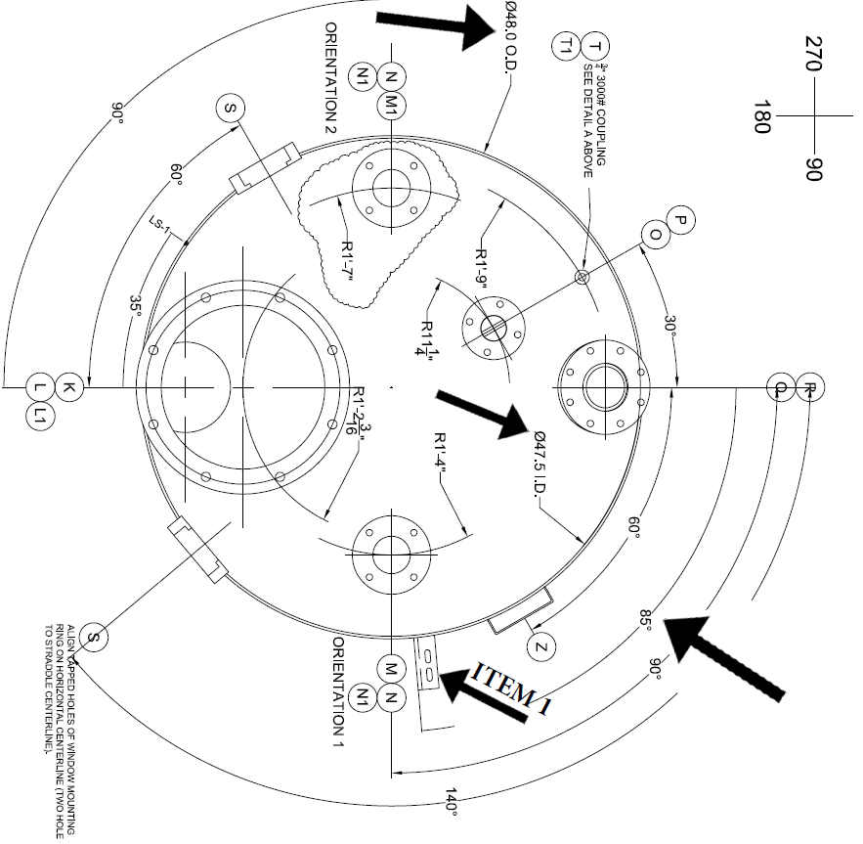

Part 2 (0:39-1:05)

- Play video (0:39-1:00), pause at prompt (1:01-1:05) for “Break 2” to answer the discussion questions.

  - Determine the length that you think needs to be measured from the top of the tank to where the item needs to be welded. Determine if you got the same answer as Jeremy’s 35.23” or something different.
    - Jeremy’s calculation is incorrect because he uses the inner diameter instead of the outer diameter. This will be revealed in the next part.
    - Jeremy calculated 85/360 * π * 47.5 = 35.23”

  - What is the mathematical term for this dimension that Jeremy found? What is the industry term for this dimension?
    - In math, this is called the arc length. In industry, this is called the wrap.

Part 3 (1:06-2:01)

- Play video (1:06-1:47), pause at (1:48) to verify your dimension for the wrap and how it was calculated. Answer the discussion question below.

  - Did you determine the correct length using a different method or calculation?
    - If students had used the inner diameter like Jeremy, allow students to recalculate based on the correct diameter.
    - Allow students a chance to share alternative methods for getting to 35.60”. Discussion on this may include if they used the radius, if they converted the angle to radians, or if they had only used 3.14 they would have gotten 36.59”

- Play video (1:49-1:57), pause at prompt (1:58-2:01) for “Break 3” to answer the discussion questions.

  - Chad said that “we were about $\frac{3}{8}$ of an inch off” from using the inner diameter instead of the correct outer diameter. How did Chad determine this?
    - Chad probably determined this by looking at what fractions Jeremy’s 35.23” is and Chad’s 35.60” is. If Chad had determined the fractional inch to the nearest 16th, 35.23” is 35$\frac{1}{4}"$ and 35.60” is 35$\frac{5}{8}"$. This can be determined using a chart or by multiplying the decimal part by 16 and putting the nearest whole number over 16 and reducing. If Chad had determined the fractional inch to the nearest 32nd, 35.23” is 35$\frac{7}{32}"$ and 35.60” is 35$\frac{19}{32}"$. Either way, the difference between the dimensions is $\frac{3}{8}"$.
  - Does this seem like a significant difference?
    - On a tank as large as they are dealing with, it may not seem to be that big of a difference, but there is a good chance that this lines up with something that may need to be exactly correct. Often things like this needed to be done correctly within a tolerance of $\frac{1}{16}"$.

Part 4 (2:02-3:19)

- Play video (2:02-3:19).

  - Chad and Jeremy discuss that it was good that they double checked their calculations because it “saved you a couple hours of labor having to cut that off”. What would be all of the things that would need to be done to redo this job in the correct location? Do you think this would have substantial costs associated with it?
    - There would be labor costs in needing to cut the part off, clean up the cut section, possibly having another part made, and welding the new part in the correct location. The cost of the new part would also need to be factored in. The costs may not be too substantial but, still may result in another hundred dollars or more, plus time away from working on another project.

A close-up of the side of the tank:

