

**Video:** [**https://youtu.be/xZ6jJUptOwU**](https://youtu.be/xZ6jJUptOwU)

**Video Summary:**

How can companies make sure that their equipment lasts as long as possible and works to the best of its ability? In this video, you will see an example of a linkage that has too much tolerance and is wearing out. You will need to use decimals to calculate minimum and maximum tolerances in order to find a tolerance that allows the part to work, yet not wear out as quickly.

**EMT International - Biography**

EMT International has been in business for over 80 years starting as a tool and die manufacturer transforming into a full service Engineering and Manufacturing company producing its own line of finishing equipment that serves the digital and offset printing industry producing equipment for OEM's such as HP, Canon/Oce, Screen, Kodak, Xerox, Ricoh and Pitney Bowes in addition to the largest print producers in the world.  Our business is headquartered in Hobart, WI with a sales office in Chicago IL and employs ~140 skilled team members.

**Common Core Mathematical Content Standards:**

**5.NBT.7:** Add, subtract, multiply, and divide decimals to hundredths.

**6.NS.3**: Fluently add, subtract, multiply, and divide multi-digit decimals using the standard algorithm for each operation.

**Common Core Mathematical Practice Standards:**

1. Make sense of problems and persevere in solving them.
2. Reason abstractly and quantitatively.
3. Model with mathematics.

**Teacher note:** *Please preview the entire video and pre-work solutions in order to anticipate students’ needs, misconceptions and materials unique to your classroom.*

The student work page at the end of the lesson will give students a place to jot down ideas and work through answers as they are following along with the video.

**Pre-Activity Discussion**

Question to ask students:

Discussion: There is a lot of vocabulary in this lesson that might need to be explained to studnets.

A *linkage* in a machine is a part that links two or more pieces together. In this example of a linkage, there is a *pin* that holds together multiple pieces (snap rings, bushings, and the actual arms of the linkage). You might need to demonstrate an example of a bolt that might go through a hole but then has a washer on each side before the nut gets tightened. If we have the wrong size pin (or bolt) the pieces might not fit together as tightly as needed. This is called the *tolerance*, or the amount of allowable variability between the pieces that create the linkage. We can often calculate the minimum allowable tolerance and the maximum allowable tolerance. Students may also need a reminder of the word *dimension* in reference to the lengths of the objects involved.

**Part 1**

* Play Video (0:00-0:55), pause at (0:55) to answer the discussion questions.
* The linkage diagram on the Student Work Page shows the parts and the way that they are put together on the pin. The students should calculate the maximum and minimum allowable tolerances. As a teacher, you may need to explain how to understand the tolerances. For example: the arm is 0.250 inches and has a tolerance of 0.000 or -0.003, which means that it cannot get any larger, but could be 0.003 smaller. 0.250 – 0.003 = 0.247 inches total for the minimum dimension.
* Have students work through this problem. Discuss methods and answers as necessary.
* Answers:

|  |  |  |  |  |  |  |  |  |  |  |
| --- | --- | --- | --- | --- | --- | --- | --- | --- | --- | --- |
| **Before** | | | | | | | | | | |
|  | | | | | | | | | | |
|  |  | **1** | **2** | **3** | **4** | **5** | **6** | **7** | Total Stack-Up | Pin Effective Length |
| **Maximum** | | 0.044 | 0.250 | 0.121 | 0.500 | 0.121 | 0.250 | 0.044 | 1.3300 | 1.3500 |
| **Minimum** | | 0.040 | 0.247 | 0.120 | 0.497 | 0.120 | 0.247 | 0.040 | 1.3110 | 1.3300 |
|  |  |  |  |  |  |  |  |  |  |  |

After the students calculate the minimum and maximum, they should understand that the parts “stacked up” will equal a maximum of 1.3300 inches or a minimum of 1.3110 inches. If the pin can only be between 1.3300 and 1.3500, the clearance between the minimum stack-up and the maximum pin length would be 0.0390, which was found by subtracting 1.3500 and 1.3110.

|  |  |  |
| --- | --- | --- |
|  | Max Clearance | 0.0390 |
|  | Min Clearance | 0.0000 |

If the pin is made smaller, there will be less clearance. This will be discussed in the next section of the video.

**Part 2**

* Play Video (0:56 – 1:56), pause at (1:56) to answer the discussion questions.
* Now that the pin is being made shorter to tighten up the linkage, students should calculate possible lengths of the parts so that the total length of the linkage is between 1.3110 and 1.3300 inches. Remind students that if a part is a certain length on one side of the diagram, it should be the same length anywhere it is located on the diagram. For example, if the arm is 0.249 inches on the left, it should also be 0.249 inches on the right.
* Have students work through this problem. Discuss methods and answers as necessary.
* Answers: There could be multiple solutions to this problem. This is one solution.

|  |  |  |  |  |  |  |  |  |  |  |
| --- | --- | --- | --- | --- | --- | --- | --- | --- | --- | --- |
|  |  |  |  |  |  |  |  |  |  | 0.0195 |
|  |  |  |  |  |  |  |  |  |  |  |
| **Actual** | | 0.042 | 0.249 | 0.119 | 0.495 | 0.118 | 0.249 | 0.042 | 1.3140 |  |

**Part 3**

* Play Video (1:57 – 2:17).



Student Work Page

Name_______________________

This is a diagram of a linkage being used in a machine. The dimensions and tolerances for the parts are listed in the chart at the right.

|  |  |  |  |
| --- | --- | --- | --- |
| Parts | Description | Nominal | Tolerance |
| **1** | Snap Ring | 0.042" | **±** .002 |
| **2** | Arm | 0.250" | + .000 |
| - .003 |
| **3** | Bushing | 0.125" | 0.121 |
| 0.12 |
| **4** | Arm | 0.500" | + .000 |
| - .003 |
| **5** | Bushing | 0.125" | 0.121 |
| 0.12 |
| **6** | Arm | 0.250" | + .000 |
| - .003 |
| **7** | Snap Ring | 0.042" | **±** .002 |

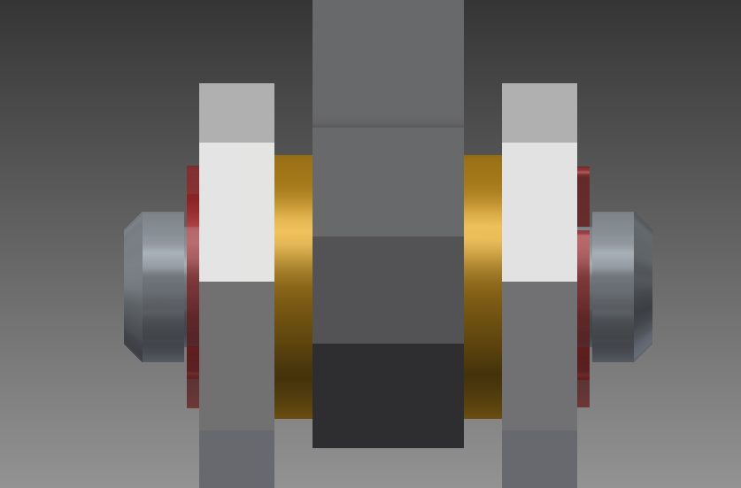

**1**

**2**

**3**

**4**

**5**

**6**

**7**

**Part 1**

Calculate the maximum and minimum lengths for the pin.

**Part 2**

Use the maximum and minimum tolerances to find lengths of the parts to fit on a pin between 1.3110 and 1.3300 inches.