What does a stable ship have to do with Math?
VIDEO: https://www.youtube.com/watch?v=AknPSTpS7Ig
Lesson Plan
Teacher Note: Please preview the entire video and pre-work the questions in order to anticipate students’ needs, misconceptions and other situations that may be unique to your classroom.
You will also need to determine the background knowledge of your students regarding the following topics, and decide the best method for providing that background in order to support the conceptual understanding of the mathematics shown in the video.
  - Right triangle trigonometry
  - Order of operations

Common Core Mathematical Content Standards
- G.SRT.8 Use trigonometric ratios and the Pythagorean Theorem to solve right triangles in applied problems.
Common Core Mathematical Practice Standards
1. Make sense of problems and persevere in solving them.
2. Reason abstractly and quantitatively
3. Construct viable arguments and critique the reasoning of others.
4. Model with mathematics
6. Attend to precision

Company Information
Fincantieri Marinette Marine (FMM) was founded in 1942 along the Menominee River in Marinette, Wisconsin to meet America's growing demand for naval construction. From humble beginnings with a contract to build five wooden barges, FMM has grown into a world-class shipbuilder, having designed and built more than 1,500 vessels.
Parent company, FINCANTIERI, has recently completed a $73.5 million capital expansion program for Fincantieri Marinette Marine which has transformed FMM into a modern shipbuilding powerhouse, now with 550,000 square feet of manufacturing, warehouse and receiving space, and the capacity to simultaneously build six Littoral Combat Ships in serial production. FMM employs cutting-edge computer-controlled manufacturing equipment and has heavy-lift capabilities to meet the most demanding requirement.
FMM boasts some of the best engineering and naval architecture minds in the industry, a skilled, safe and motivated workforce, and a management team keenly focused on quality. The company is internationally recognized for innovative and highly efficient, modular, subassembly and assembly-line manufacturing techniques. This sophistication in construction methods has allowed Fincantieri Marinette Marine to build some of the most technologically advanced vessels on the planet.
Fincantieri Marinette Marine’s performance on government contracts is impressive. Its portfolio includes the U.S. Navy’s Littoral Combat Ship, the improved Navy Lighterage System, mine countermeasure vessels and ocean tugs, as well as U.S. Coast Guard icebreakers, buoy tenders and response vessels. Because of its record of delivering ahead of schedule and within contracted costs, FMM has a long-standing relationship with the United States Navy and United States Coast Guard.
Fincantieri Marinette Marine is an FOCI mitigated SSA company and is part of the Fincantieri Marine Group, the United States division of Italian enterprise FINCANTIERI, one of the world's largest shipbuilders with 20 shipyards on four different continents and employing nearly 20,000 shipbuilding professionals. The company has a history dating back 200 years and a track record of producing more than 7,000 ships.
Summary
Vessel stability is a critical topic for marine engineers. They need to use mathematics and science principles to ensure that a ship is stable and safe for crew, passengers and cargo. You can imagine stability by thinking about standing up in a canoe or kayak and the feeling of being unbalanced and like you may fall in the water. Once you are sitting in the canoe or kayak you likely will feel more stable. This video explores the math and science of ship stability.
Pre-Activity Discussion:
- Vocabulary
  - Center of Gravity –It is the point at which the total weight of the object is acting vertically downwards. It is also the point at which the ship will balance
  - Displacement – is the mass of the water that is displaced by the hull of the floating ship. It is equal to the total weight of the vessel, including any passengers and cargo. It is based on the Archimedes Principle.
  - Buoyancy – the force that acts vertically upward on an object in water. The point on the vessel that this force acts is called the Center of Buoyancy.
  - The two forces (Gravity and Buoyancy) acting in opposite directions cause the vessel to float.
  - Heeling –term for tipping or rotating to one side.
  - Metacentric height (GM) is calculated as the distance between the center of gravity of a ship and its metacenter. A larger metacentric height implies greater initial stability against overturning.
  - $GM= \frac{m*d}{∆*tanθ}$
m = mass of the object
d = distance the object is moved
∆ = displacement of the vessel
θ = angle at which the vessel rolled
  - Moment = force at a distance or Force x Distance
  - Marine measurements
    - Length (L)
    - Width is called “Beam” (B)
    - Height is called “Draft” (T)
  - The Greek letter delta ∆ is used to represent displacement of the vessel.

Differentiation:
- The questions on the student handout are scaffolded to meet the needs of middle school students who may need extra support.
- Eliminating some of the added questions and/or just posing the question(s) from the video would be a possible differentiation strategy for students who do not need the extra support.
- Students may also benefit by working with others as part of a partner/group investigation of this problem.

Summary of Information needed and the problems posed in the video:
- Two forces (Gravity and Buoyancy) acting in opposite directions allow the vessel to float.
- In order for a ship to be stable, it’s center of gravity and center of buoyancy need to align vertically.
- Moving weight on the vessel causes the center of buoyancy to move left or right. The ship will no longer be upright because the COG and COB will no longer be in alignment vertically. It will heel to one side until they become aligned again.
- It is important to know the degree to which the ship is heeling. Is the angle acceptable or is it unsafe?
- Mass of the water displaced by the floating vessel is equal to the total weight of the vessel.
- Mass of water = 1 metric ton (MT) per cubic meter
- Moment = force at a distance or Force x Distance
- Length (L) = 10 m
- Width is called “Beam” (B) = 4m
- Height is called “Draft” (T) = 1.2m
- To determine the angle of heeling, a pendulum that is 3 meters long shows a horizontal change of 15.24 centimeter

Part 1: (0:00 – 2:16)
- Discuss the problem that we are being asked to solve. What will happen if the ship’s center of gravity and center of buoyancy are not in vertical alignment? What will the effect be on the ship?
- What are some things that could cause this to happen?

Part 2: (2:22 – 2:58)
- Students are asked to calculate volume of the vessel, displacement of the water and the mass of the water in the student handout. It is shown in the video as well.
- Question posed: What is the moment imparted on the vessel of we move 5MT of cargo from the center to 1.5 meters off the center?

Part 3: (3:00 – 3:23)
- Question: How much did the barge heel over?
- A pendulum allows us to use right triangle trigonometry and determine the angle of heeling. While standing on the ship, a pendulum that is 3 meters long shows a horizontal change of 15.24 centimeters.
- The student handout also asks students to use the formula for GM that was given at the beginning of the video to determine the Metacentric Height (GM) of this ship.
- Answers are not shared in the video. Classroom discussion will be needed.

Part 4: (3:30 – 4:00)

Extension:
- Investigate the stability of the vessel if it were traveling in salt water.
- Investigate different angles of vessel stability. What is the range that is considered “safe” for passengers? Does the size of the vessel make a difference?
- How does hull shape affect vessel stability?

Student Handout - What does Vessel Stability have to do with Math?
Name(s):

Pre-Video Discussion: Notes on important background information.

Break 1: What will happen if the ship’s center of gravity and center of buoyancy are not in vertical alignment?

Break 2:
- What is the volume of the ship?

- What is the volume of the water displaced by the ship?

- What is the mass of the water displaced by the ship?

- What is the moment imparted on the vessel of we move 5MT of cargo from the center to 1.5 meters off the center? (Hint: Moment = Force x Distance)

Break 3:
- How much did the vessel heel over?

- Use the formula for GM that was given at the beginning of the video to determine the Metacentric Height (GM) of this ship
$$GM= \frac{m*d}{∆*tanθ}$$

ANSWER KEY – What does Clean Drinking Water have to do with Math?

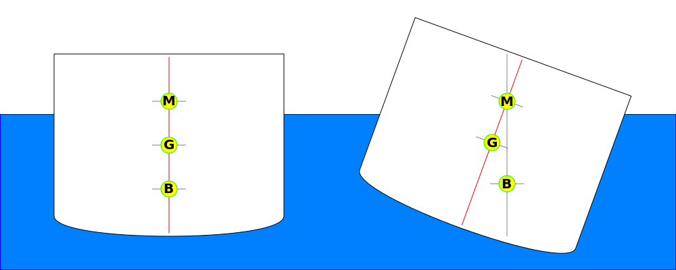
File:MetacentricHeight.png by Georgewilliamherbert

In the graphic above -
M is the Metacenter
G is the Center of Gravity
B is the Center of Buoyancy

Break 1: What will happen if the ship’s center of gravity and center of buoyancy are not in vertical alignment?

The ship will heel to one side (rotate) until the COB and the COG are aligned again

Break 2:
What is the volume of the ship?

10m x 4m x 1.2 m = 48 cu meters

What is the volume of the water displaced by the ship?

The same as the volume of the ship – 48 cu meters

- What is the mass of the water displaced by the ship?

If 1 cu meter of water = 1 metric ton (MT) , then 48 cu m = 48 MT

- What is the moment imparted on the vessel of we move 5MT of cargo from the center to 1.5 meters off the center? (Hint: Moment = Force x Distance)

moment = 5 MT x 1.5m = 7.5 MT(m)

Break 3:
- How much did the vessel heel over?

θ

3m tan θ = 0.1524m / 3m
θ = tan⁻¹(0.1524m / 3m)
θ = 2.91 degrees
0.1524m

- Use the formula for GM that was given at the beginning of the video to determine the Metacentric Height (GM) of this ship
$$GM= \frac{m*d}{∆*tanθ}$$

= $\frac{7.5 MT(m)}{48MT * tan⁡(2.91)}$

= 3.07 meters

