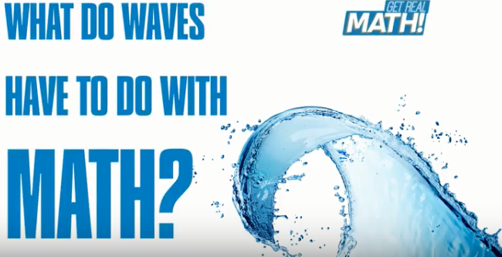

Video: https://youtu.be/fgKnVpuwcxc
Lesson Plan
Teacher Note: Please preview the entire video and pre-work the solutions in order to anticipate students’ needs, misconceptions and materials unique to your classroom.
You will also need to determine the background knowledge of your students regarding the following topics, and decide the best method for providing that background in order to support the conceptual understanding of the mathematics shown in the video.
- Sample
- Frequency
- Mean
- Percent

Common Core Mathematical Content Standards
- 6.SP.2 Understand that a set of data collected to answer a statistical question has a distribution which can be described by its center, spread and overall shape.
- 6.SP.3 Recognize that a measure of center for a numerical data set summarizes all of its value with a single number, while a measure of variation describes how it’s values vary with a single number.
- 6.SP.5 Summarize numerical data sets in relation to their context.
- 7.SP.1 Understand that statistics can be used to gain information about a population by examining a sample of the population. Understand that random sampling tends to produce representative samples and support valid inference.
- S-ID Summarize, represent and interpret data on a single count or measurement variable.
- S-IC Make inferences and justify conclusions from sample surveys, experiments and observational studies.

Common Core Mathematical Practice Standards
1. Make sense of problems and persevere in solving them.
2. Reason abstractly and quantitatively
3. Construct viable arguments and critique the reasoning of others.

Company Information
Fincantieri Marinette Marine (FMM) was founded in 1942 along the Menominee River in Marinette, Wisconsin to meet America's growing demand for naval construction. From humble beginnings with a contract to build five wooden barges, FMM has grown into a world-class shipbuilder, having designed and built more than 1,500 vessels.
Parent company, FINCANTIERI, has recently completed a $73.5 million capital expansion program for Fincantieri Marinette Marine which has transformed FMM into a modern shipbuilding powerhouse, now with 550,000 square feet of manufacturing, warehouse and receiving space, and the capacity to simultaneously build six Littoral Combat Ships in serial production. FMM employs cutting-edge computer-controlled manufacturing equipment and has heavy-lift capabilities to meet the most demanding requirement.
Summary
Waves in a body of water are not constant. They often have different lengths, heights and directions. In order to design ships to survive these varied wave conditions, naval architects analyze wave data from bodies of water where the ship will be sailing. In this video you will be given Lake Michigan wave data to analyze and make inferences about. We are confident you will be able to sail through the mathematics in this video without getting sea sick!

Pre-Activity Discussion:
- Why would collecting wave data be important for marine/naval architects?
- What type of wave data would need to be collected?

Differentiation:
- The questions on the student handout are scaffolded to meet the needs of students who may need extra support.
- Eliminating some of the added questions and just posing the questions from the video would be a possible differentiation strategy for students who do not need the extra support.
- Students may also benefit by working with others as part of a partner/group investigation.

Information that will be given in the video:
Waves in a body of water are not constant. They often have different lengths, heights, and directions. In order to design ships to survive these conditions, naval architects analyze data from the areas where their ships intend on operating.

Lake Michigan Wave Data Sheet (on the student handout and at the end of this lesson plan)

Part 1: (0:00 – 0:35)
- Simple background information is given about waves and how wave data helps in the design of ships.
- Revisit the pre-video discussion and use Part 1 of the student handout to record the types of wave data that could/should be collected.

BREAK 1
Part 2: (0:45 – 1:26 )
- Wave data from a buoy in Lake Michigan is introduced.
- Have students brainstorm some initial “wonderings” about the data. What do they see? What do they notice? Part 2 of the student handout asks students to list their ideas and questions.

BREAK 2

Part 3: (1:30 – 1:46)
- Question 1: How many wave records were sampled in March?
- Question 2: What is the mean wave height in March?
- Question 3: Using wave heights, which month appears to be the worst for marine travel?
- Question 4: Why is there no wave data for January and February?
- Part 3 of the student handout asks the students to answer the four questions posed.
- Before showing Part 4, have students share their thinking and solutions with the whole group

BREAK 3

Part 4: (1:50 – 2:38)

- Solutions to the four questions are revealed
- After showing the solutions, have students reflect on any errors in their thinking and calculations.

Extra Questions:
- Which month appears to be the BEST for marine travel? (June)
- Which months have the most similar distribution of wave heights to the “annual” wave height distribution? (April) The most different? (November)
- What is the median wave height for March? ( 50% of data is approx. 0.4 m) Compare this with the mean from video question #2. Which measure of central tendency would you use if you were the marine/naval architect? Why?

Extension Ideas:

- Using the given data, calculate the 25th and 75th percentiles for wave heights each month (quartiles 1 and 3)
- What other types of Lake Michigan data would impact marine travel? How could the data be sampled?
- Explore the career of marine/naval architecture.
- Explore wave motion and its impact on ship stability
- Explore the history of marine travel on the Great Lakes

Student Handout - What do Waves have to do with Math? Name(s):

Pre-Video Discussion: Notes on important background information.

Problem: How can analyzing wave data help a marine/naval architect make decisions?
Part 1:

- Why would collecting wave data be important for marine/naval architects?

- What types of wave data would need to be collected?

Part 2:

- Using the wave data in the table below…What do you notice? What do you wonder? List 8 things.

Lake Michigan Wave Data
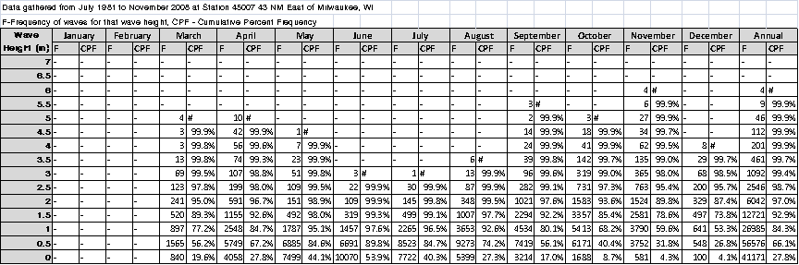

Part 3: (Show your work to justify your solutions)
Video Question 1: How many wave records were sampled in March?

Video Question 2: What is the mean wave height in March?

Video Question 3: Using wave heights, which month appears to be the worst for marine travel?

Video Question 4: Why is there no wave data for January and February?

ANSWER KEY – What do Waves have to do with Math?

- Answers vary
- Answers vary
- Answers vary

Video Question 1: How many wave records were sampled in March?

Adding the frequencies for March (4 + 3 + 3 + 13….) = 4275 wave records

Video Question 2: What is the mean wave height in March?

Using each wave height for March data -
840 waves recorded at 0 m high = 0 + 0 + 0…..+0 = 0 OR 840 (0) = 0 meters
1565 waves recorded at 0.5 m high = 0.5 + 0.5 + …+ 0.5 = 782.5 OR 1565(0.5) = 782.5 meters
897 waves recorded at 1 m high = 897 OR 897(1) = 897 meters
520 waves recorded at 1.5 m high = 1.5 + 1.5 + 1.5…+1.5 = 780 OR 520(1.5) = 780 meters
241(2) = 482
123(2.5) = 307.5
69(3) = 207
13(3.5) = 45.5
3(4) = 12
3(4.5) = 13.5
4(5) = 20
Add up all products (3547 total meters) and divide by total number of wave records (4275) = 0.8297 meters (average meters per wave)

Video Question 3: Using wave heights, which month appears to be the worst for marine travel?

November

Video Question 4: Why is there no wave data for January and February?

The lake is frozen

Lake Michigan Wave Data

