What does a clean machine have to do with math?
VIDEO: https://youtu.be/26wZT8xA0f4
Lesson Plan
Teacher Note: Please preview the entire video and pre-work the questions in order to anticipate students’ needs, misconceptions and other situations that may be unique to your classroom.
You will also need to determine the background knowledge of your students regarding the following topics, and decide the best method for providing that background in order to support the conceptual understanding of the mathematics shown in the video.
  - Angle measure
  - Right triangle trigonometry
  - Fluid Dynamics
    - Flow Velocity = Volumetric Flow Rate / Cross Sectional Area of the Flow (V = Q/A)
  - Unit conversion

Common Core Mathematical Content Standards
- G-SRT - Define trigonometric ratios and solve problems involving right triangles.
- A-REI.2 - Solve simple rational and radical equations in one variable.

Common Core Mathematical Practice Standards
1. Make sense of problems and persevere in solving them.
2. Reason abstractly and quantitatively.
3. Construct viable arguments and critique the reasoning of others.
4. Model with mathematics.
6. Attend to precision.

Company Information
With approximately 300 facilities across North America, South America and Europe, Georgia-Pacific is one of the world's leading manufacturers and marketers of bath tissue, paper towels and napkins, tableware, paper-based packaging, office papers, cellulose, specialty fibers, nonwoven fabrics, building products and related chemicals. In Northeastern Wisconsin, its Green Bay facilities make nationally-known products (Quilted Northern®, Angel Soft® and Compact® bath tissue; enMotion® and SofPul® paper towels; and Vanity Fair® and Mardi Gras® napkins) and packaging is produced in Sheboygan and Oshkosh. Each year, GP's Ecosourceä facility in Green Bay recycles nearly 100,000 tons of wastepaper - equal to 1.7 million trees - and saves 5 million cubic feet of landfill space. In addition, its Neenah-based research and development laboratory, iNNOVATION institute®, constantly develops creative and innovative products, and tests them in Green Bay using the latest technology available. For more information, visit: gp.com.

Summary
A clean paper machine is a happy paper machine! Right triangle trigonometry and knowledge of simple fluid dynamics formulas are used to help engineers at Georgia Pacific trouble shoot ways to keep the paper production process running smoothly.

Pre-Activity Discussion:
- How is paper made?
  - Discuss the steps in the process that may require equipment to be cleaned on a regular basis.
- What does the water look like as it comes out of a nozzle? What geometric shape could model that?
- Vocabulary etc.
  - Single coverage
  - Double coverage
  - psi = pounds per square inch
  - fps = feet per second
  - Flow Velocity = Volumetric Flow Rate / cross sectional area of the flow (V = Q/A)
  - Inside diameter
  - Outside diameter
  - 1 gallon = 0.133681 cubic feet
  - 1 sq inch = 0.00694 sq feet

Differentiation:
- Teachers can add questions to the handout that would scaffold the student’s focus toward the desired solution.
- Students may also benefit by working with others as part of a partner/group investigation of these problems.

Summary of Information presented in the video:
- Single nozzle coverage
  - Spray from each nozzle doesn’t overlap.
  - Nozzles spray water at a 45 degree angle.
  - Nozzles have 3 inches of spacing center to center.
- Double coverage
  - Spray from each nozzle overlaps in such a way that the fabric is hit with spray twice.
  - How the nozzle sprays remains the same.
- Shower Bar
  - 90 nozzles on the shower bar
  - Maximum velocity of water through shower bar – 10 feet per second
  - Outside pipe diameter is 4.5 inches
  - Pipe walls are 0.25 inches thick
  - Current psi– 80
  - New psi – 100
  - At 100 psi, each nozzle sprays 4.5 gallons of water per minute

Part 1: (0:00 – 1:01)
- A brief summary of the paper making process is shared, as well as how the fabric that the paper pulp adheres to is cleaned.
- Information given in Part 1
  - Currently spraying fabric at single coverage. ( no spray overlap)
  - Nozzles spray water at a 45 degree angle.
  - Nozzles measure 3 inches apart center to center.
- Problem posed
  - How far away is the shower bar from the fabric?
- Discuss the problem that we are being asked to solve.
- What are the things we need to figure out? Do we have all the information we need? If not, what else do we need?
- Have students use Part 1 of student handout to document their discussion.
- Before showing Part 2 have students share their answers and methods.
- Discuss any errors or misconceptions in student thinking and calculations.

Part 2: (1:06 – 1:22)
- Solution to Part 1 question is given in video
- Fabric still has paper particles left on it, causing production problems.
- New question posed:
  - If the shower bar is moved in order to make the nozzle spray overlap to double coverage, how far would it need to be moved?
- Students should discuss the new problem being asked and document their discussion and solution on the student handout.
- Before showing Part 3, have students share their solution methods.
- Discuss any errors or misconceptions in student thinking and calculations.

Part 3: (1:30 – 2:22)
- Solution to Part 2 is shown
- Double coverage helped eliminate some particles, but not enough.
- Increasing water pressure may help
  - 90 nozzles on the shower bar
  - Maximum velocity of water through shower bar – 10 feet per second
  - Outside pipe diameter is 4.5 inches
  - Pipe walls are 0.25 inches thick
  - Current psi – 80
  - New psi – 100
  - At 100 psi, each nozzle sprays 4.5 gallons of water per minute
- New question posed:
  - If the change is made from 80 psi to 100 psi, what happens to the velocity of the water?
- Students should determine that a conversion from gallons to cubic feet is needed. This is not given in the video ( 1 gal = 0.133681ft³)
- Students should determine that a conversion from sq inches to sq feet is necessary also (1sq inch = 0.00694 sq. feet)
- Flow Velocity = Volumetric Flow Rate / Cross Sectional Area of the Flow (V = Q/A)
- Students should discuss the new problem being asked and document their discussion and solution on the student handout.
- Before showing Part 4, have students share their solution methods
- Discuss any errors or misconceptions in student thinking and calculations.

Part 4: (2:26 – 2:57)

- Solutions to Part 3 are given
- Switching to 100 psi puts the velocity over the maximum allowable amount.
- Discuss ramifications of exceeding the allowable flow velocity.
- Bonus question posed:
  - How many gallons per nozzle per minute would allow us to stay under the 10 fps limit?

Extension:
- See bonus question
- Add problems that change the nozzle measurements in order to incorporate a variety of trigonometric ratios.
- Investigate any possible cost increases or decreases for the company due to change in water usage for the various cleaning methods.
- Investigate how the type of liquid that flows through piping affects the psi and flow rate.

Student Handout - What does a Clean Machine have to do with Math? Name(s):

Pre-Video Discussion: Notes on important background information.

Break 1: How far away is the shower bar from the fabric?

Break 2: If the shower bar is moved in order to make the nozzle spray overlap to double coverage, how far would it need to be moved?

Break 3: If the change is made from 80 psi to 100 psi, what happens to the velocity of the water?

Bonus Question: How many gallons per nozzle per minute would allow us to stay under the 10 fps limit?

Graphics Templates and ANSWER KEY -- What does Safety have to do with math?

Single Coverage
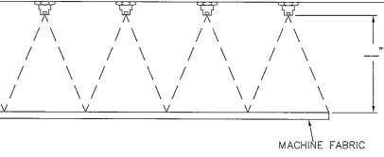

Double Coverage
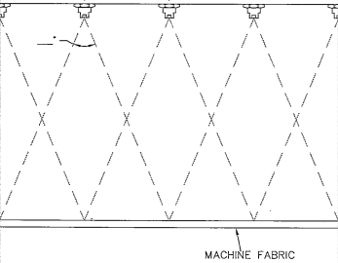

One Nozzle 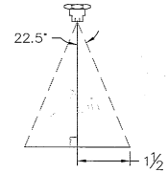

Shower bar pipe cross section 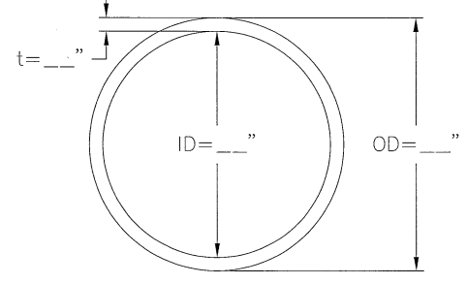

Part 1 How far away is the shower bar from the fabric?
$$\tan{22.5°=\frac{1.5 in}{x}}$$

x = 3.62 inches

Part 2 If the shower bar is moved in order to make the nozzle spray overlap to double coverage, how far would it need to be moved?
$$\tan{22.5°=\frac{3 in}{x}}$$
x = 7.24 inches

Part 3 If the change is made from 80 psi to 100 psi, what happens to the velocity of the water?
Flow Velocity needs to be < = 10 ft/sec
Find gallons per second flow in shower bar
4.5 gal/1 min x 90 nozzles = 405 gal/1 min= 6.75 gal/1 sec

To find Q, the volumetric flow rate, convert gallons to cubic feet
6.75 gal/1 sec x 0.1337 ft³ / 1 gal = 0.90 ft³/1 sec

Find A, the cross sectional area of the flow…
Inside area of pipe = 12.56 in²
Convert square inches to square feet
0.00694 ft² / 1 in² x 12.56 in² = 0.087 ft²

Flow Velocity = Volumetric Flow Rate / cross sectional area of the flow (V = Q/A)
$$\frac{0.90 {ft}^{3} /sec}{0.087 {ft}^{2}}$$

10.3 ft / sec

Bonus Question
One possible solution –
Use the previous process, only backwards. Substitute x for the 0.90ft³ and set equal to 10ft³/sec
$\frac{x {ft}^{3} /sec}{0.087 {ft}^{2}}$ = 10 ft³/sec
x = 0.87 ft³/sec
Then
y gal/1 sec x 0.1337 ft³ / 1 gal = 0.87 ft³/1 sec
Solving for y ….
y = 6.0507 gal/sec

Then convert to gallons per minute per nozzle.
4.338 gal/min per nozzle.
Conversion to psi would require additional information that was not provided in the video.

