Video: https://youtu.be/47FxHkhcguo

Video Summary:
What is a laser guided vehicle? How do they work? How can we program a laser guided vehicle? In this video, you will learn about laser guided vehicles and how to program them to work in your company. You will need to calculate distances and angles.

Georgia-Pacific - Biography
With approximately 300 facilities across North America, South America and Europe, Georgia-Pacific is one of the world's leading manufacturers and marketers of bath tissue, paper towels and napkins, tableware, paper-based packaging, office papers, cellulose, specialty fibers, nonwoven fabrics, building products and related chemicals. In Northeastern Wisconsin, its Green Bay facilities make nationally-known products (Quilted Northern®, Angel Soft® and Compact® bath tissue; enMotion® and SofPul® paper towels; and Vanity Fair® and Mardi Gras® napkins) and packaging is produced in Sheboygan and Oshkosh. Each year, GP's Ecosourceä facility in Green Bay recycles nearly 100,000 tons of wastepaper - equal to 1.7 million trees - and saves 5 million cubic feet of landfill space. In addition, its Neenah-based research and development laboratory, iNNOVATION institute®, constantly develops creative and innovative products, and tests them in Green Bay using the latest technology available. For more information, visit: gp.com.

Common Core Mathematical Content Standards:
**This lesson plan can be used in multiple different grade levels, depending on which skills you choose to highlight.
3.MD.4: Generate measurement data by measuring lengths using rulers marked with halves and fourths of an inch.
4.MD.6: Measure angles in whole number degrees using a protractor.
or
7.G.1: Solve problems involving scale drawings of geometric figures, including computing actual lengths from a scale
drawing and reproducing a scale drawing at a different scale.
8.G.7: Apply the Pythagorean Theorem to find the distance between two points in a coordinate system.
HS.G.STR.8: Use trigonometric ratios and the Pythagorean Theorem to solve right triangles in applied problems.

Common Core Mathematical Practice Standards:
- Make sense of problems and persevere in solving them.
- Reason abstractly and quantitatively.
- Model with mathematics.
Teacher note: Please preview the entire video and pre-work solutions in order to anticipate students’ needs, misconceptions and materials unique to your classroom.

The student work page at the end of the lesson will give students a place to jot down ideas and work through answers as they are following along with the video.

Pre-Activity Discussion
Question to ask students: How can robots help in production? Is there a way to have a “driver-less” forklift? How might something work when it runs on lasers?

Discussion: Even though there is not a driver, someone still needs to program these vehicles.

Part 1

- Play Video (0:00-0:36), pause at (0:36) to answer the discussion questions.

- What does a laser-guided vehicle (LGV) do? What information might you need to program the vehicle?

- Have students discuss necessary information that they might need.

- Possible answers: distance of segments, measure of angle turns

Part 2

- Play Video (0:37-0:53), pause at (0:53) to answer the discussion questions.

- What is the total distance that the LGV will travel?

- Have students work through this problem. Discuss methods and answers as necessary.

- Answers: Total Distance is 62.68 feet.
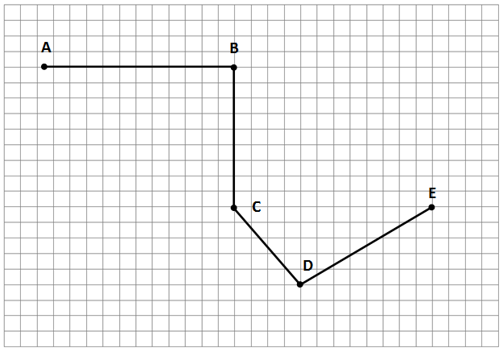
Each square equals two feet.
18.87 feet
12.81 feet feet
18 feet
23 feet
Part 3

- Play Video (0:54-1:30), pause at (1:30) to answer the discussion questions.

- What are the angle measures that the LGV will need to turn?

- Have students work through this problem. Discuss methods and answers as necessary.

- Answers:

90$°$

141.34$°$

96.65$°$

Part 4

- Play Video (1:31-2:44).

- Teachers can also extend the learning for this example by using a coding program to program a device to travel the path shown, or to create and program a device to their own maps.

- Resources:

Code.org https://code.org/learn

Use Logo programming at Turtle Academy https://turtleacademy.com/

Use a Sphero ball http://www.sphero.com/sphero

Student Work Page

Name_______________________

Part 1
What is a Laser-Guided Vehicle? What information might you need to program the vehicle?

Part 2
What is the total distance that the LGV will need to travel?
Each square equals two feet.

Part 3
What are the angle measures that the LGV will need to turn?

