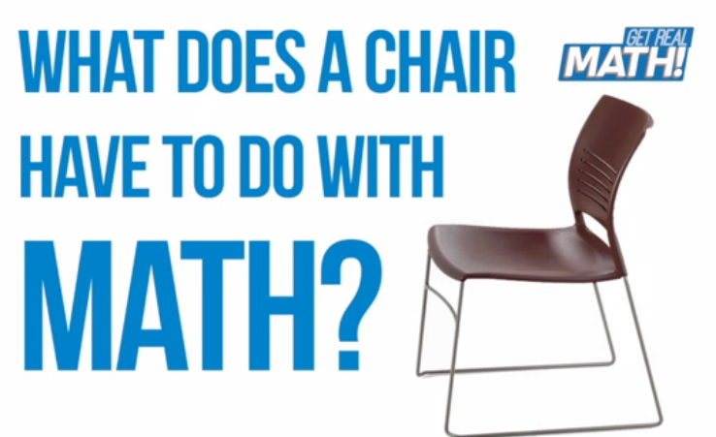

Video: https://youtu.be/s0q7wwe1WbY
Chair backs and seats are manufactured using a mix of various materials. In this task, students will determine amounts of materials necessary to produce an order of chairs for a classroom.

Common Core Mathematical Content Standards:

7.RP Analyze proportional relationships and use them to solve real-world and mathematical problems.
1. Compute unit rates with ratio of fractions, including ratios of lengths, area and other quantities measure in like or different units.
2. Recognize and represent proportional relationships between quantities.
3. Use proportional relationships to solve multistep ratio and percent problems.

Common Core Mathematical Practice Standards:

- Make sense of problems and persevere in solving them.

- Reason abstractly and quantitatively.

6. Attend to precision.

KI Manufacturing
KI is an international manufacturer of office and institutional furniture. KI has ten different manufacturing plants, with its headquarters located in Green Bay, Wisconsin. Each plant focuses on a different aspect of business. At the Green Bay plant, the focus is on chairs, desks and tables.
The largest part of what KI-Green Bay produces is for educational markets, in both K-12 and post-secondary settings. In 2012, KI shipped about 876,000 combined units total.
Consider that a chair, like the one shown, involves multiple parts for its assembly. The process used to manufacture the plastic seat and back section of the chair shown involves “injection molding”, one of several different types of plastic processing methods. The type of process used depends on the application and volume needed. Injection molding is a process commonly used for plastic parts where large volumes are required. It is a highly repeatable process, in which melted plastic is injected into cavities of a mold. From there, the parts cool with water circulating around the cavities.
The chair seats and backs are primarily made of polypropylene, with other additives mixed in specific ratios based on the customer’s needs. These additives include colorant and sometimes fire retardant (FR). KI uses 3.5-4 million pounds of polypropylene each year. The materials are delivered by the 50,000-pound truck load and stored in silos outside the manufacturing building.

Video Summary:

Teacher note: Please preview the entire video and pre-work solutions in order to anticipate students’ needs, misconceptions and materials unique to your classroom.
Part 1
Pre-Activity Discussion | (0:00-0:12) | What does a chair have to do with math?
Information & Estimates | (0:13-1:14) | What information do you think is necessary to determine how much of each of 3 materials is needed to manufacture plastic seat and back sections for a customer’s order of chairs?  What estimates can you make?
Part 2
Strategies & Solutions | (1:15-2:43) | Includes Break 1  How do the strategies in the video compare to the strategies you used? How do your solutions compare? How do the solutions compare to your estimates?  Includes Break 2
New information | (2:44-3:11) | How does new information regarding the manufacturing process affect your work? How does this have an effect on your estimates?
Strategies & Solutions | (5:26-6:19) | Includes Break 3  What does the production process look like? How do the strategies in the video compare to the strategies you used? How do your solutions compare? How does this compare to your estimates? What do you think might happen if the amounts of materials were calculated incorrectly?

Part 1

Pre-Activity Discussion (0:00-0:12)

- Play Video (0:00-0:04).

- Pause at (0:05-0:11).

- Class Discussion: “What does a chair have to do with math?”

Students should brainstorm regarding what mathematics might be involved in the design, production, assembly and shipment of chairs for schools.
It may be helpful to consider:
  - What is “the journey” of a chair, from design to classroom?
  - What jobs do people have who support this “journey”?
(Examples: engineer, tool and die, human resources manager, production technician, product distribution, etc.)
  - What knowledge and skills might be associated with these fields? What types of mathematics do you think are involved?

Information and Estimates (0:12-1:14)

- Background Information: How is a chair’s seat and back section manufactured?

If students are having difficulty envisioning the process, it may be helpful to show them the section of the video (3:15 – 5:23) involving the manufacturing process: mixing of the materials, release of a chair and seat back section, and assembly of a chair.

- Class Discussion:
You are on a team in charge of producing the plastic seat and back sections for chairs, like the one you just saw. You need to determine the amount of each “ingredient” needed to produce parts for an order of classroom chairs. What information do you think you need?

  - Size of order
Instructional furniture may come in all sizes of orders. How many chairs may be needed for a classroom situation?
In the video, the order includes 35 chairs.

  - Part weight
What is the “part weight” for the particular chair the customer has ordered? (i.e., How much material is needed to manufacture one chair’s seat and back section?)
This value includes the total weight of the seat, the back, and the runners. (The “runner” is where the plastic is injected during injection molding and will be removed by a technician. This wasted material will be recycled.)
In the video, the part weight is 4.68 pounds.

  - Materials and Amounts
What materials are needed for this particular order? What ratios are these “ingredients” in?
Polypropylene and colorant will be needed. (You would need to know what color, though this isn’t a mathematical question.) Some states also require that instructional furniture be manufactured with fire retardant, so you would need to know where the chairs will be going and whether the state requires fire retardant.
In the video, the materials and their ratios are polypropylene (84.5%), colorant (7.5%), and FR concentrate (8%).

- Play Video (0:12-1:14).

- Pause at prompt (1:15-1:18) at “Break 1” for class discussion.

- Class Discussion:

Prior to solving the problems, create an estimate for the amounts of materials involved in the problem.

Students should make sense of the information in the situation. It may be helpful to consider:

  - How do these various values affect each other?
There is a proportional relationship that exists among the various materials, the part weight, and the total amount of materials.

  - What level of precision do you think is necessary and appropriate?
It is important to be accurate in our calculations, but the calculations need not be overly precise. Rounding is appropriate, since the materials will only be measured out to a certain level of accuracy. However, rounding down could result in shortages of materials.

  - What strategies would you use to calculate the values?
    - Strategy 1: Calculate the total weight for the whole order and then find the amount of each material using the given ratio information.
    - Strategy 2: Calculate the amount of each material needed for each part and then find the amount of each material for the whole order.
Which strategy do you believe is more efficient, and why?
Is one strategy more accurate than the other? If so, why do you think this is the case?
How do you know your answers make sense?
How do your answers compare to your estimate?
Part 2
Strategies & Solutions (1:15-2:43)

- Play Video (1:15-2:37).

- Pause at prompt (2:38-2:43) at “Break 2” for class discussion.

- Class discussion:

How do the strategies in the video compare to the strategies you used?
How do your solutions compare?
How do these values compare to your estimates?

New Information (2:44-3:11)

- Play Video (2:44-3:07).

- Pause at prompt (3:08-3:11) at “Break 3” for class discussion.

- Class discussion:

Students should make sense of the new information in the situation.

  - How does this new information change your estimate for the amounts of materials needed?

  - What strategies would you use to re-calculate the values?
Is it necessary to completely “re-think” the problem, or can you use some of your previous reasoning?
How do you know your answers make sense?
How do you answers compare to your new estimate?

Strategies & Solutions (3:12-6:19)

- Play Video (3:12-6:19).
Encourage students to think about where they see elements of the process that have an effect on the mathematics of the situation.
(Examples: mixer is engineered to make sure that the ratio of “ingredients” is constant throughout the mixture, when the “runners” are trimmed off – this is part of the part weight but we wouldn’t include it if we were to only consider the end-product of the chair back and seat, etc.)

- Video Ends at 6:19.

- Class Discussion:

How do the strategies in the video compare to the strategies you used?
How do your solutions compare?
  - In the video, the technician rounds up to the nearest 25 pounds. This is done in case more material needs to be purged from the machine or in case there is a part that exits the machine that is not up to the quality expectations. It is important, however, that in the process of rounding up all proportions stay the same.

How do these values compare to your estimates?

What do you think the effects of “being wrong” would be?

Ex: Underestimate the amounts of materials
If we were to underestimate the amount of material, the injection molding machine would run out & the calculations would have to be re-done. This would include starting the process, from mixing to machine purge and part production, over again. This would cost materials and time. (Time equates to wages paid out.)

Ex: Overestimate the amounts of materials
This would result in excess material left over and it is not practical to store excess barrels of materials. There is limited space and many color changes being done, which yields the potential build-up of much extra material if not monitored properly. In some cases, we may be forced to store it in a warehouse or use it for upholstered product. Both options have a negative impact on the organization.

Ex: Miscalculate the amount for one of the “ingredient” materials
The color may be too light or too dark. (If the part is too light, the parts may “stress whiten” too easily – an effect that happens when a plastic part takes an impact or is bent.)
Also, an incorrect amount of fire retardant material might result in not meeting a state’s manufacturing criteria so that the chairs could not be sold.

What do you know about your chair that you didn’t know before? What jobs did your chair require? What mathematics was involved?

