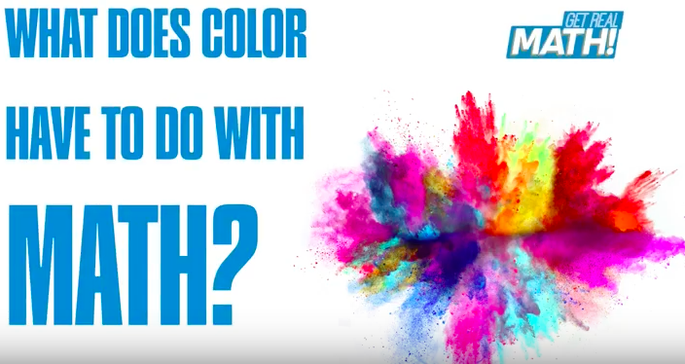

What does color have to do with math?
Video Link: https://youtu.be/Y49Vyk2nu2Q
Lesson Plan
Teacher Note: Please preview the entire video and pre-work the solutions in order to anticipate students’ needs, misconceptions and materials unique to your classroom.
You will also need to determine the background knowledge of your students regarding the following topics, and decide the best method for providing that background in order to support the conceptual understanding of the mathematics shown in the video.
  - Ratio and proportion
  - Percentages
  - Solving 1-step equations

Common Core Mathematical Content Standards
- 6.EE.2 Write, read, and evaluate expressions in which letters stand for numbers.
- 6.EE.6 Use variables to represent numbers and write expressions when solving a real-world or mathematical problem, understand that a variable can represent an unknown number, or depending on the purpose at hand, any number in a specified set.
- 6.RP.3 Use ratio and rate reasoning to solve real world and mathematical problems.
- 7.EE.4 Use variables to represent quantities in a real-world or mathematical problem, and construct simple equations and inequalities to solve problems by reasoning about the quantities.
- 7.RP.3 Use proportional relationships to solve multistep ratio and percent problems.

Common Core Mathematical Practice Standards
1. Make sense of problems and persevere in solving them.
2. Reason abstractly and quantitatively
3. Construct viable arguments and critique the reasoning of others.
4. Model with mathematics
6. Attend to precision

Company Information
In 1941, when Krueger Metal Products, Inc. was founded, the war made resources scarce. Daily, founder Al Krueger would call on steel companies to purchase materials to make folding chairs. The scrap available determined what he could produce…a novel way of manufacturing. Today, KI is still known for innovative manufacturing. What’s different is that innovation also includes the approach it takes with its workforce.
That approach helped the company expand its portfolio well beyond the folding chair. The Green Bay plant manufactures various seating products, Manitowoc focuses on architectural wall and panel systems, while Bonduel produces fixed seating and tables.
KI purposely cultivates a work environment that encourages employees to share ideas and try new things. During a shift, you won’t just see repetitive work at a single machine. Rather, employees also engage in all facets of the business – from cross-training in other cells to planning sessions and discussions with customers.
KI prides itself on mentoring the next generation of skilled workers. KI has partnered with local schools, supports both youth and adult apprenticeships, and supports continuing education for all employees. KI has entered into a unique partnership that pairs high school students with the company’s engineers to solve real-world manufacturing problems. During its busy summers, the company hires more than 400 students across its three plants.
That’s why KI’s tagline “Furnishing Knowledge” is so fitting…it offers far more than furniture.
Learn More About KI Manufacturing
<QR CODE to mfg video: https://www.youtube.com/watch?v=huFCL-7S42s&t=26s>
Summary
Companies are always trying to find ways to save money while still maintaining the quality of their products. Looking for different sources for raw materials and different types of raw materials are methods procurement staff may use to find a cost savings. Careful calculations and problem solving are necessary when making these decisions. In this video we will investigate a possible new colorant supplier for chair backs and seats at KI.
Pre-Activity Discussion:
- Vocabulary
  - Polypropylene – Thermoplastic polymer. A plastic material the becomes moldable at a specific temperature and solidifies upon cooling
  - Granular – material that is in small pieces (grains)
  - Liquid – material that is in fluid form, a substance that flows freely, having a consistency like that of water or oil.
  - Colorant – the material that colors the plastic (polypropylene)
  - Let Down Ratio – percentage of the total weight that is the actual colorant.

Differentiation:
- The questions on the student handout are scaffolded to meet the needs of students who may need extra support.
- Eliminating some of the added questions and/or the table, and just posing the questions from the video would be a possible differentiation strategy for students who do not need the extra support.
- Students may also benefit by working with others as part of a partner/group investigation.

Information that will be given in the video:
- Liquid Colorant
  - 2240 pounds of liquid colorant is needed per year
  - It is mixed with polypropylene at a ratio of 1.9% of the total mixture to get the required color intensity.
  - Cost is $11.42 per pound
- Granular Colorant
  - It is mixed with polypropylene at a ratio of 4% of the total mixture to get the required color intensity.
  - Cost is $5.79 per pound

Part 1: (0:00 – 1:04)
- Ask students why they think Katie is being cautious about the possible savings?
- Use part one of student handout to brainstorm some factors will she have to consider before switching to the new colorant.

BREAK 1

Part 2: (1:07 – 2:10)
- Ask students to explain “Let Down Ratio” in their own words.
- Ask students to explain “Annual Usage of Colorant” in their own words.
- Have students complete the next part of the of the student handout.

BREAK 2
Part 3: (2:14 – 3:36)
- Solutions
- Before showing Part 3, have students share their thinking and solutions with the whole group.
- After showing the solutions, have students reflect on any errors in their thinking and calculations.

BREAK 3

Part 4: (3:38 – 4:12)

- Katie shares her findings with Lisa

BREAK 4

Part 5: (4:14 – end)

- Discuss with students different mathematical methods that could be used to determine which colorant would be more cost effective.

Extension:
- Use one of the other methods discussed in Part 5 above as another way to prove that the granular colorant is more expensive.
- What price per pound of the granular colorant would be needed to make it more cost effective?

Student Handout - What does color have to do with math? Name(s):
Pre-Video Discussion: Notes on important background information.

Problem: Which is more cost effective, the liquid or granular colorant?
Break 1:
- Name at least three factors, besides cost, that Katie will have to consider before switching to the new colorant.

Break 2:

- Fill in the table with the given information.
- How much is spent on the current liquid colorant every year? Put this value in the table.

Type of Colorant | Let Down Ratio | Cost per pound | Annual amount of colorant used. | Annual Cost of Colorant
Liquid

Granular

- How much total chair material mixture is needed each year?

- Use your answer from question E above to calculate how much of the granular colorant will be needed each year if it has a 4% let down ratio. Put this value in the table.

- What is the annual cost of the new granular colorant? Put this value in the table.

- Write a summary of your findings. What should Katie tell Lisa about switching colorants?

ANSWER KEY – What does color have to do with math?

- Name at least three factors, besides cost, that Katie will have to consider before switching to the new colorant.
Answers will vary
Examples: quality of product, customer service of supplier, ease of storage

- Fill in the table with the given information.
- How much is spent on the current liquid colorant every year? Put this value in the table.
($11.42)(2240) = $25,580.80

Type of Colorant | Let Down Ratio | Cost per pound | Annual amount of colorant used in pounds | Annual Cost of Colorant
Liquid | 1.9% or 0.019 | $11.42 | 2240
Granular | 4% or 0.04 | $5.79

- How much total chair material mixture is needed each year?
1.9% of total mixture is liquid colorant. Let x = the total chair material mixture
(0.019)( x ) = 2240 lb.
X = 117,894.7 pounds
- Use your answer from question E above to calculate how much of the granular colorant will be needed each year if it has a 4% let down ratio. Put this value in the table.
4% of total mixture is granular colorant
(0.04)(117894.7 lb.) = 4715.8 lb.

- What is the annual cost of the new granular colorant? Put this value in the table.
($5.79)(4715.8 lb.) = $27,304.48

- Write a summary of your findings. What should Katie tell Lisa about switching colorants?
Answers will vary
Example: The cost of the granular is actually more expensive by $1723.68. The cost savings per pound for the granular was not enough to make up for the larger amount of granular colorant needed (due to the higher let down ratio).

