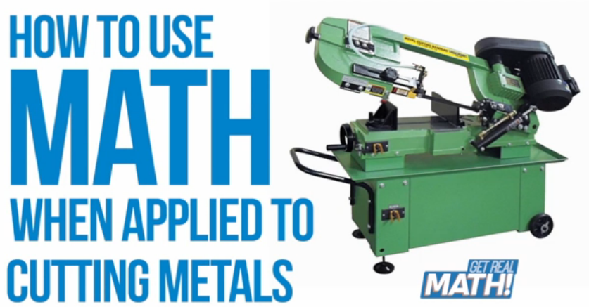

Video: https://youtu.be/ZQFoqTf25gA
Parts of a specified length must be cut from a length of milled metal. In this task, students will determine the number of parts that may be cut.

Common Core Mathematical Content Standards:

6.NS Apply and extend previous understandings of multiplication and division to divide fractions by fractions.
1. Interpret and compute quotients of fractions and solve word problems involving division of fractions by fractions, e.g. by using visual fraction models and equations to represent the problem.

7.NS Apply and extend previous understandings of operations with fractions to add, subtract, multiply, and divide rational numbers.
2d. Convert a rational number to a decimal using long division.

7.G Draw, construct, and describe geometrical figures and describe the relationships between them.
3. Describe the two-dimensional figures that result from slicing three-dimensional figures, as in plane
sections of right rectangular prisms and right rectangular pyramids.

Common Core Mathematical Practice Standards:
- Make sense of problems and persevere in solving them.
- Reason abstractly and quantitatively.
- Attend to precision.

KI Manufacturing
KI is an international manufacturer of office and institutional furniture. KI has ten different manufacturing plants, with its headquarters located in Green Bay, Wisconsin. Each plant focuses on a different aspect of business. At the Green Bay plant, the focus is on producing products such as chairs, desks and tables.
The largest part of what KI-Green Bay produces is for educational markets, in both K-12 and post-secondary settings. In 2012, KI shipped about 876,000 combined units total.

What is a machinist/tool and die maker?
The job of a machinist or tool and die maker is to:
- Provide on-sight repairs and designs/builds of dies, fixtures, molds, equipment, etc.
- Operate tool room equipment to product tooling/machined components for manufacturing process.

In this video, Spencer is a college intern in KI’s Tool and Die Shop. Interns receive hands-on training at a company, with employer supervision and evaluation, allowing a student to apply skills learned in the classroom and/or skills lab. A college instructor facilitates an internship and provides some classroom training. College internships may be paid or unpaid, but their greatest value lies in accumulating on-the-job knowledge and experience.

Spencer is cutting components for “check fixtures”. A check fixture is a flat surface that serves as a tool into which a bent part is set in order to double check all the lengths and angles are correct for the part being produced. (In this case, the part being checked will be the metal “leg section” for a chair.) The pieces Spencer is cutting are parts that will be added to the flat surface and will define where the corners of the chair legs will fit.
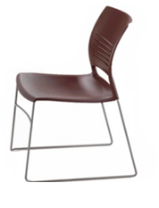
A check fixture ensures that the leg sections of a chair are bent at the correct angles so that the chair will sit flat on the floor. When leg sections are not cut and bent precisely, this is what causes chairs to jostle and rock.

Video Summary:

Teacher note: Please preview the entire video and pre-work solutions in order to anticipate students’ needs, misconceptions and materials unique to your classroom.
Introduction | (0:00-0:22) | What do you think Spencer would need know in order to determine how many smaller pieces can be cut from the longer piece of metal? What operations make sense in the context of this problem?  Includes Break 1
Information & Estimates | (0:23-0:34) | What estimates can you make? What strategies might you use to solve the problem?  Includes Break 2
New information | (0:35-0:48) | How does new information regarding the width of the saw blade and amount cleaned from the edges affect your work? How does this have an effect on your estimates?  Includes Break 3
Solution & Extension | (0:49-2:22) | What does the production process look like? How do you make sense of the situation using the blueprint? What do you think might happen if the amounts of materials were calculated incorrectly?
What is an Intern? | (2:23-2:43) | What other mathematics do you think are used by a tool and die maker?

Appendix: Check Fixture Schematic

Introduction (0:00-0:22)

- Class discussion: “What does a chair have to do with math?”

Students should brainstorm regarding what mathematics might be involved in the design, production, assembly and shipment of chairs for schools.
It may be helpful to consider:
- What is “the journey” of a chair, from design to classroom?
- What jobs do people have who support this “journey”?
(Examples: engineer, tool and die, human resources manager, production technician, product distribution, etc.)
- What knowledge and skills might be associated with these fields? What types of mathematics do you think are involved?

- Play Video (0:00-0:14).

- Pause at (0:20-0:22) at “Break 1” for class discussion.

- Class Discussion:

“You are on a team in charge of manufacturing check fixtures for the production of classroom chairs. Part of this process involves cutting the parts from a longer machined piece of metal, and you need to determine the number of parts that can be cut from given length. What information do you think you need?

  - Length of part

  - Length of given machined metal to cut parts from

Information and Estimates (0:23-0:34)

- Play Video (0:23-0:30).

- Pause at prompt (0:31-0:34) “Break 2” for class discussion.

- Class Discussion:
Prior to solving the problem, create an estimate for the amounts of materials involved in the problem.

Students should make sense of the information in the situation. If may be helpful to consider:

  - How might you make sense of the values – written as decimals or as fractions?
In the manufacturing environment, it is important to be able to make sense of quantities in both their fraction and decimal forms, since both may be used for communication and problem solving purposes. In this case, the given blueprint shows measurements in their decimal form.

  - What operations make sense in the context of the problem? What strategies would you use to solve the problem?
The problem might be solved as either a repeated subtraction or as a division problem. It is important to discuss which methods may be more accurate or more efficient.

  - What level of precision do you think is necessary and appropriate?
It is important to reflect on the need for accuracy and a high level of precision in a tool and die shop. (Frequently, materials need to be produced to a level of precision representing the thousandth of an inch.)
In the case of this calculation, we are determining the number of whole parts that can be calculated, so our solution will have to be a whole number.

- Strategies and Solutions
  - Division strategy - using fractions:
Number of parts =
=
  - Division strategy – using decimals:

    - Number of parts =

    - In either strategy, we come to that only 11 parts can be cut. (Whatever the fractional leftover part would have been, the value would always be truncated. – never rounded up.)

  - Which strategy do you believe is more efficient, and why?
  - Is one strategy more accurate than the other? If so, why do you think this is the case?
  - How do you know your answer makes sense?
  - How does your answer compare to your estimate?
  - Is there anything else that you would need to account for when cutting the metal? If so, what are some examples?

New Information (0:35-0:48)

- Play Video (0:35-0:44).

- Pause at prompt (0:45-0:48) “Break 3” for class discussion.

- Class discussion:

Students should make sense of the new information in the situation.
  - Why do the edges of the part have to be filed down?
The type of cutting seen in the video is not 100% accurate and leaves a rough edge. On each end of the part, is cleaned off to ensure a good, straight cut without saw marks or burs.
(In the video, you will also notice that prior to filing the part down Spencer will “de-bur” the part with a buffing wheel to ensure he doesn’t cut himself.)

  - How can you make sense of this new information?
Etc.
file
file
file
file
blade
blade
  - How does this new information change your estimate for the number of pieces that can be cut?

  - What strategies would you use to re-calculate the values?
Is it necessary to completely “re-think” the problem, or can you use some of your previous reasoning?

Example: Division Strategy – using fractions, refigured

Length of metal “used” per cut =

Number of parts =
=

We now come to that only 10 parts can be cut. (Whatever the fractional leftover part would have been, the value would always be truncated. – never rounded up.)
How do you know your answer makes sense?
How does your answer compare to your new estimate?
How much metal was “wasted” from the original piece?

Solution & Extension (0:49-2:22)

- Play Video (0:49-2:22).
Encourage students to think about where they see elements of the process that have an effect on the mathematics of the situation.
- Pause at (2:21-2:22) for visual of completed check fixture component.

- Class discussion: (See Schematic – Appendix)
Students should discuss where they saw mathematics as part of the manufacturing process.

  - How are the “specifications” of the part communicated?
A blueprint is used to communicate information (called specifications) about a part, including its dimensions, orientation, etc. (Originally drawn by hand, blueprints are now generated using computer-automated design technology.)

    - Compare the blueprint to the completed check fixture part.
      - Measurements described using decimal notation, to the thousandth of an inch.
      - Manufacturing information (width of blade, etc.) not included
      - 3 views of the part are provided (Is this enough? What if there was less?)
      - The scale of the drawing is 1:1 – What does this mean?

  - What do you think the effects of “being wrong” would be?

Ex: What we didn’t mention is that Spencer was the person who had milled the original length of material. This means that if Spencer underestimated the number of parts per length, he might have to mill another length of material (resulting in wasted time). If he over-estimated the number of parts per length, he might have length leftover (resulting in wasted material).
What is an Intern? (2:23-2:43)

- Play Video (2:23-2:43).

- Video Ends at 2:43.

- Class Discussion:

What other mathematics do you think are used by a tool and die maker?

What do you know about your chair that you didn’t know before? What jobs did your chair require? What mathematics was involved?

