Math Trades 1
Trigonometry (Pythagorean Theorem) Video

Name _______________________________

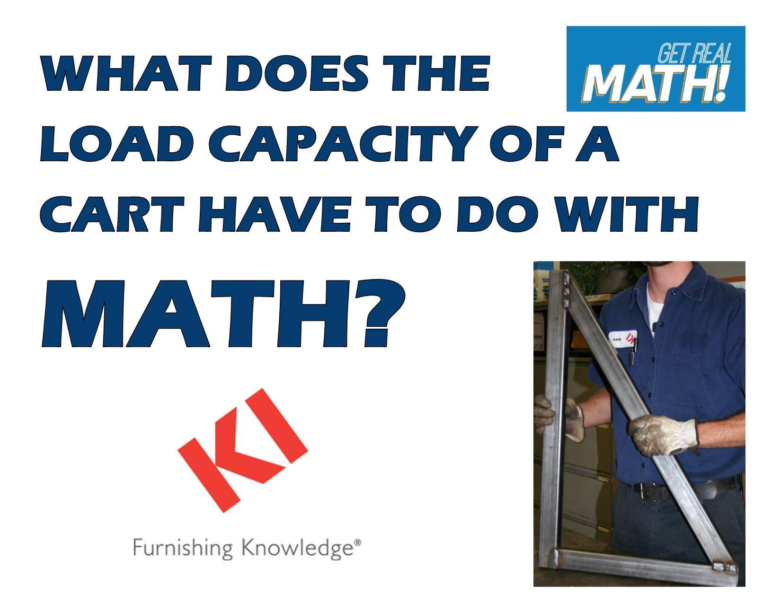
Video Link: https://youtu.be/MAS8htdbH4Y
Summary: In this video, students are challenged to determine the length of a cross brace for a cart. They also need to determine the angle to set the cross brace at. The Pythagorean Theorem and right triangle trigonometry is needed to determine these dimensions. The importance of a strong weld is also discussed as the load the cart may need to carry could be very heavy and a solid cross brace put on securely is necessary.

Company Information: KI is an international manufacturer of office and institutional furniture. KI has ten different manufacturing plants, with its headquarters located in Green Bay, Wisconsin. Each plant focuses on a different aspect of business. At the Green Bay plant the focus is on chairs, desks and tables. The largest part of what KI-Green Bay produces is for educational markets, in both K-12 and post-secondary settings. In 2012, KI shipped about 876,000 combined units total.

Common Core Grade Level for this Lesson Plan:
8.G Understand and apply the Pythagorean Theorem.
G-SRT Define trigonometric ratios and solve problems involving right triangles.
Part 1 (0:00-0:48)

- Play video (0:00-0:44), pause at prompt (0:45-0:48) for “Break 1” to answer the discussion questions.

  - What type of product are they talking about making?

  - Why would a cross brace be needed for the cart?

  - Based on the blueprint on the next page, what information is needed and what formulas can be used to determine these missing parts.
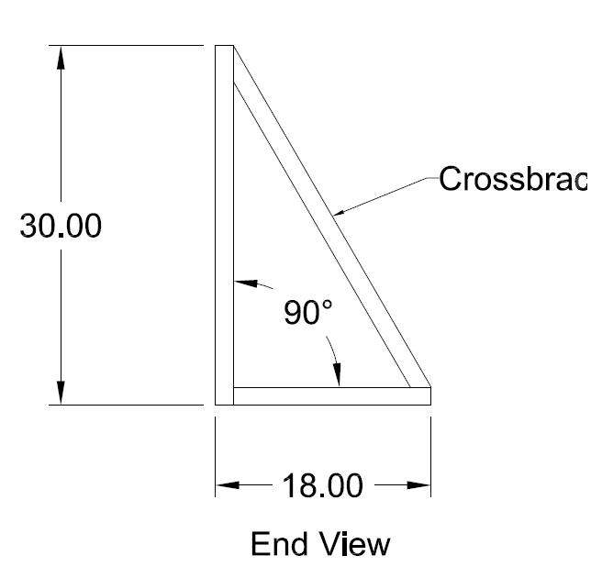
Crossbrace
Part 2 (0:49-1:25)

- Play video (0:49-1:20) verifying that you determined the correct formulas needed to find the missing length and angles, pause at prompt (1:21-1:25) for “Break 2” to answer the discussion question.

- Determine the cross brace length using the Pythagorean Theorem at this point.

Part 3 (1:26-1:44)

- Play video (1:26-1:40) verifying you determined the correct length of the cross brace, pause at prompt (1:41-1:44) for “Break 3” to answer the discussion question.

- Determine the angles the cross brace is set using the tangent function at this point.

Part 4 (1:45-2:14)

- Play video (1:45-2:08) verifying that you determined the correct angles for how the cross brace should be set, pause at prompt (2:08-2:14) for “Break 4” to answer the discussion questions.

  - Did you calculate the angles differently?

  - Once one of the angles is determined, is there another way to determine the other missing angle besides taking 180-90-31 = 59.

Part 5 (2:15-3:13)

- Play video (2:15-3:13) and then answer the discussion questions.

  - What material is being used to create this part of the cart?

  - What does it look like are some of the issues with the weld? (Go back to 2:47 to look closely).

  - Why is it so important to have a strong weld here?

  - What other things could be done to make the cart even stronger if a heavier load is needed?

  - Once this part of the cart is complete, what else will probably be done to complete the cart?

