Math Trades 1
Measurement Video

Name __________________________________
Video Link:
https://youtu.be/BY2nK4B3qtk

Summary: In this video you will look at needing to change dimensions to determine the proper robotic arm to order for a new welding enclosure. A blueprint is provided that you will measure several dimensions which then needs to be turned into a real world dimension using the blueprint scale. The dimensions then need to be converted from inches to millimeters to determine the type of robotic arm to order.

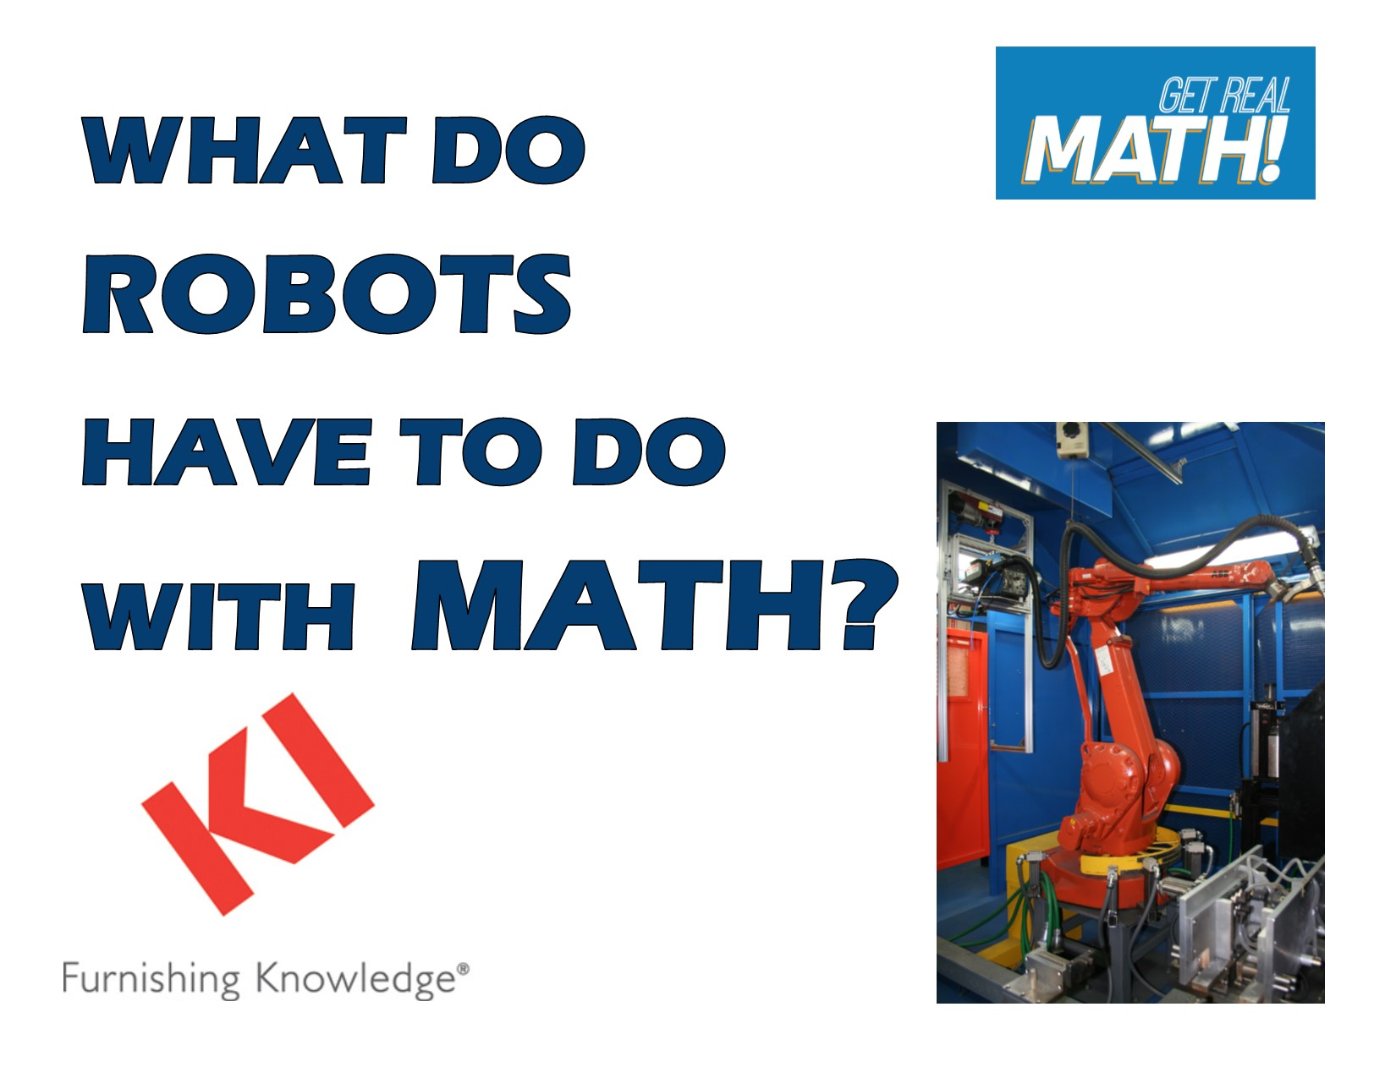
Company Information: KI is an international manufacturer of office and institutional furniture. KI has ten different manufacturing plants, with its headquarters located in Green Bay, Wisconsin. Each plant focuses on a different aspect of business. At the Green Bay plant the focus is on chairs, desks and tables. The largest part of what KI-Green Bay produces is for educational markets, in both K-12 and post-secondary settings. In 2012, KI shipped about 876,000 combined units total.

Common Core Grade Level for this Lesson Plan:
6.RP Understand ratio concepts and use ratio reasoning to solve problems.
3. Use ratio and rate reasoning to solve real-world and mathematical problems.
7.G Draw, construct, and describe geometrical figures and describe the relationships between them.
1. Solve problems involving scale drawings of geometric figures including computing actual lengths and areas from a scale drawing and reproducing a scale drawing at a different scale.

Part 1 (0:00-1:10)

- Play video (0:00-1:06), pause at prompt (1:07-1:10) at “Break 1” to answer the discussion questions.

- What does this robotic welder look like? What is the purpose of the robotic welder? Joe said that that arm needs to “properly hit all the points that we need.” What does he mean by this?

- Joe said that the robotic welder will be for dolly production. What do you think this may look like or what might this be?

- Why would it be so important to know the dimension of the robotic arm needed?

- Now, work in groups to determine the lengths going from the middle of the robot to each of the four stations by measuring the blueprint on the next page in inches and record below. Then determine the real dimension using the blueprint to actual scale of 1 to 15.5:

 | Measured Blueprint Dimension (to nearest 32nd or 16th) | Actual Dimension Based on 1:15.5 scale
Station 1
Station 2
Station 3
Station 4
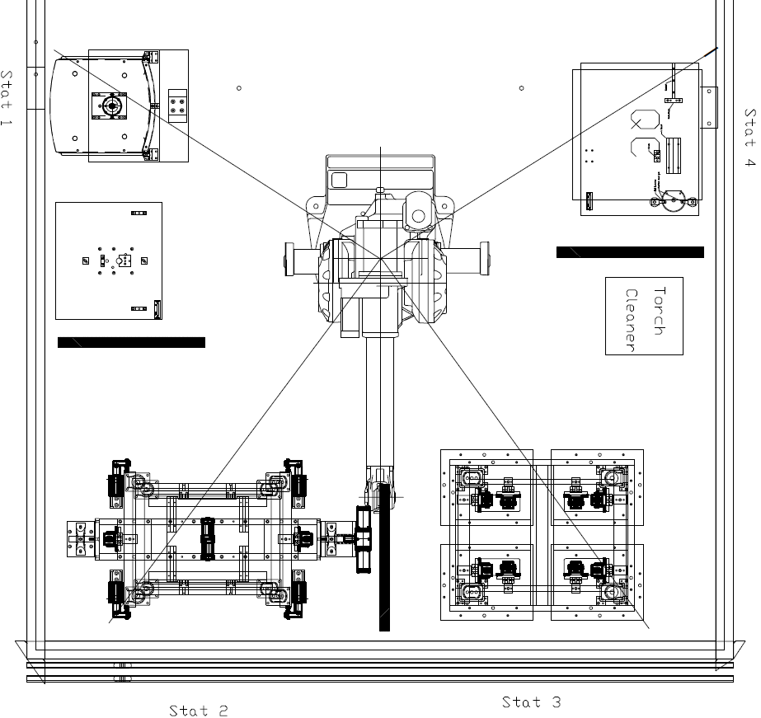

**Note: The blueprint is to scale here so do not adjust the size of the image. Converting the document to a pdf will change the size of the image and will no longer be to scale.
Part 2 (1:11-2:00)

- Play video (1:11-1:55), pause at prompt (1:56-2:00) at “Break 2” to verify that you measured correctly from the blueprint and converted correctly using the appropriate scale. Then answer the discussion questions.

- Did anyone obtain different dimensions? Since we are using a ruler to determine the dimension from the blueprint, is this a precise way to measure?

- How did Jake seem to measure?

- For this application do we need to make very precise measurements?

Part 3 (2:01-3:43)

- Play video (2:01-2:05), pause at (2:05) to answer the discussion questions

- Are there any ideas of why the dimensions would need to be converted to millimeters?

- What is the conversion factor that allows us to convert inches to millimeters?

- Why wouldn’t Jake have just measured the blueprint in millimeters initially?

- Do you think it is common that millimeters and inches need to be converted in situations like this or industries like manufacturing in general?

- Now, work in groups to determine the dimensions of the reach of each station in millimeters.
 | Dimension in inches | Dimension in millimeters
Station 1
Station 2
Station 3
Station 4

- Play video (2:06-2:31), pause at prompt (2:32) to verify that you converted correctly to the dimensions in millimeters. Then answer the discussion questions.

- Did you have the same calculations as Jake? Jake rounded up to the nearest 10 millimeters. Why do you think he would have done this? Why did he always round up instead of to the nearest ten?

- Play video (2:33-3:08), pause at prompt (3:09) to answer the discussion questions.

- Jake said that the standard robotic arms are series IRB 1400 being 1440 mm and the series IRB 2400 being 1800 mm. He then added 13.5” or 343 mm to each. How did he get 343 mm?

- Based on the dimensions we found for the distance of each station, which robotic arm should they order?

- Play video (3:10-3:39), pause at prompt (3:40-3:43) at “Break 3” to answer the discussion questions

- What were some of the reasons Joe said it is so important that this is correct, and the calculations Jake made were accurate?

Part 4 (3:44-4:15)

- Play video (3:44-4:15) and answer the discussion question

- Discuss the importance of the calculations being made in this situation. Summarize what things Jake had to have a confident understanding of to be sure he was making correct calculations.

