Math Trades 1
Algebra Video

Name _____________________________________

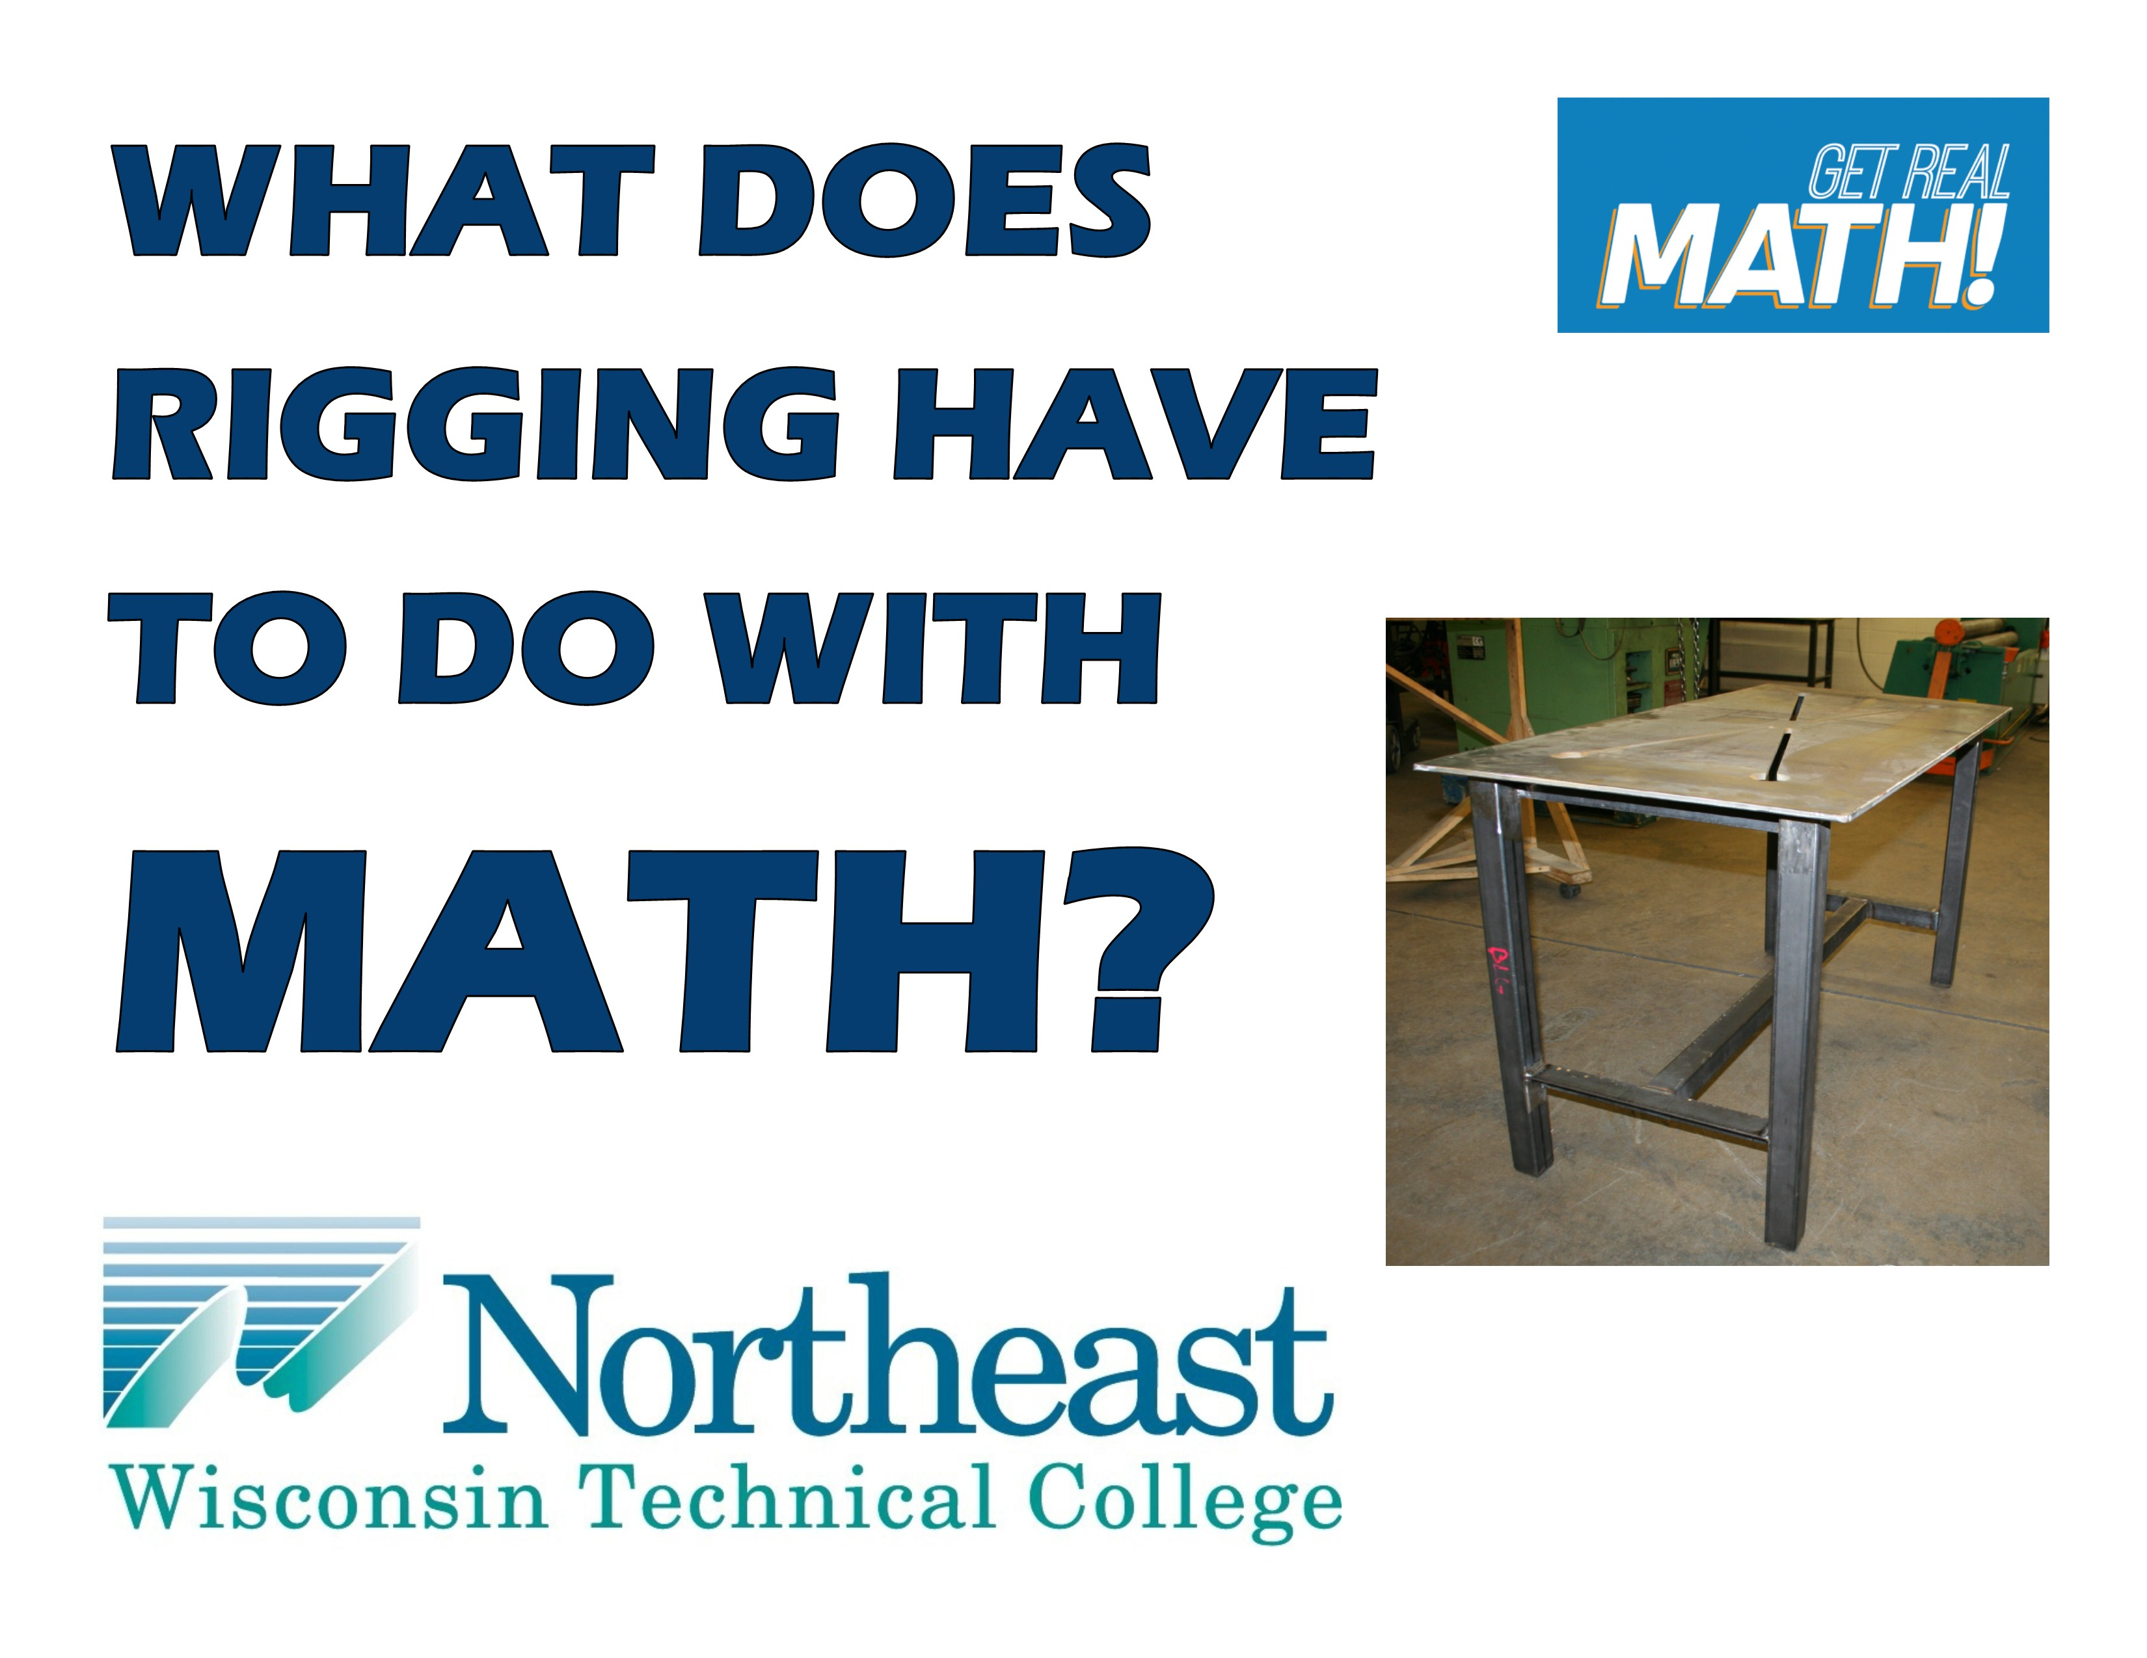
Video Link: https://youtu.be/Nrf-47lB-Tw
Summary: Understanding the weight of different things is very important for many reasons – safety being one of the main reasons. In this task, students learn how to calculate the weight of a table in order to determine the appropriate straps to use for rigging the table to move it properly and safely.
NWTC Information: Northeast Wisconsin Technical College is a nationally-ranked, two-year public college where students prepare for high-tech careers and begin their bachelor’s degrees. NWTC is one of 16 colleges in the Wisconsin Technical College System. The College has three campuses in Green Bay, Marinette, and Sturgeon Bay; five regional learning centers in Crivitz, Luxemburg, Niagara, Oconto Falls, and Shawano; and several additional sites.

Common Core Grade Level for this Lesson Plan:
4.MD Solve problems involving measurements and conversion of measurements.
5.MD Convert like measurement units within a given measurement system.
6.RP Understand ratio concepts and use ratio reasoning to solve problems.
Part 1 (0:00-0:23)

- Play video (0:00-0:17), pause at prompt (0:18-0:23) for “Break 1” to answer the discussion questions.

- What information will Austin and Wayne need to figure out the weight of the table?

- What will be used to lift the table?

- Why would they need to figure this out? Why not just lift the table to move it themselves?

- What types of material does it look like are being used for this table?

Part 2 (0:24-1:13)

- Play video (0:24-0:37), pause at (0:38) to answer the discussion question.

- What kind of information does it seem the Ryerson book includes?

- Play video (0:39-0:51) filing in the dimensions measured in the chart below, pause at (0:52) to then look up the appropriate weight in the Ryerson Sheet Metal/Steel Plate chart below.

Material | Stock Size | Weight/unit | Quantity/Dimensions | Weight
Sheet Metal | $\frac{3}{8}$”
Square Tubing | 1$\frac{1}{2}$” x 1$\frac{1}{2}$ “ x $\frac{1}{8}$”
Angle Iron | 1$\frac{1}{2}$” x 1$\frac{1}{2}$ “ x $\frac{1}{8}$”
 |  |  | Total

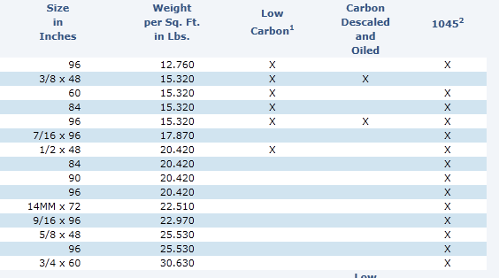

- Did you notice anything about the top of the table that could affect the weight?

- Play video (0:53-1:08) verifying your weight/unit, pause at prompt (1:09-1:13) for “Break 2” to calculate the weight of the top of the table. Be careful to think about what units you are using and if necessary, convert to an appropriate unit. Record this in the chart above.
Part 3 (1:14-2:32)

- Play video (1:14-1:38) writing the dimensions of square tubing below, pause at (1:39) to determine the total number of inches of square tubing needed and record this in the chart on page 2. Also, look up the appropriate weight in the Ryerson square tubing table below and record in the chart.

***Note: $\frac{\text{1}}{\text{8}}\text{"}$ thickness is 11 Wall Gauge
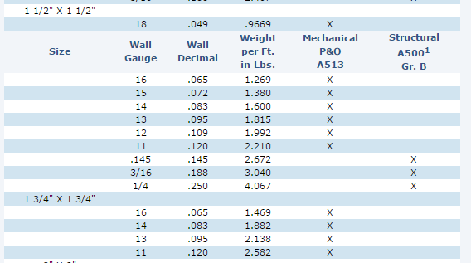

- Play video (1:40-2:15) verifying your weight/unit for square tubing and writing the dimensions of angle iron below, pause at (2:16) to determine the total inches of angle iron needed and record this in the chart on page 2. Also, look up the appropriate weight in the Ryerson angle iron table below and record in the chart.

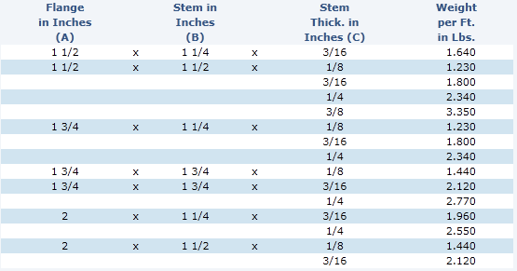
- Play video (2:17-2:25) verifying your weight/unit for angle iron, pause at prompt (2:26-2:32) for “Break 3” to calculate the weight of the square tubing and angle iron. Again, be careful about what the units are. Find the total weight in the chart. Also, answer the discussion question below.

- Why was the sheet metal weight given in pounds per square foot versus the square tubing and angle iron weights given in pounds per foot?

Part 4 (2:33-4:31)

- Play video (2:33-4:26) verifying your weights for each part and total weight, pause at prompt (4:27-4:31) for “Break 4” to answer the discussion questions below.

- Does this weight seem reasonable? Based on earlier discussions, would this table be safe to move by having two people pick it up and move it? What weight should they be looking at the straps being able to handle in order to safely move this table?

Part 5 (4:32-5:49)

- Play video (4:32-5:49) and then answer the discussion questions.

  - The process Austin and Wayne were performing is called rigging. Why is this process so important?

  - The capacity of the strap they were planning to use is 500 pounds. What would happen if the strap only had a capacity of 100 pounds? Or if the table was over 500 pounds? What are possible things that could happen?

  - See some videos of improper rigging and the consequences:
    - https://www.youtube.com/watch?v=ok9DNb2VJY8 – This is very long, but you can skip around and watch several parts
    - https://www.youtube.com/watch?v=axjmK_vjYCM – Watch the first 40 seconds, then skip to watch 1:35-2:00, then skip to 3:00-end

