Math Trades 1
Integer Video

Name _________________________________

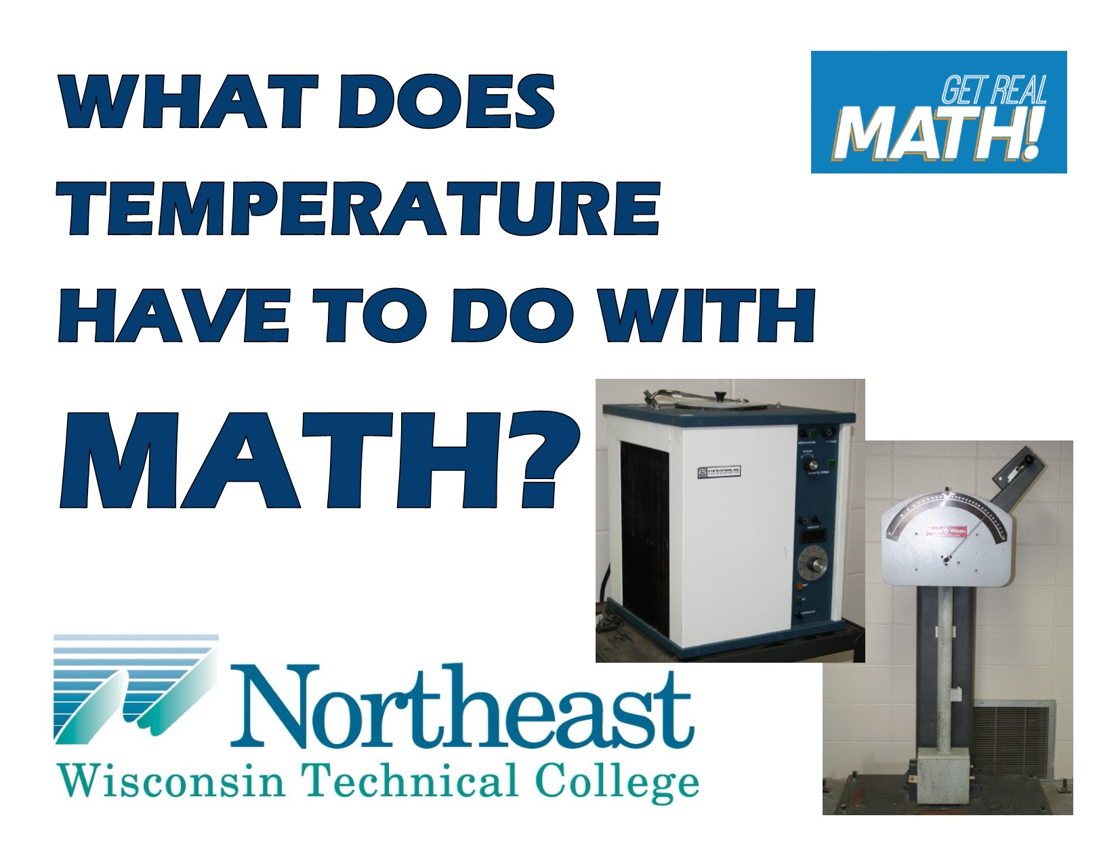
Video Link:
https://youtu.be/IvX0Oncxnss

Summary: In this lesson, you will see a material’s strength being tested using the Charpy Impact Test. In this particular situation, the material is to be tested under very cold temperatures and to do so, the temperature at which the material needs to be tested needs to be converted from Fahrenheit to Celsius.

NWTC Information: Northeast Wisconsin Technical College is a nationally-ranked, two-year public college where students prepare for high-tech careers and begin their bachelor’s degrees. NWTC is one of 16 colleges in the Wisconsin Technical College System. The College has three campuses in Green Bay, Marinette, and Sturgeon Bay; five regional learning centers in Crivitz, Luxemburg, Niagara, Oconto Falls, and Shawano; and several additional sites.

Common Core Grade Level for this Lesson Plan:
6.EE Apply and extend previous understanding of arithmetic to algebraic expressions.
2c. Evaluate expressions at specific values of their variables. Include expressions that arise from formulas used in real-world problems.
Part 1 (0:00-1:44)

- Play video (0:00-0:36), pause at (0:37) to answer the discussion questions.

  - John says that the Charpy Impact Tester is used for “measuring the actual impact toughness of materials”? What do you think the different materials he is talking about could be?

  - Why would something need to be tested at twenty below or forty below?

  - The impact is measured in foot-pounds. What do you think foot-pounds are?

- Play video (0:38-1:40), pause at prompt (1:41-1:44) for “Break 1” to answer the discussion questions.
- Why would the dimensions need to be specifically these dimensions with the groove in that specific location?
- The notch is to be placed outward from the impact? Why would this be?

- John stated that three to five specimens will be tested and then an average of the foot-pounds will be taken. How would this be done – how do you find an average?

Part 2 (1:45 – 2:31)

- Play video (1:45-2:27), pause at prompt (2:28-2:31) for “Break 2” to answer the discussion questions.

- So, without the specimen the Charpy impact machine read zero foot-pounds of energy. Explain in your own words why and what is going to happen differently once a specimen is there?

- How do you think the temperature stipulated on contract documents are determined?

- Since the contract document stipulates the temperature in Fahrenheit and the machine needed to cool the specimen is in Celsius, what will need to be done in order to convert the temperatures?

- The contract document states that the temperature is listed at -20°F. Determine what this temperature is in Celsius.

Part 3 (2:32 – 3:51)

- Play video (2:32-3:20), pause at (3:21) to answer the discussion question and verify that you have determined the correct temperature in Celsius.

- John shows that -40°F is equal to -40°C. Does this happen at any other temperature?

- Play video (3:22-3:51) and answer the discussion questions.

- What does it look like the impact is measured to be? (Go back and pause at 3:39 to look closer.) Looking at the scale, if a stronger material were in the machine, would the foot-pounds be more or less than this?

- What may this measurement mean for the material being tested?

