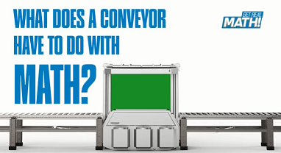

What does a conveyor have to do with math?
Video: https://youtu.be/Cf-jJv_xFZE
Lesson Plan
Teacher Note: Please preview the entire video and pre-work the solutions in order to anticipate students’ needs, misconceptions and materials unique to your classroom.
You will also need to determine the background knowledge of your students regarding the following topics, and decide the best method for providing that background in order to support the conceptual understanding of the mathematics shown in the video.
- Conveyor systems
- Elevation change
- The three-dimensional coordinate system (xyz axis system) and ordered triples (x, y, z)
- Distance Formula
- Pythagorean Theorem

There are two approaches to solving this problem. The approach you use should be determined by the background/grade level of your students
- The solution method used in the video asks students to use the distance formula to find the length of the legs of a right triangle, then the Pythagorean Theorem to find the hypotenuse. This approach eliminates the z coordinate in the calculations and allows students to apply the CCSSM middle school standards in a real world context.
- A more efficient approach is to find the distance between the two (x, y, z) points given using the distance formula with 3 variables. This method does not utilize a CCSSM middle school standard and therefore was not the selected solution method.

Common Core Mathematical Content Standards
- 7.EE.B.3 Solve real-life mathematical problems using numerical and algebraic expressions and equations.
- 8.EE.A Work with radicals and integer exponents.
- 8.G Understand and apply the Pythagorean Theorem
- G-GMD Visualize relationships between two-dimensional and three-dimensional objects
- G-MG Apply geometric concepts in modeling situations

Common Core Mathematical Practice Standards
1. Make sense of problems and persevere in solving them.
2. Reason abstractly and quantitatively
3. Construct viable arguments and critique the reasoning of others.
4. Model with mathematics
6. Attend to precision

Company Information: Nercon Eng. & Mfg., Inc. - Biography
Nercon Eng. & Mfg., Inc. has been engineering and manufacturing conveyor and consumer goods packaging equipment for over 38 years. We are known for our expertise in design. Our growing business currently employs about 150 people. With the Nercon Corporate and Engineering office located in Neenah, Wisconsin and the production facility in Oconto, Wisconsin, our local family-owned business has been an active part of both the Fox Valley and Oconto area communities.
Summary
In this video, we see that a conveyor system does not always move product horizontally or vertically. It can also move product in more than one direction at a time, including an elevation change. Building this type of conveyor incline requires more knowledge of mathematics. Let’s see how 3D geometry helps us accomplish this.
Pre-Activity Discussion:
- Definition of conveyor system
  - Equipment that safely transports material from one area or level to another.
  - Basic components of a conveyor system include a frame to support the material being transported, motor or “driving unit”, and an “extremity unit” which includes the pulleys, etc.
  - Discuss real world applications’ of conveyors. (food, mining, order fulfillment)
  - Discuss 3D movement of materials on conveyors (horizontal, vertical, and with an incline)

Differentiation:
- The questions on the student handout are scaffolded to meet the needs of students who may need extra support.
- Eliminating some of the added questions and just posing the questions from the video would be a possible differentiation strategy for students who do not need the extra support.
- Students may also benefit by working with others as part of a partner/group investigation.

Information that will be given in the video:
- Starting point of elevation change: 4 feet north of the wall, 5 feet east of the wall, and elevation of 3 ft.
- Ending point of the elevation change: 10 feet north of the wall, 22 feet east of the wall and elevation of 8 feet.
- Graphics templates are available at the end of this lesson plan.

Part 1: (0:00 – 2:53)
- Ask – “What is the problem posed in this video?”
- Have students use the handout to complete the following:
- Using the coordinates given in part 1, plot the points on the graph, label them as point A and B and also with their ordered triple.
- Sketch the segment AB. What does it represent in the context of this problem?
- Sketch the legs of the right triangle if segment AB is the hypotenuse.
- Label the intersection of the legs (the right angle) as point C. How do you know this is a right angle?

- What are the coordinates of point C?

- Use the distance formula to find the distance between point A and point C (length of the base leg of the right triangle). Write the distance you calculated on your sketch.

- Use the drawing (or the distance formula) to find the distance between point B and point C (length of the other leg of the right triangle or its height). Write the distance you calculated on your sketch.

BREAK 1

Part 2 (2:55 – 3:11):
- Have students use the handout to complete the following:
- Make any needed adjustments or corrections to your 3D sketch.
- If you know the length of two sides of a RIGHT triangle and need to find the length of the third side, what famous formula can you use?
- How much conveyor belt will the Nercon salesman need to order? Show your calculations.

BREAK 2
Part 3 (3:14- 3:38)
- Have students use the handout to answer the following question:
- Why was the length doubled?

Extension:
- Ask students to make and test a conjecture about the distance formula used with ordered triples.
- What other measurement would we need to consider? (the rollers on the ends of the conveyor…1/2 circumference would need to be added)
- Extend the problem to include pricing of the conveyor belt at a rate of $35 per foot.
- Modify the problem by increasing/decreasing the elevation by 10%

Student Handout - What does a conveyor have to do with math? Name(s):

Pre-Video Discussion: Notes on important background information.

Problem: How many feet of conveyor belt will need to be ordered?
Break 1:
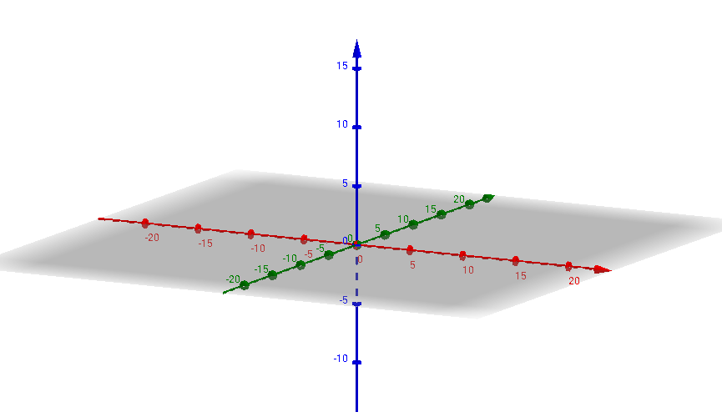
Z
Y
X

- Using the coordinates given in part 1, plot the points on the graph, label them as point A and B and also label them with their ordered triple.

- Sketch the segment AB. What does it represent in the context of this problem?

- Sketch the legs of the right triangle if segment AB is the hypotenuse.

- Label the intersection of the legs (the right angle) as point C. How do we know that this is a right angle?

- What are the coordinates of point C?
- Use the distance formula to find the distance between point A and point C (length of the base leg of the right triangle). Write the distance you calculated on your sketch

- Use the drawing (or the distance formula) to find the distance between point B and point C (length of the other leg of the right triangle or its height). Write the distance you calculated on your sketch.

Break 2:

- Make any needed adjustments or corrections to your 3D sketch.
- If you know the length of two sides of a RIGHT triangle and need to find the length of the third side, what famous formula can you use?

- How much conveyor belt will the Nercon salesman need to order? Show your calculations.

Break 3:
- Why was the length doubled?

ANSWER KEY – What does a conveyor have to do with math?

The graphics below (and in the video) were created using Geogebra https://www.geogebra.org/3d
When created online, the graphic can be manipulated to give students a better representation of the XYZ coordinate axis and the problem posed in the video.

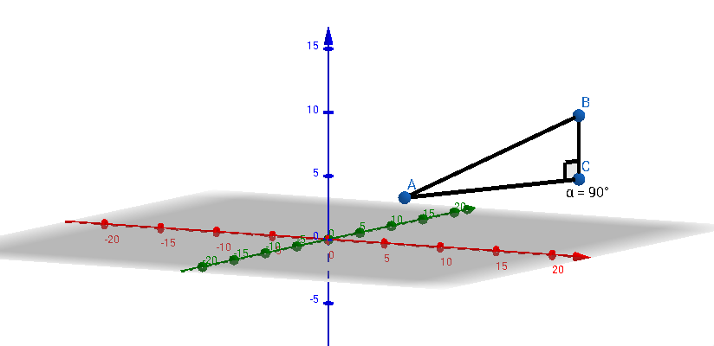
X
Y
Z
(4,5,3)
(10,22,8)
(10,22,3)

#1 through #5 are shown in the graphic above.

#6
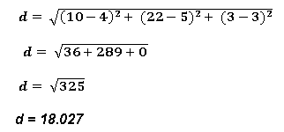

Length of segment AC is 18.027 feet

#7 Vertical Change is 5 ft

Length of segment BC is 5 feet

#9 Pythagorean Theorem

#10 If the figure is a right triangle, then Leg² + Leg² = Hypotenuse²

(AC)² + (BC)² = (AB)²

5² + (18.027)² = (AB)²

25 + 325 = (length of conveyor belt needed)²

350 = (length of conveyor belt needed)²

(350)^{1/2} = length of conveyor belt needed

18.7 feet = length of conveyor belt needed

#11 For the return (loop) of the belt.

The Geogebra commands that created the graphic are shown below

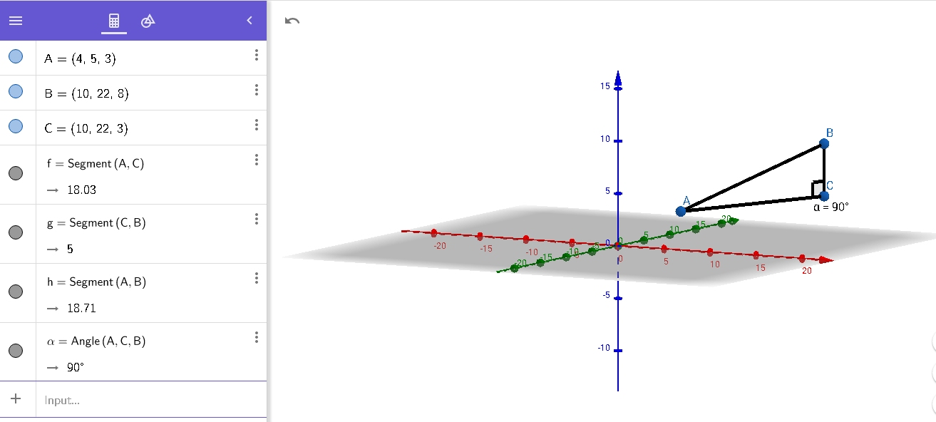

Graphic Templates
Y
Z
X

