Math Trades 1
Geometry Video

Name _____________________________

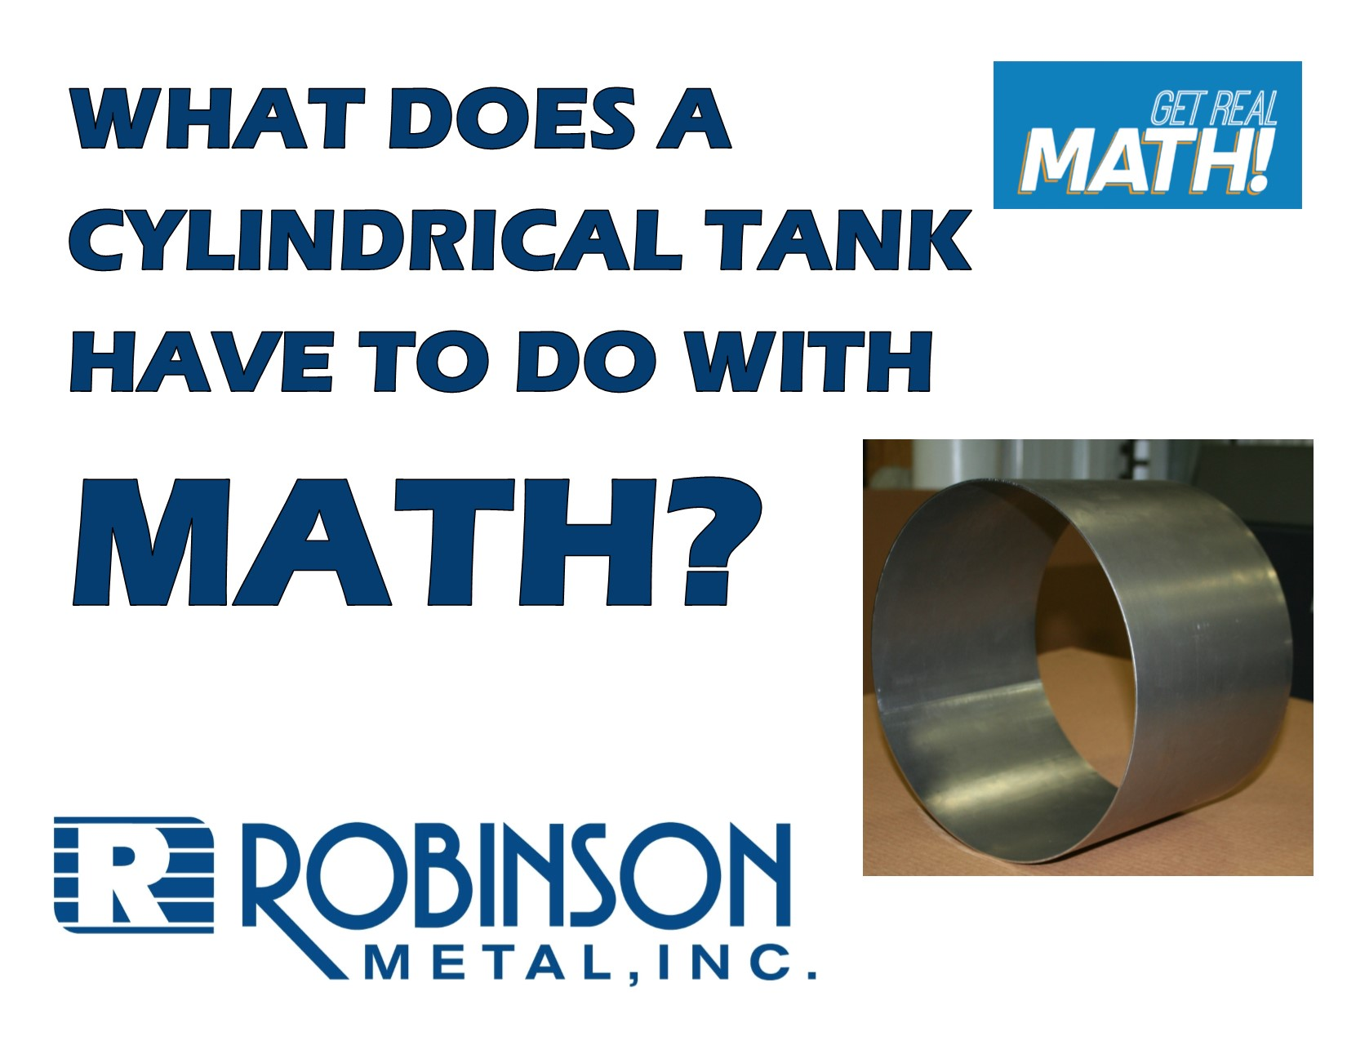
Video Link:
https://youtu.be/-5naDjodNls
Summary:
In this video, specifications for a set of tanks that are ordered are given in regard to the volume in gallons and the diameter of the tank. The height of the tank needs to be determined using some conversions and the formula for volume of a cylinder. The process of how the tank is produced is discussed and shown.

Company Information: Robinson Metal was established in 1975 in Green Bay, WI. RMI now resides in De Pere WI., with a 185,000 sq. ft. manufacturing facility, offering a single comprehensive source, for custom metal fabrication, machining and assembly. RMI has combined the skills and knowledge of our highly trained craftsman with the latest tools and technologies. RMI specializes in stainless steel, aluminum, carbon steel and polycarbonates, resulting in quality finished products, offering a first class customer experience, building products to their designed specifications.

Common Core Grade Level for this Lesson Plan:
5.MD.C Geometric measurement: understand concepts of volume.
8.G.C Solve real-world and mathematical problems involving volume of cylinders.

Part 1 (0:00-0:28)

- Play video (0:00-0:24), pause at prompt (0:25-0:28) for “Break 1” to answer the discussion questions.

  - What information is Mark given?

  - What can he assume based on the information given?

  - What information will he need to determine to make these tanks?

  - What formulas or information can he use to determine missing information?

  - What may be the process that Robinson will go through to go from taking this order to fulfilling the order for the customer?

Part 2 (0:29-0:55)

- Play video (0:29-0:51), pause at prompt (0:52-0:55) for “Break 2” to answer the discussion questions.

  - Mark tells Jesse the material thickness of the “wrap”. What does the wrap denote?

  - Now that we are given the thickness of the sheet metal that will used is, determine the inner diameter of the cylinder. Then determine the inner radius.

  - How many cubic inches are in 4 gallons?

Part 3 (0:56-1:38)

- Play video (0:56-1:33), verifying that you have the correct inner radius and cubic inches, pause at prompt (1:34-1:38) for “Break 3” to answer the discussion questions.

  - Use the information determined so far and the formula for volume of a cylinder to find the missing dimension – the height.

Part 4 (1:39-3:07)

- Play video (1:39-3:07), verifying that you calculated the correct height of the tank. They answer the discussion questions below.

  - When Jesse was measuring the height of the tank, he is using a tape measure so the measurement is to fractional inches. What fractional inch measurement would Jesse be measuring if he was measuring to the nearest 16th of an inch? What if he was measuring to the nearest 32nd of an inch?

  - This tank was being inspected by Jesse? Why is it important to inspect products?

  - What things will probably still be done from this point to complete the tank?

Extension

- This is not discussed in the video – but the wrap starts as a rectangular sheet of metal, which we can see in the video at (2:31). One side is the height. What is the other side of the rectangle?

- What would make the most sense to use for the diameter since we have an outer diameter and inner diameter?

- Determine what the dimensions of the sheet of metal that creates the wrap of the cylinder should be. If time allows, measure out the dimensions on a piece of paper and tape the piece of paper together to replicate making the tank and verify the diameter.

