Math Trades 1
Decimals Video

Name ______________________________

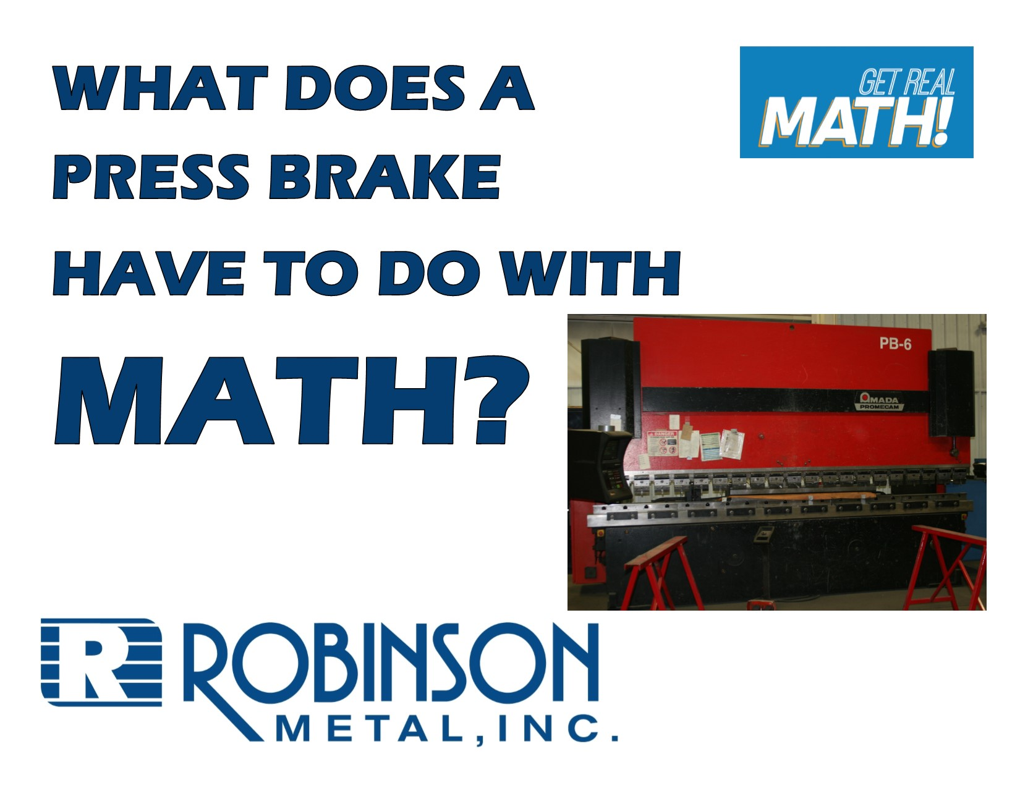
Video Link:
https://youtu.be/e544waetKNA
Summary: In order to operate many machines in the manufacturing industry, dimensions need to be entered a certain way. In this video the dimensions on a blueprint to make a box are in fractions of an inch, but when the sides of the sheet metal are bent using a press brake, the dimensions need to be entered in decimal form. You will need to convert fractional inches into decimals.

Company Information: Robinson Metal was established in 1975 in Green Bay, WI. RMI now resides in De Pere WI., with a 185,000 sq. ft. manufacturing facility, offering a single comprehensive source, for custom metal fabrication, machining and assembly. RMI has combined the skills and knowledge of our highly trained craftsman with the latest tools and technologies. RMI specializes in stainless steel, aluminum, carbon steel and polycarbonates, resulting in quality finished products, offering a first class customer experience, building products to their designed specifications.

Common Core Grade Level for this Lesson Plan:
5.NFB Apply and extend previous understandings of multiplication and division.
B3. Interpret a fraction as division of the numerator by the denominator (a/b = a ÷ b).
Part 1 (0:00-0:31)

- Play video (0:00-0:26), pause at prompt (0:27-0:31) at “Break 1” to answer the discussion questions.

- What do you think a press brake does? How would a box be formed using the sheet of metal we can see on the table?

- Why would the dimensions need to be entered in decimals versus fractions?

- How do you convert fractions to decimals?

- You can now work to convert the fractions on the blueprint below to decimals.

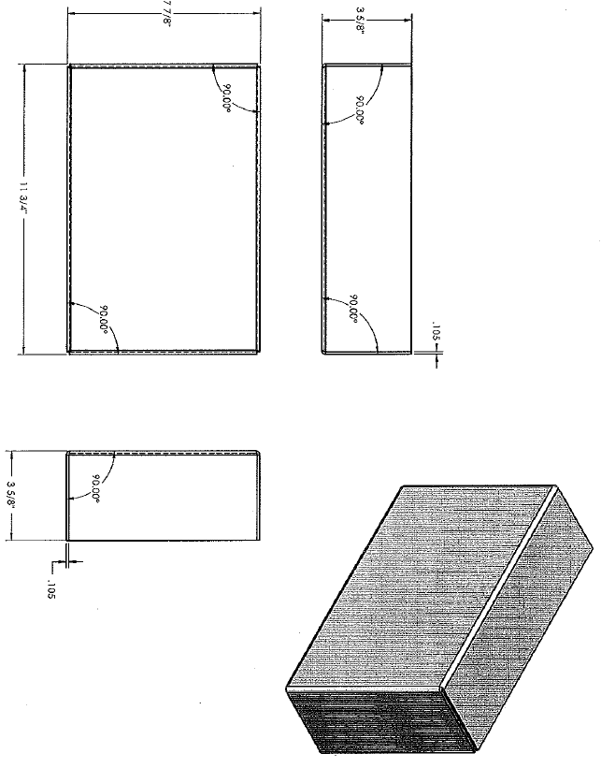
Part 2 (0:32-1:00)

- Play video (0:32-0:56), pause at prompt (0:57-1:00) at “Break 2” to verify your conversions as a class and answer the discussion question below.

- What do you think Jesse means when he says he “knows his decimal-fraction conversions up to the nearest 16th?”

Part 3 (1:01-1:45)

- Play video (1:01-1:45), verifying remaining conversions and answer the discussion questions below.

- At what angle is the metal being bent to create the box?

- What additional things may be done to this box to complete it? What might be the purpose for this box?

Extension

- What about converting the other way? What if a blueprint labelled dimensions in decimals but they needed to be converted to the nearest 16th of an inch to be able to use measuring tools that are on a scale of 16^{ths} of an inch or 32nds of an inch? How can this be done?

- If the sheet metal being used on this box needs to be ordered but the dimensions of what you can order are to the nearest 16th, what would you order?

What about to the nearest 32nd?

To the nearest 64th?

