Math Trades 1
Trigonometry (Arc Length) Video

Name ______________________________
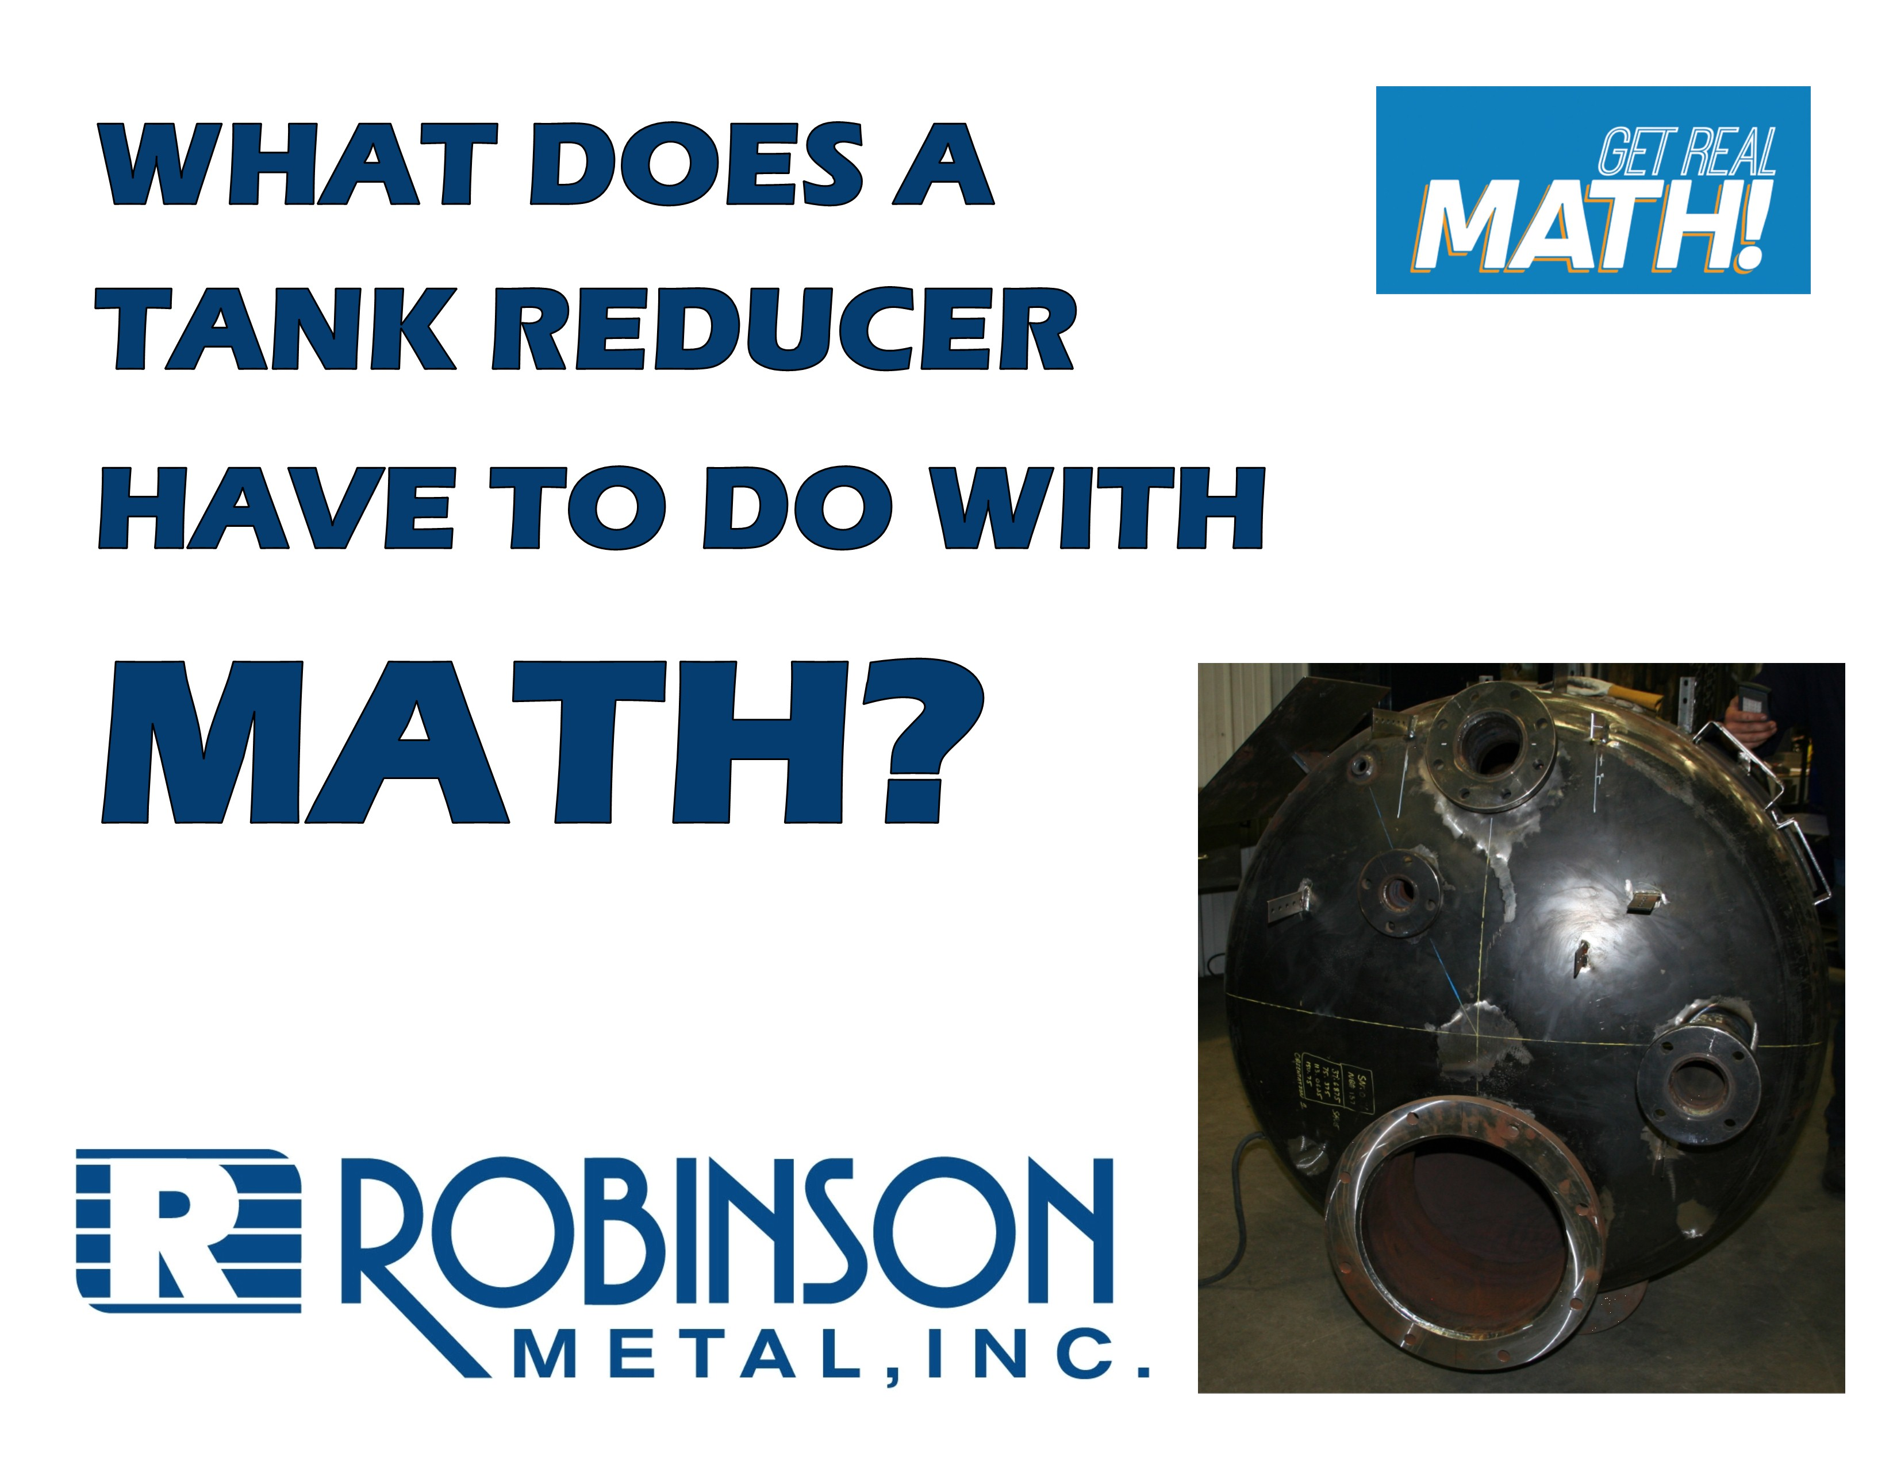
Video Link: https://www.youtube.com/watch?v=zuJqUDkPHO8
Summary: A part needs to be welded onto an exterior part of a tank reducer. Exactly where the part is to be attached needs to be determined first, based on a blueprint. In this activity, students need to determine the correct length from the top of the tank to place the object.

Company Information: Robinson Metal was established in 1975 in Green Bay, WI. RMI now resides in De Pere WI., with a 185,000 sq. ft. manufacturing facility, offering a single comprehensive source, for custom metal fabrication, machining and assembly. RMI has combined the skills and knowledge of our highly trained craftsman with the latest tools and technologies. RMI specializes in stainless steel, aluminum, carbon steel and polycarbonates, resulting in quality finished products, offering a first class customer experience, building products to their designed specifications.

Common Core Grade Level for this Lesson Plan:
4.MD Geometric measurement: understand concepts of angle and measure angles.
7G Solve real-life and mathematical problems involving angle measure, area, surface area, and volume.
HSG.C Find arc lengths and areas of sectors of circles.
B5 Derive using similarity the fact that the length of the arc intercepted by an angle is proportional to the radius.
Part 1 (0:00-0:38)

- Play video (0:00-0:22), pause at (0:23) to answer the discussion questions.

- What do you think a “revision” for a job is?

- What information in general would be needed to determine where to weld on a piece on the side of a circular tank like the one shown on the first page of the student handout?

- What tools will Jeremy need to make these calculations and lay out the part?

- Play video (0:24-0:33), pause at prompt (0:34-0:38) for “Break 1” to answer the discussion questions.

- Based on the blueprint below, what specific dimensions are needed and why? What is the difference between ID – inner diameter and OD – outer diameter? Why would it be important to know both?

- Based on the ID and OD of the tank, what does this tell us about the thickness of the tank?

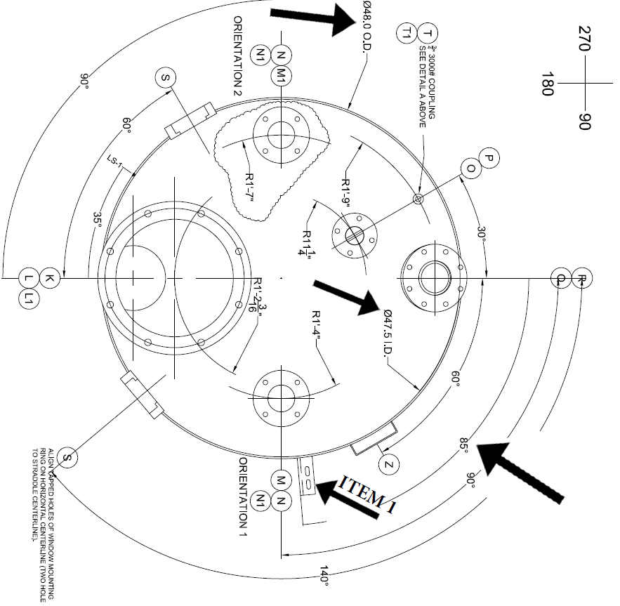

Part 2 (0:39-1:05)

- Play video (0:39-1:00), pause at prompt (1:01-1:05) for “Break 2” to answer the discussion questions.

  - Determine the length that you think needs to be measured from the top of the tank to where the item needs to be welded. Determine if you got the same answer as Jeremy’s 35.23” or something different.

  - What is the mathematical term for this dimension that Jeremy found? What is the industry term for this dimension?

Part 3 (1:06-2:01)

- Play video (1:06-1:47), pause at (1:48) to verify your dimension for the wrap and how it was calculated. Answer the discussion question below.

  - Did you determine the correct length using a different method or calculation?

- Play video (1:49-1:57), pause at prompt (1:58-2:01) for “Break 3” to answer the discussion questions.

  - Chad said that “we were about $\frac{3}{8}$ of an inch off” from using the inner diameter instead of the correct outer diameter. How did Chad determine this?

  - Does this seem like a significant difference?

Part 4 (2:02-3:19)

- Play video (2:02-3:19).

  - Chad and Jeremy discuss that it was good that they double checked their calculations because it “saved you a couple hours of labor having to cut that off”. What would be all of the things that would need to be done to redo this job in the correct location? Do you think this would have substantial costs associated with it?

A close-up of the side of the tank:

