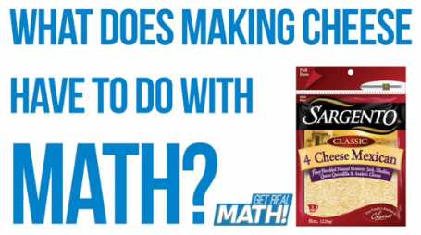

Video:

https://youtu.be/UYwZSnsJ80I

Shredded cheese blends are manufactured using a mix of specified cheese varieties. In this task, students will determine amounts of different cheese varieties necessary to produce an order of shredded cheese blend for a distribution order.

Common Core Mathematical Content Standards:

6.RP Understand ratio concepts and use ration reasoning to solve problems.
1. Understand the concept of a ratio and use ratio language to describe a ratio relationship between two quantities.
2. Understand the concept of a unit rate a/b associated with a ratio a:b with $b≠0$, and use rate language in the context of a ratio relationship.
3. Use ratio and rate reasoning to solve real-world and mathematical problems.

7.RP Analyze proportional relationships and use them to solve real-world and mathematical problems.

1. Compute unit rates with ratio of fractions, including ratios of lengths, area and other quantities measure in like or different units.

2. Recognize and represent proportional relationships between quantities.

3. Use proportional relationships to solve multistep ratio and percent problems.

Common Core Mathematical Practice Standards:

- Make sense of problems and persevere in solving them.

- Reason abstractly and quantitatively.

Sargento Cheese

Sargento Foods Inc. is a family-owned company comprising four business divisions: Consumer Products, Food Service, Food Ingredients and Culinary Solutions. The company employs more than 1,500 people at four Wisconsin facilities. The Consumer Products Division is a leading national packager and marketer of natural shredded, sliced, snack and specialty cheeses sold under the Sargento brand.
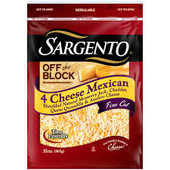
Consider that a package of shredded cheese blend, like the one shown, involves multiple stages for its production and packaging. Different varieties of cheese are brought in from quality outside producers and cut into 40-pound blocks. In order to create a shredded cheese blend, these different blocks are intermittently fed into a shredding machine. The shred is then mixed and packaged.

Video Summary:
Teacher note: Please preview the entire video and pre-work solutions in order to anticipate students’ needs, misconceptions and materials unique to your classroom.

Part 1
Pre-Activity Discussion | (0:00-0:11) | What does making cheese have to do with math?
Part 2 – What Makes a “Set” of this Blend?
Information & Estimates | (0:12-1:05) | What information to you think is necessary to determine how much of each of 4 cheeses are needed to manufacture a “set” of a shredded cheese blend?  Based on given information, what strategies would you use to calculate these amounts?  Includes Break 1
Strategies & Solutions | (1:06-1:20) | How do your solutions compare?
Part 3 - 20,000 Pounds of Cheese
Information & Estimates | (1:21-1:40) | What estimates can you make? What strategies can you use to calculate the amounts of each cheese needed for a 20,000-pound blend order?  Includes Break 2  How do your answers compare to the given solutions?
Solutions | (1:41-1:53) | How do your answers compare to the given solutions?
Part 4 – Adding Trim to the Mix
Information & Estimates | (1:54-2:27) | How does this new information relate to your previous problem solving? What estimates can you make?  Includes Break 3
Solutions & Strategies | (2:28-2:43) | How do your strategies compare? How do you answers compare to the given solutions?
Part 5 – What Happens When Mistakes are Made?
Information & Estimates | (2:44-3:07) | What questions need to be answered in order to makes sense of the problem?  Includes Break 4
Solutions & Strategies | (3:08-4:09) | What strategies could be used to solve this problem?  Includes Break 5  How do your solutions compare with the video?  What additional problems does this “correction” create?

Part 1

Pre-Activity Discussion (0:00-0:11)

- Play Video (0:00-0:09).

- Pause at visual (0:10-0:11) for class discussion.

- Class Discussion: “What does making cheese have to do with math?”

Students should brainstorm regarding what mathematics might be involved in the production, packaging and distribution of blended shredded cheese.
It may be helpful to consider:
  - What is “the journey” of cheese, from production to kitchen?
  - What jobs do people have who support this “journey”?
(Examples: farmers, cheese makers, packaging engineers, human resources manager, production managers, heavy duty utility workers, product distribution and marketing, etc.)
  - What knowledge and skills might be associated with these fields? What types of mathematics do you think are involved?
When a shredded cheese blend, like the variety shown, is created, the types of cheese in the blend are set in specific ratios to maximize taste and minimize cost. (It is rare for a blend to be created using equal amounts of each cheese variety.) These ratios must be strictly adhered to in order to ensure product consistency and information communicated by the product labeling.

Part 2: What Makes a “Set” of this Blend? (0:12-1:05)

- Play Video (0:12-1:00).

- Pause at prompt (1:01-1:05) at “Break 1”for class discussion.

- Class Discussion:
What question needs to be answered?
  - How many of each of the blocks of cheese is needed to make a set of the shredded blend?
(A “set” is a unit of the measure, referring to the minimum number of whole blocks needed to make the 4-cheese blend.)

What necessary information was provided during this section of the video?
  - There are 4 cheese varieties used to create the blend of shred: A, B, C, D.
  - The ratios of the varieties are:
    - A: 20%
    - B: 20%
    - C: 20%
    - D: 40%

Was there any information given during this video segment that is not needed to answer the question?
  - The fact that the cheese blocks are 40-pounds is not necessary to answer the question related to “a set”.

Teacher Note: In the video the manufacturer was not able to disclose the specific cheese varieties with their actual precise ratios in order to protect product confidentiality. In order to have a more meaningful class discussion, it may be helpful to assign cheese variety names to the labels A-D used in the video.
A
B
C
D
D

Solutions and Strategies:

A: $20\%=\frac{20}{100}=\frac{1}{5}$ interpretation: 1 block out of 5 needs to come from block A
B: $20\%=\frac{20}{100}=\frac{1}{5}$ interpretation: 1 block out of 5 needs to come from block B
C: $20\%=\frac{20}{100}=\frac{1}{5}$ interpretation: 1 block out of 5 needs to come from block C
D: $40\%=\frac{40}{100}=\frac{2}{5}$ interpretation: 2 blocks out of 5 need to come from block D

1 set = 5 blocks of cheese. 1 – A, 1 – B, 1 – C, 2 – D.

- Play Video (1:06-1:18).

- Pause at prompt (1:19-1:20) for class discussion.

  - How do you solutions compare?
  - Why do you think the “set” concept is used by the manufacturer? What does a “set” relate to in terms of part-to-whole ratios?

Part 3: 20,000 Pounds of Cheese (1:06-1:53)

- Play Video (1:20-1:36).

- Pause at prompt (1:37-1:40) at “Break 2” for class discussion.

- Class Discussion:

What strategies would you use to calculate the values?
Example Strategy:
  - Step 1: Calculate the number of sets needed to create a 20,000 pound order.
$$1 block=40 pounds, 1 set=5\left(40\right)= 200 pounds.$$
$$20,000 pound order=20,000 pounds ÷200 pounds per set=100 sets$$
  - Step 2: Calculate the amount of each material needed for each cheese variety to fill a 20,000 pound order.
Amount of each block needed:
Within the 100 sets, there are:
Cheese A: $100 blocks=100 blocks\left(40 pounds per block\right)= 4000 pounds$
Cheese B: $100 blocks=100 blocks\left(40 pounds per block\right)= 4000 pounds$
Cheese C: $100 blocks=100 blocks\left(40 pounds per block\right)= 4000 pounds$
Cheese D: $200 blocks=200 blocks\left(40 pounds per block\right)= 8000 pounds$

How do you know your answers make sense?

- Play Video (1:41-1:53).

- Pause at (1:53) (there is not a “break” in the video) for class discussion.

How do your answers compare to the given solutions?

Part 4: Adding Trim to the Mix (1:54-2:43)

- Play Video (1:54-2:23).

- Pause at prompt (2:24-2:27) at “Break 3” for class discussion.

- Class Discussion:

What questions need to be answered?
  - Within a “set”, how many pounds of “Cheese A Trim” can be used? What would be the remainder of “Cheese A” to use?
  - Within the 100 sets necessary to create a 20,000-pound order, there would be 4000 pounds of Cheese A. How much “Cheese A Trim” can be used to fill this order?
What necessary information was provided during this section of the video?
    - The maximum amount of “Cheese A Trim” that can be added to a blend is 10% of that cheese variety. (For example, if there are 100 pounds of A needed, only 10 pounds of that can be “trim”.)

Solutions and Strategies:
  - Within a “set”, how many pounds of “Cheese A Trim” can be used? What would be the remainder of “Cheese A” to use?
$$1 block of Cheese A=40 pounds$$
$$Allowed trim for cheese A=10\% of 40 pounds=0.10\left(40\right)= 4 pounds of trim$$
We would use 36 pounds of the block of cheese A and add 4 pounds of cheese A trim.
A

Does it make sense to cut off 4 pounds of each block of cheese A, use only 36 pounds of it, so that you can add 4 pounds of trim?

  - Within the 100 sets necessary to create a 20,000-pound order, there would be 4000 pounds of Cheese A. How much “Cheese A Trim” can be used to fill this order?
- What would make better sense?
  - To eliminate having to cut off 4 pounds from each block, use full blocks and add trim. How many full blocks of cheese A would you use? How much of cheese A trim would you add?

If 10% of the 100 sets can be “trim” then we can use 1/10 as trim. (1 out of every 10 blocks would be trim.)

A
A
A
A
A
A
A
A
A
A
Replace this block with Cheese A trim.

Within the 100 sets $→$ 100 blocks of cheese A (4000 lbs)

For every 100 blocks of cheese A $→$ 10% can be trim.
10/100 is trim and 90/100 is full blocks
10(40 lb) = 400 lb of trim and 90(40 lb) = 3600 lb of cheese A

20,000 lb order = 100 sets

- Play Video (2:24-2:42).

- Pause at (2:43) for class discussion.

How do your answers compare to the given solutions?
Part 5: What Happens When Mistakes are Made (2:44 - 4:09)

- Play Video (2:44-3:02).

- Pause at prompt (3:03 – 3:07) at “Break 4” for class discussion.

- Class discussion:

  - What question needs to be answered?
An employee accidently adds 2 blocks of cheese A to 1 block of cheese B. The order calls for 10,000 pounds of product. How much extra of cheese A did they use?

CLARIFICATION NOTE: It is not entirely clear based on the dialog in the video regarding the size and mistakes made in the order:
- This represents a new order calling for 10,000 pounds of cheese (not 20,000 pounds).
- The mistake was two-fold: The person put in too much of Cheese A (4000 lbs) and not enough of Cheese D (2000 lbs).
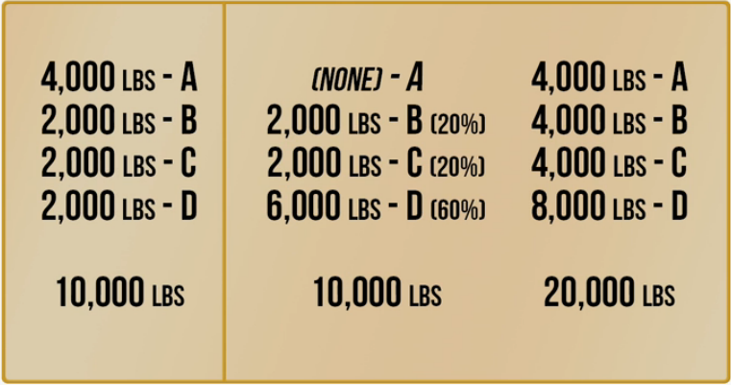
Mistake made
Added to correct
Final mixture

- Play Video (3:08 – 3:16).

- Pause at prompt (3:17 – 3:21) at “Break 5” for class discussion.

- Class discussion:

  - What question needs to be answered?
How are we going to fix this to get the correct percentages to make the blend? (We can’t throw out the entire batch and start over.)

Solution Strategies:
Mistake
Made

They would now need to reopen all of the boxes, all of the packages within the boxes, and dump all of the blends back together to be re-blended with the “correction”.

The amounts of Cheeses A, B, and C, need to be equal. Since there was already 4,000 pounds of Cheese A added to the mix, there would need to be a total of 4,000 pounds of Cheese B and Cheese C to maintain the one-to-one-to-one ratio amongst them. In order to make this happen, they would need to add an extra 2,000 pounds of each. The amount of Cheese D needs to be twice that of the other cheeses, so it needs to total 8,000 lbs. This would need to be corrected by adding 6,000 lbs more of Cheese D.

The correction and final mixture would look like the following:
Mistake made
Added to correct
Final mixture

- Play Video (3:22 – 4:09).

What additional problem does this “correction” now create?
They have an order that is twice the size of the original order that was placed. They now need to find an outlet for the additional 10,000 pounds of cheese that was blended. (Remember that cheese has a “shelf life”.)

