What Does A Huddle Have to Do with Math?

Video Link: https://youtu.be/2wMbsE0T0IU

Video Summary:
Manufacturers want to make sure that they can make quality products while still being cost efficient. Sometimes companies must make decisions to determine what machines they will run to ensure they meet their weekly production goals. Companies must consider the production output of their machines, the staff they have available to run those machines, the additional factors that go into running a second shift, the differential in pay for the workers on the second shift, and the additional pay costs associated with overtime. Decisions must be made to determine the most cost-effective method to meet the production goals for their orders. How do companies figure out what machines to run to meet their production goals?

About TIDI Products-

TIDI® Products has a history of providing forward-looking solutions to healthcare professionals—solutions that help reduce the risk of contamination and deliver the highest-quality patient care. Each day, caregivers turn to TIDI Products for a supply of user-friendly, compliance-enhancing, and risk-reducing solutions. The TIDI Products portfolio of brands includes TIDIShield®, C-Armor®, Grip-Lok®, Sterile-Z®, Posey® and Zero-Gravity®. To learn more about our company, our history, and our products, please visit www.TIDIProducts.com.

Common Core Mathematical Content Standards:

6.NS.2: Fluently divide multi-digit numbers using the standard algorithm.
6.RP.3d: Use ratio reasoning to covert measurement units; manipulate and transform units appropriately when multiplying or dividing quantities.
6.SP.B.5: Summarize numerical data sets in relation to their context.
7.RP.A3: Use proportional relationships to solve multistep ratio and percent problems.

Common Core Mathematical Practice Standards:
- Make sense of problems and persevere in solving them.
- Reason abstractly and quantitatively.
- Construct viable arguments and critique the reasoning of others.

Teacher note: Please preview the entire video and pre-work solutions in order to anticipate students’ needs, misconceptions and materials unique to your classroom.

The student work page at the end of the lesson will give students a place to jot down ideas and work through answers as they are following along with the video.
Pre-Activity Discussion
Question to ask students: How do manufacturers use goals to determine staffing? How can the company meet their goals while managing the money they spend and the workforce available?

Discussion: Manufacturing companies like TIDI Products are faced with meeting production goals while managing a budget as well as a workforce. They utilize statistics and graphic representations to track production and to make predictions based on those statistics. What are some possible statistical representations that companies could use to display their weekly production and goals? What are possible methods manufacturers could use to meet their production goals while staying on budget? (only work first shift to save on the extra pay second shift receives; eliminate overtime)

Part 1

- Play Video (0:00-1:00), pause at (1:00) to answer the discussion questions.

- The employees are trying to determine how many pieces they are short of their weekly production goal through the analyzation of statistical data showing their progress?

- Have students work through this problem. Have students share how they arrived to their answer with a peer and then have several students explain how they calculated their answer. Encourage students to ask “I wonder…” and “I noticed….” Questions of the reasoning of their peers. Discuss methods and answers as necessary.

Answers:
Total the amount produced this week: 16,000 + 21,000 + 20,500 + 19,500 = 77,000
83,000 pieces is their goal – 77,000 pieces completed = 6,000 pieces left to attain goal.
Part 2

- Play Video (1:05 – 2:24), pause at (2:24) to answer the discussion questions.

- Now that the employees know how many products the company needs to meet their weekly production goal, they need to determine which of the machines they should run during the second shift to meet their production goal.

- Have students work through this problem. Have students share how they arrived at their answer with a peer and then have several students explain how they calculated their answer. Encourage students to ask, “I wonder…” and “I noticed….” Questions of the reasoning of their peers. Discuss methods and answers as necessary.

- Machine 1 produces 6 boxes/hour with 50 pieces/box for a 10-hour shift
Answer: 6 boxes x 10 hours = 60 boxes x 50 pieces = 3,000 pieces

- Machine 2 produces 12 boxes/hour with 50 pieces/box for a 10-hour shift
Answer: 12 boxes x 10 hours = 120 boxes x 50 pieces = 6,000 pieces
So Machine 2 will allow them to meet their weekly production goal.

Extension

Use this extension question for students you believe could use the challenge.

If a worker is paid $14/hour on first shift and it takes two workers to run machine 2 and one worker to run machine 1, which staffing option is more cost effective for TIDI Products?
Option 1: Run both machines during only the first shift, paying overtime (x1.5 after 8 hours) five days a week
Answer: $14/hour for 8 hours = $112/worker
$14 x 1.5 = $21 per hour for 2 hours = $42/worker
Total per worker per 10-hour shift $154/shift
$154 x 5 days = $770/week per worker
$770 x 3 = $2310/week for three workers working 50 hours/week each
Option 1 = $2310

Option 2: Run both machines on first shift for 8 hours and only machine 2 on second shift for 8 hours? (No Overtime) for a five-day work week. Don’t forget the differential the workers receive for working second shift
Answer: $14/hour for 8 hours = $112/worker for an 8-hour first shift
$14 + $1 = $15/hour for 8 hours = $120/worker for an 8-hour second shift

$112 x 5 days = $560/week per worker on first shift
$560 x 3 = $1680/week for three workers working 40 hours/week each

$120 x 5 = $600/week per worker on second shift
$600 x 2 = $1200/week per worker on second shift

$1680 + $1200 = $2880

Option 2 = $2880

Will they meet their production goal of 83,000 pieces using both options?

Option 1: Machine 1 can run 3,000 pieces/10 hour shift
Machine 2 can run 6,000 pieces/10 hour shift

Answer: 3,000 + 6,000 = 9,000/day
9,000 x 5 days/week = 45,000 pieces/week

Option 2: Machine 1- 300 pieces/hour x 8 hours = 2,400 pieces
2,400 pieces x 5 days = 12,000 pieces/week

Machine 2- 600 pieces/hour x 8 hours = 4,800 pieces/day
4,800 pieces x 5 days = 24,000 pieces/week x 2 shifts = 48,000

Answer: 12,000 + 48,000 = 60,000 pieces/week
Neither Option 1 nor Option 2 would have met the 83,000 weekly production goal Nick set
Student Work Page

Name______________________________________

Part 1
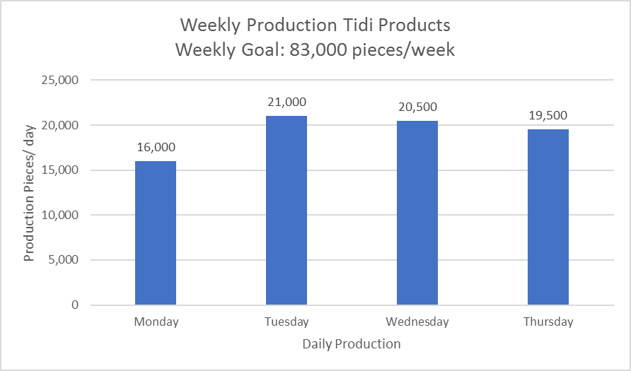
Using the Graph Nick analyzed at the HUDL Board, how many pieces are they short of their weekly production goal?

Part 2
How many pieces are they able to produce on Machine 1 in a 10-hour shift? Machine 2 in a 10-hour shift? Which machine will allow TIDI Products to meet their weekly manufacturing goal?

Extension:
If a worker is paid $14/hour on first shift and it takes two workers to run machine 2 and one worker to run machine 1, which staffing option is more cost effective for TIDI Products?
Option 1: Run both machines during only the first shift, paying overtime (x1.5 after 8 hours) five days a week

Option 2: Run both machines on first shift for 8 hours and only machine 2 on second shift for 8 hours? (No Overtime) Don’t forget the differential the workers receive for working second shift for a five-day work week

Will they meet their production goal of 83,000 pieces using both options?

