What does Quality Inspection have to do with math?

Video: https://youtu.be/pip3x18X6Pc

Video Summary:
Manufacturers need to do random sampling of their product to determine if the products they receive and ship to their customers meet the quality standards that have been contracted between the two businesses. This video highlights the mathematics utilized in the process to determine if the product meets the quality standards in the specs set up with the customer. Pete and Jeff use binomial probability distribution and random sampling to determine if the shipment meets the standards.

About TIDI Products-

TIDI® Products has a history of providing forward-looking solutions to healthcare professionals—solutions that help reduce the risk of contamination and deliver the highest-quality patient care. Each day, caregivers turn to TIDI Products for a supply of user-friendly, compliance-enhancing, and risk-reducing solutions. The TIDI Products portfolio of brands includes TIDIShield®, C-Armor®, Grip-Lok®, Sterile-Z®, Posey® and Zero-Gravity®. To learn more about our company, our history, and our products, please visit www.TIDIProducts.com.

Common Core Mathematical Content Standards:

8.EE.A.1: Know and apply the properties of integer exponents to generate equivalent numerical expressions.
8.EE.C.8.C: Solve real-world and mathematical problems leading to two linear equations in two variables.
HSN.RN.A.1: Explain how the definition of the meaning of rational exponents follows from extending the properties of integer exponents to those values, allowing for a notation for radicals in terms of rational exponents.
HSN.Q.A.1: Use units as a way to understand problems and to guide the solution of multi-step problems; choose and interpret units consistently in formulas; choose and interpret the scale and the origin in graphs and data displays.
HSS.CP.A.3: Understand the conditional probability of A given B as P(A and B)/P(B), and interpret independence of A and B as saying that the conditional probability of A given B is the same as the probability of A, and the conditional probability of B given A is the same as the probability of B.

Common Core Mathematical Practice Standards:
- Make sense of problems and persevere in solving them.
- Reason abstractly and quantitatively.
- Construct viable arguments and critique the reasoning of others.

Teacher note: Please preview the entire video and pre-work solutions in order to anticipate students’ needs, misconceptions and materials unique to your classroom.

The student work page at the end of the lesson will give students a place to jot down ideas and work through answers as they are following along with the video.

Pre-Activity Discussion
Manufacturing companies like TIDI Products are faced with quality inspection of the products they produce and ship to customers as well as products they purchase to manufacture the products they sell. To ensure they are receiving and shipping quality product, they must randomly sample product they receive and produce. Developing a quality sample that is unbiased is essential in calculating the percent of product to meet the specs set up between the companies.

Part 1

- Play Video (0:00-1:51), pause at (1:51) to answer the discussion questions.

- Brad and Pete are trying to determine if their customer will accept the product they ship if 10% of the boxes contain a smudge and therefore considered defective.

- Pete will use the binomial distribution formula to determine the percent of the total order is defective if the Probability falls between 0 and 1.

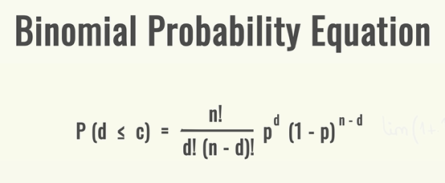
- Use the Binomial Probability Distribution Formula

The variables in the Binomial Probability Equation can determine the probability of the shipment to the customer meeting the quality standards and being accepted.
n = sample size
c = acceptance number
d = number of items defective or “wonky”
p = percent defective
If the given sample has the given values,
p = .10
n = 25
c = 1
P(d) = 1 and P(d) = 0

Determine the Probability using the Binomial Probability Distribution Formula if d = 1 and d = 0. Using the formula calculate the P(d=1) and P(d=0)

Populate the formula with the given values of p, n, and c when P(0) and P(1).

Answer:

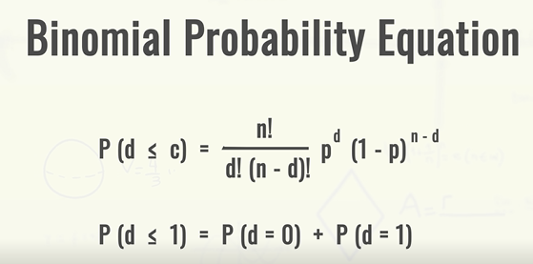

Part 2

- Play Video (1:51- 2:21), pause at (2:21) to give students an opportunity to determine an answer to the problems.
- If 10% of the product is defective, does this meet the quality standards set up by the customer?
- Have students work through this problem. Have students share how they arrived at their answer with a peer and then have several students explain how they calculated their answer. Encourage students to ask, “I wonder…” and “I noticed….” Questions of the reasoning of their peers. Discuss methods and answers as necessary.

Answers:

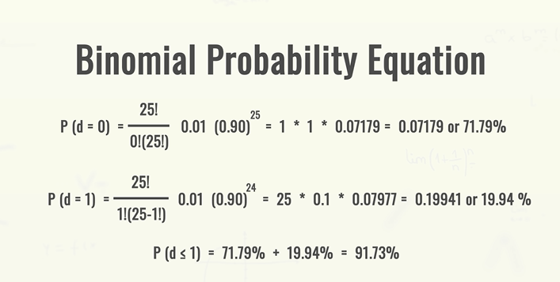

Part 3

- Play Video (2:21-3:24), pause at (3:24) to give students an opportunity to determine an answer to the problem.
- Pete must complete a sample for a load of cartons that TIDI products is purchasing, can you help Jeff and Pete determine if the shipment meets their quality standards?
- To determine this Pete and Jeff need to take a Representative Sample. What is a Representative Sample?

Answer:
A Representative Sample is a sample that covers a wide distribution of the product that is random and unbiased. To do this you take samples of the product from the beginning, middle and end of the lot to ensure a quality sample.

Student Work Page

Name______________________________________

Part 1
Brad and Pete are trying to determine if their customer will accept the product they ship if 10% of the boxes contain a smudge and therefore considered defective. Pete will use the binomial distribution formula to determine the percent of the total order is defective if the Probability falls between 0 and 1.

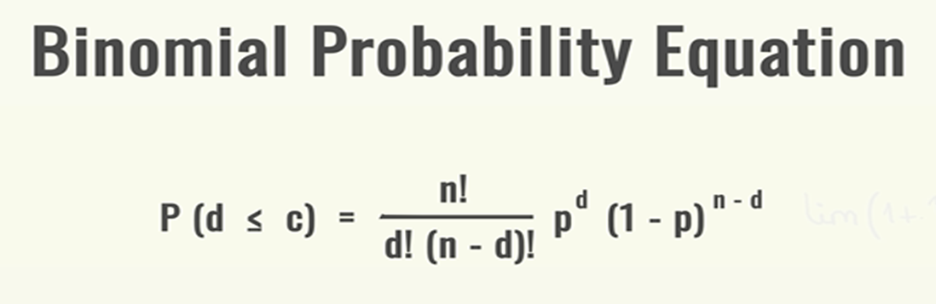

The variables in the Binomial Probability Equation can determine the probability of the shipment to the customer meeting the quality standards and being accepted.
n = sample size
c = acceptance number
d = number of items defective or “wonky”
p = percent defective

If the given sample has the given values,
p = .10
n = 25
c = 1
P(d) = 1 and P(d) = 0

Determine the Probability using the Binomial Probability Distribution Formula if d = 1 and d = 0. Using the formula calculate the P(d=1) and P(d=0)

Populate the formula with the given values of p, n, and c when P(0) and P(1).

Part 2
If 10% of the product is defective, does this meet the quality standards set up by the customer? Solve the formula for P(d=0) and P(d=1).

Part 3:

Pete must complete a sample for a load of cartons that TIDI products is purchasing, to do this Jeff and Pete must determine if the shipment meets their quality standards. To determine this, they need to take a Representative Sample. What is a Representative Sample?

