What does a surge tank have to do with math?

Video Link: https://youtu.be/-Rc0FHDuNq8

Lesson Plan

Teacher Note: Please preview the entire video and pre-work the questions in order to anticipate students’ needs, misconceptions, and materials unique to your classroom.

You will also need to determine the background knowledge of your students regarding the following topics and decide the best method for providing that background in order to support the conceptual understanding of the mathematics shown in the video.

- Using volume formulas for cylinders and cones
- Using rates to understand and solve problems
- Converting from one unit type to another

Common Core Mathematical Content Standards

- 6.RP Understand ratio concepts and use ratio reasoning to solve problems.
- 8.G Solve real-world and mathematical problems involving volume of cylinders, cones, and spheres.
- G-GMD Explain volume formulas and use them to solve problems.

Common Core Mathematical Practice Standards

1. Make sense of problems and persevere in solving them.
2. Reason abstractly and quantitatively.
3. Attend to precision.

Company Information

At Werner Electric Supply, our story is defined by progress. From our modest beginnings in 1948, we have grown to serve the needs of our loyal customers and valued partners. While 400+ employees now provide diverse, high quality products and services for businesses throughout the entire state of Wisconsin, Michigan’s Upper Peninsula, and North Dakota, it all started with just one man in a small shop in Neenah Wisconsin.

Today, we offer over $30-million in inventory made up of 24,000 SKUs in our state-of-the-art, 250,000-square-foot warehouse and offices. As a key partner to our customers in all areas of business, Werner Electric strives to provide service that goes above and beyond expectations from 13 locations and counting. With growth based on the needs of our customers and partners, we are dedicated to long-term growth as an independent B2B distributor with customizable solutions that make a difference for those with whom we work.

Summary

Companies that work with fluids such as beverages and syrups require a large number of automated processes that aid in quality, safety, efficiency, and cost. The development of a new bottling line, for instance, often involves consultation with a process engineer who will advise them. This involves understanding a complex system and the various measurements involved in the process. In this video we will act as the consultant and determine the necessary measurements to advise our customer.

Differentiation

- The questions on the student handout are scaffolded to meet the needs of students who may need extra support.
- Eliminating some of the background information such as formulas or conversion factors would be a possible strategy for those who may need more of a challenge.
- A diagram of a surge tank is given, but for some it may be better to ask them to draw it.
- Students may also benefit from working with others while investigating the problem.

Pre-Activity Discussion

- This video opens with a discussion between a customer and a Werner Electric Supply engineer. They are discussing a surge tank for a bottling line. Systems like these have a variety of components and variables to understand. Pipe length, pipe diameter, pump pressure, liquid pressure, temperature, liquid level, air pressure, flow rate, and tank size are several of these.
- Discuss this and help students develop a list of these variables. They could do this through group discussions and/or drawings.
- Discuss possible reasons why the volume would not have been known on the surge tank.
- Using the provided vocabulary discuss the purpose of a surge tank.
- If necessary review unit conversions and volume.
- It is worth noting that some values will be rounded and then used in other calculations. The error is negligible as the values are used for baseline estimates. Due to the variability of the system, the numbers will never completely match the real situation.
- Vocabulary
- Surge Tank – A holding vessel between the point where fluid is distributed and the point where the fluid is filled into containers. When fluids are in motion and a process needs to change or stop, the fluids will continue to move for a time. A surge tank allows for fluids to have a place to go as the dynamics of the system change. The level in the tank will vary, but with careful monitoring can be maintained at a pre-determined level.
- Setpoint – This is the liquid level that will be maintained in the surge tank. This is often given as a percentage and is determined by the needs of the system with the help of an engineer. It is common to maintain the level at 50% of the tank capacity.

Information Needed to Solve:

- Diagram of the surge tank which is a cylinder connected to a cone.

- Dimensions of the tank.

- Inside radius of tank = 22.6 inches

- Inside height of tank = 72 inches

- Cylinder height = 54 inches

- Cone height = 18 inches

- Volume of a Cylinder =

- Volume of a Cone =

- 1 cubic foot = 12³ cubic inches

- 1 cubic foot = 7.48052 gallons

- 1 gallon = 128 ounces

Part 1 (0:00 – 2:20)

BREAK 1

- Have students revisit and discuss the purpose of a surge tank and record their ideas in part one of the student handout.
- Discuss as a whole group if needed.
- Students should label the diagram of the surge tank with the given dimensions.
- Have students determine the volume of the tank to the nearest cubic inch.

Part 2 (2:26 – 3:04)

BREAK 2

- Have students convert the volume to cubic feet rounded to the nearest hundredth.
- With this information, students should determine how many gallons the surge tank will hold rounded to the nearest hundredth.
- Have students convert the number of gallons to ounces rounded to the nearest hundredth.

Part 3 (3:10 – 4:08)

BREAK 3

- Students will need to recognize that there is extraneous information in the question posed. They should then calculate the number of 12 ounce bottles that can be filled in one batch. Keep in mind that the tank is only 50% full of product.

- Optional Bonus Questions (Most students should complete)
- The filler can complete 600 bottles per minute. What is the rate in gallons per minute that soda is being drawn from the surge tank?
- How long will the filler need to operate to complete a batch size of 208.4 gallons, using 12 ounce bottles, at 600 bottles per minute?

Part 4 (4:13 – 5:07)

- Discuss any final thoughts regarding the situation.
- Move on to extension questions if appropriate.

Extension

- While the batch is being removed and the filler prepared for the next batch the surge tank will be filling up. How long will it take for the tank to be full if the flow rate does not change considering it was half full when the batch was completed?
- What must the system that provides soda to the surge tank do in order to provide enough time to safely make the switch for the next batch? Keep in mind that it is usually not preferred to stop the flow of product in the system.
- When the filler begins to operate again, the surge tank may be quite a bit more than 50% full if not properly balanced at setpoint. Describe what must happen to bring the system back to 50% during the filling process.

Student Handout – What does a surge tank have to do with math? Name(s):

Pre-Activity Discussion: Notes on necessary background information.

Problem: What is the volume of the surge tank and how many bottles can be filled?

Break 1

- Discuss the purpose of a surge tank with others and record your thoughts here.

- Label the diagram of the surge tank with the given dimensions.

- Determine the volume of the tank to the nearest cubic inch.

Break 2

- Convert the volume to cubic feet rounded to the nearest hundredth.

- With this information determine how many gallons the surge tank will hold rounded to the nearest hundredth.

- Convert the number of gallons to ounces rounded to the nearest hundredth.

Break 3

- Calculate the number of 12 ounce bottles that can be filled in one batch. Keep in mind that the tank is only 50% full of product.

- Bonus Questions

- The filler can complete 600 bottles per minute. What is the rate in gallons per minute that soda is being drawn from the surge tank?

- How long will the filler need to operate to complete a batch size of 208.4 gallons, using 12 ounce bottles, at 600 bottles per minute?

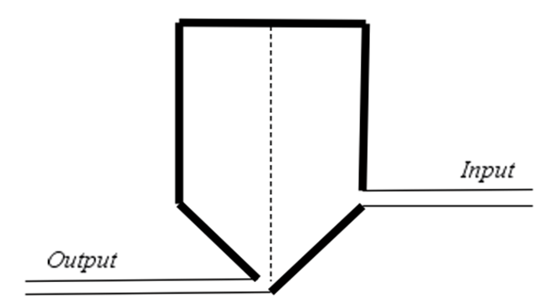
Surge Tank

Answer Key – What does a surge tank have to do with math?

Pre-Activity Discussion: Notes on necessary background information.

Problem: What is the volume of the surge tank and how many bottles can be filled?

Break 1

- Discuss the purpose of a surge tank with others and record your thoughts here.

Answers will vary.

Sample: To provide space for fluid changes in the system and to protect the system from damage due to constant changes and variation within the system.

- Determine the volume of the tank to the nearest cubic inch.
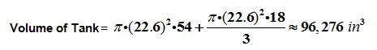

Break 2

- Convert the volume to cubic feet rounded to the nearest hundredth.

- With this information determine how many gallons the surge tank will hold rounded to the nearest hundredth.

- Convert the number of gallons to ounces rounded to the nearest hundredth.

Break 3

- Calculate the number of 12 ounce bottles that can be filled in one batch. Keep in mind that the tank is only 50% full of product.

which is 2,222 complete bottles

- Bonus Questions

- The filler can complete 600 bottles per minute. What is the rate in gallons per minute that soda is being drawn from the surge tank?

gallons per minute

- How long will the filler need to operate to complete a batch size of 208.4 gallons, using 12 ounce bottles, at 600 bottles per minute?

minutes

Surge Tank
22.6”
18”
54”

