What does a tank simulation have to do with math?

Video Link: https://youtu.be/sqrEx9e810M

Lesson Plan

Teacher Note: Please preview the entire video and pre-work the questions in order to anticipate students’ needs, misconceptions, and materials unique to your classroom. It is highly recommended to review the video and lesson plan titled “What does a surge tank have to do with math?” The tank simulation lesson is a continuation of the surge tank video and requires the context that was provided by the initial surge tank lesson. Students should complete the surge tank lesson prior to doing this one.

It is also important to note that the vocabulary and the context of the problem are at a high level of understanding. Mathematically the work is not particularly challenging, but it may take some time to develop a clear picture of the situation for students.

You will also need to determine the background knowledge of your students regarding the following topics and decide the best method for providing that background in order to support the conceptual understanding of the mathematics shown in the video.

- Using ratios and percentages to understand and solve problems
- Understanding period and frequency when working with a sine function
- Understanding the idea of calculating area under a curve (without calculus)

Common Core Mathematical Content Standards

- 6.RP Understand ratio concepts and use ratio reasoning to solve problems.
- 7.RP Analyze proportional relationships and use them to solve real-world and mathematical problems.
- F-TF Model periodic phenomena with trigonometric functions

Note: Although the mathematics done in this lesson meets 6th and 7th grade standards, the topic and the context of the material discussed is at a higher grade level. Specifically, this lesson involves discussions about trigonometric functions and the integral in calculus.

Common Core Mathematical Practice Standards

1. Make sense of problems and persevere in solving them.
2. Reason abstractly and quantitatively.
3. Attend to precision.

Company Information

At Werner Electric Supply, our story is defined by progress. From our modest beginnings in 1948, we have grown to serve the needs of our loyal customers and valued partners. While 400+ employees now provide diverse, high quality products and services for businesses throughout the entire state of Wisconsin, Michigan’s Upper Peninsula, and North Dakota, it all started with just one man in a small shop in Neenah Wisconsin.

Today, we offer over $30-million in inventory made up of 24,000 SKUs in our state-of-the-art, 250,000-square-foot warehouse and offices. As a key partner to our customers in all areas of business, Werner Electric strives to provide service that goes above and beyond expectations from 13 locations and counting. With growth based on the needs of our customers and partners, we are dedicated to long-term growth as an independent B2B distributor with customizable solutions that make a difference for those with whom we work.

Summary

Companies that work with fluids such as beverages and syrups require a large number of automated processes that aid in quality, safety, efficiency, and cost. The development of a new bottling line, for instance, often involves consultation with a process engineer who will advise them. This involves understanding a complex system and the various measurements involved in the process. This video demonstrates the need to understand how a PID controller works and how to calibrate it correctly. A process engineer will discuss the situation and the thought process for what he does.

Differentiation

- The questions on the student handout are scaffolded to meet the needs of students who may need extra support, however, it may be necessary to spend extra time during the pre-activity discussion.
- Upper level students may benefit from researching the mathematics behind the PID controller as it involves calculus.
- Extension questions have been provided for students who may need to go beyond the video.
- Students may also benefit from working with others while investigating the problem.

Pre-Activity Discussion

- This video is a continuation of the Werner Electric Supply video “What does a surge tank have to do with math.” The previous lesson discusses a surge tank for a bottling line. Systems like these have a variety of components and variables to understand. Pipe length, pipe diameter, pump pressure, liquid pressure, temperature, liquid level, air pressure, flow rate, and tank size are several of these. The current lesson involves the use of a PID controller to maintain and monitor the level of the fluid in the surge tank. A process engineer will walk students through the related vocabulary and discuss the use of simulation software. Students will discuss proportional gain and integral as it applies to tuning the controller.

- Using the provided vocabulary review and discuss the purpose of a surge tank.
- Students will need some discussion about proportional gain. When a new setpoint is entered an error is created between the actual fluid level and the new level we would like. The PID controller will send an output signal to the system for a one time correction of that error. The proportional gain acts as a scalar that amplifies the error depending on the needs of the system.

Ex. Assume that the level in the tank is 47% and a setpoint of 50% is entered while the gain is set at 2. The error is 3% but that will be multiplied by the gain of 2. This will cause the controller to output 6% beyond the setpoint or 56%.

- Regardless of the gain, a single proportional correction alone is typically not sufficient to bring the system into balance. The system will overshoot or undershoot its target. Additional corrections are made using integral correction. There is no need to actually calculate an integral as we might in calculus. The PID controller continually assesses the total error during time intervals and outputs additional adjustments to the system. This error over time is the area under the curve as shown in the graphic provided in the lesson.
- Students may need to be reminded of the difference between period and frequency when looking at a periodic function like a sine function. In the video students are asked to find the number of minutes per repeat, but in the lesson they are also asked to find the number of repeats per minute. Some PID controllers use frequency and others use period.

- Vocabulary
- Surge Tank – A holding vessel between the point where fluid is distributed and the point where the fluid is filled into containers. When fluids are in motion and a process needs to change or stop, the fluids will continue to move for a time. A surge tank allows for fluids to have a place to go as the dynamics of the system change. The level in the tank will vary, but with careful monitoring can be maintained at a pre-determined level.
- Setpoint – This is the liquid level that will be maintained in the surge tank. This is often given as a percentage and is determined by the needs of the system with the help of an engineer. It is common to maintain the level at 50% of the tank capacity.
- PID Control – Proportional, Integral, Derivative control. This is an electronic unit that allows a professional to regulate a system to maintain balance around a predetermined level.
- Error – The difference between the intended level and the actual level. These are referred to as the Set Point (SP) and the Process Variable (PV)

Error = SP – PV

- Proportional Gain – The scale factor that is used to allow the controller output to move in proportion to the error between SP and PV. This is usually designated by the variable K

Control output = K*(SP-PV)

- Integral – This term comes from calculus and is the industry term that represents the sum of all errors produced during a given time interval. Integral correction allows for greater balance in the system when tuned properly.
- Tuning – The process by which Proportional Gain and Integral values are determined and programmed into the PID for best performance.
- Steady State Offset – Condition where the level comes into balance at some point other than the set point because there is no integral correction.

Information Needed to Solve:

- Diagram of the surge tank which is a cylinder connected to a cone.

- The set point for the system is at 50%.

- Graphic that shows error over time as represented as the area under the curve. (figure 1)

- The increase in gain causes the system to oscillate and reach a maximum every 8.57 seconds.

- Graph of the oscillating function that shows the frequency or peak to peak measurement. (figure 2)

Part 1 (0:00 2:01)

BREAK 1

- Have students discuss and list any factors throughout the bottling system that might affect the level in the tank.

- Now that it has been determined that the set point will be 50%. Have students determine what the control output will be if the actual fluid level is at 55% and the gain is set to 3.

Part 2 (2:01 – 3:30)

BREAK 2

- Students should use figure 1 to determine the error between the process variable and the setpoint at each time.

- t = 10 minutes
- t = 42 minutes
- t = 70 minutes
- t = 90 minutes

- Students should now determine the scale factor that reduces the error over each of the following time intervals.

- t = 10 min. to t = 42 minutes
- t = 42 min. to t = 70 minutes

Part 3 (3:32 – 5:33)

BREAK 3

- Although not requested in the video, students should use the graph in figure 2 to determine the frequency or number of cycles per minute as some PID controllers use this value instead.

- Students should now determine the number of minutes per repeat.

- Students should use the suggested guidelines to suggest a value for the integral in minutes per repeat that could be entered into the PID controller.

Extension

- Calculate the following related to the sine function in figure 2 in the lesson::

- The period of the function in minutes per beat.
- According to the graph what is the approximate amplitude of the first peak?
- Use the amplitude and period to write an equation for f(t) where t is the time in minutes and f(t) gives the level in the tank relative to the set point. A sine function with only a phase shift and change in amplitude will not cause a dampening effect on the peaks. Experiment/research ways to cause this to happen with your graph as in figure 2.

- Find out what an Integral is in Calculus? Why does this term make sense for our situation?

- Research further about PID controls. What do the P, I, and D refer to in the controller and what are they actually doing?

- Research process engineering and describe some of the work done in that field.

Figure 1

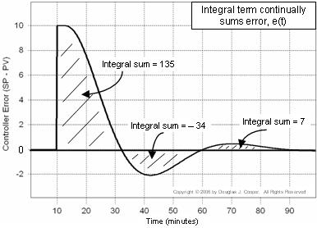

Figure 2

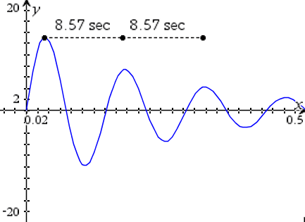

Student Handout – What does a tank simulation have to do with math? Name(s):

Pre-Activity Discussion: Notes on necessary background information.

Problem: Determine the effects of proportional gain and determine the proper integral value for a PID controller

Break 1

- Discuss and list any factors throughout the bottling system that might affect the level in the tank.

- Now that it has been determined that the set point will be 50%, determine what the control output will be if the actual fluid level is at 55% and the gain is set to 3.

Break 2

- Use figure 1 to determine the error between the process variable and the setpoint at each time?

- t = 10 minutes

- t = 42 minutes

- t = 70 minutes

- t = 90 minutes

- Now determine the scale factor that reduces the error over each of the following time intervals.

- t = 10 min. to t = 42 min.
- t = 42 min. to t = 70 min.

Break 3

- Before answering the question in the video, use the graph in figure 2 to determine the frequency or number of cycles per minute as some PID controllers use this value instead.

- Now determine the number of minutes per repeat.

- Use the suggested guidelines to suggest a value for the integral in minutes per repeat that could be entered into the PID controller.

Surge Tank
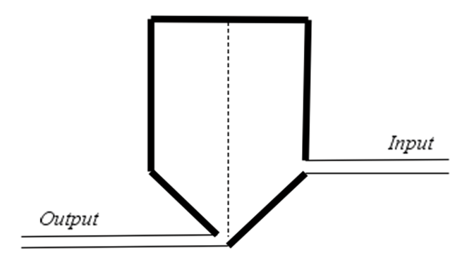

Figure 1

Figure 2

Answer Key – What does a tank simulation have to do with math?

Pre-Activity Discussion: Notes on necessary background information.

Problem: Determine the effects of proportional gain and determine the proper integral value for a PID controller

Break 1

- Discuss and list any factors throughout the bottling system that might affect the level in the tank.

Answers will vary. Possible factors may include: Number of bottles to fill, error in filling, variability of the pump, temperature changes, change in flow input or output made by the operator etc.

- Now that it has been determined that the set point will be 50%, determine what the control output will be if the actual fluid level is at 55% and the gain is set to 3.

Because the fluid level is currently above the setpoint, the controller output will be less than the setpoint. The current error of 5% will be scaled by a factor of 3 to give 15% error below the setpoint.

The control output will be 35%

Break 2

- Use figure 1 to determine the error between the process variable and the setpoint at each time?

At t = 10 minutes the error is 10%
At t = 42 minutes the error is 2%
At t = 70 minutes the error is .5%
At t = 90 minutes the error is nearly 0%

- Now determine the scale factor that reduces the error over each of the following time intervals.

Between t = 10 minutes and t = 42 minutes the error decreases from 10 to 2. gives a scale factor of

Between t = 42 minutes and t = 70 minutes the error decreases from 2 to .5. gives a scale factor of

Break 3

- Before answering the question in the video, students use the graph in figure 2 to determine the frequency or number of cycles per minute as some PID controllers use this value instead.

60 ÷ 8.57 ≈ 7 repeats per minute

- Now determine the number of minutes per repeat.

1 minute for every 7 repeats is 0.14 minutes per repeat

- Use the suggested guidelines to suggest a value for the integral in minutes per repeat that could be entered into the PID controller.

.8 x 7 = 5.6 repeats per minute
This is 1 minute for every 5.6 repeats or a value of 0.1785 minutes per repeat

(Note: Multiplying .8 times 0.14 would actually increase the number of beats per minute)

Surge Tank

Figure 1

Figure 2

