What does a Bathroom Remodel have to do with Math?
Video: https://youtu.be/wh205XKaZ50
Lesson Plan
Teacher Note: Please preview the entire video and pre-work the solutions in order to anticipate students’ needs, misconceptions and materials unique to your classroom.
You will also need to determine the background knowledge of your students regarding the following topics and decide the best method for providing that background in order to support the conceptual understanding of the mathematics shown in the video.
- Area of squares, rectangles and triangles
- Order of Operations
- The student handout shows a floor plan with a grid and scale noted.
- The teacher handout offers floor plan options that could be used to modify the student handout, including no grid, just the closet, and just the powder room.

Common Core Mathematical Content Standards
- 6.G.1 – Find the area of right triangles, other triangles, special quadrilaterals, and polygons by composing into rectangles or decomposing into triangles and other shapes; apply these techniques in the context of solving real world and mathematical problems.
- 7.G.6 – Solve real-world and mathematical problems involving area, volume and surface areas of two and three dimensional objects composed of triangles, quadrilaterals, polygons, cubes and right prisms.
- HS - Modeling

Common Core Mathematical Practice Standards
1. Make sense of problems and persevere in solving them.
2. Model with mathematics.
3. Attend to precision.

Company Information
Since 1873, Kohler Co. has been improving the level of gracious living by providing exceptional products and services for our customers’ homes and their lifestyles. We believe better business and a better world go hand-in-hand. Watch Our World video. Whether that is beautiful kitchen and bath products, innovative engines and generators, memorable hospitality offerings or developing clean water, sanitation, and community development solutions around the world. To put it simply, we strive to enhance the quality of life for current and future generations through design, craftsmanship and innovation, fueled by the passion of more than 36,000 associates worldwide.
Summary
The Kohler designers have handed you a floor plan for the new bathroom. The customer is excited for you to get started…but, first we need to order the materials for the job! In this video, you will help the team figure out the carpet, tile and paint needs for a bathroom remodel.
Pre-Activity Discussion:
- When remodeling a bathroom what are some things that would normally be upgraded, or changed?
- Discuss how carpet is bought by contractors and consumers…by the square foot.
- Use the student handout to preview the bathroom floor plan and answer any background questions. What is a “Powder Room”? What do the shapes represent in the floor plan?
- Take time to have students label the measurements on the drawing for the dimensions of the closet, powder room area and whole bathroom.
  - Closet: long walls 6ft by 6ft, short walls are 3ft long. (the diagonal wall length is not needed or can be calculated later as part of an extension of the problem)
  - Powder Room: 7 ft by 5 ft
  - Bathroom: 16 ft by 12 ft
  - Doors: 3 ft wide and 7 ft tall
  - Ceilings: 8 ft tall
  - Windows: 2 ft by 2 ft

Differentiation:
- The questions on the student handout are scaffolded to meet the needs of students who may need extra support.
- Eliminating some of the added questions, and just posing the questions from the video would be a possible differentiation strategy for students who do not need the extra support.
- Students may also benefit by working with others as part of a partner/group investigation.
Part 1: (0:00 – 0:54)
BREAK 1
- Problem posed: How much carpet will be needed for the floor of the closet?
- Information given
  - The closet has a wall that is on a diagonal.
  - The area of the closet can be determined by calculating the area of a square and subtract the area of a triangle. Discuss other ways this area could have been calculated.
  - This first part only asks for the area of the square. Part 2 below asks students to finish the calculations by finding the area of the triangle and then subtracting.
- Have students use part one of student handout to document their calculations and thinking.
- Before showing Part 2, have students share their solution methods for the area of the square.

Part 2: (0:55 – 1:10)
BREAK 2
- Discuss the solution from Part 1 and any calculation errors or misconceptions
- Problem posed: How much carpet is covering the floor in the closet? (Carpet will only be used in the closet area).
  - Students are asked to finish the calculations by finding the area of the triangle and then subtracting the area of that triangle from the area of the square.
  - A question on the student handout asks students to determine if carpet ordered is equal to carpeted area of the closet.
- Before showing Part 3 have students share their answers and problem solving methods.

Part 3: (1:11 – 1:30)
BREAK 3
- Discuss the solution from Part 2 and any calculation errors or misconceptions
- Problem posed: How much tile will be needed for the rest of the bathroom floor?
- Before showing Part 4, have students share their answers and problem solving methods.

Part 4: (1:31 – 2:05)
- Discuss the solution from Part 3 and any calculation errors or misconceptions
- Problem posed: How many gallons of paint are needed for the ceiling?
- Information given:
  - 1 gallon of paint can cover 250 square feet.
  - The paint used for the walls and the paint used for the ceiling will be different
  - Two coats of paint are needed
- Before showing Part 5, have students share their answers and problem solving methods.

Part 5: (2:06 – 2:33)
- Discuss the solution from Part 4 and any calculation errors or misconceptions
- Problem posed: How many gallons of paint are needed for the POWDER ROOM walls?
- Students may ask if they should subtract the area of the window and door. This question is a great way to introduce extensions to this task.
  - “If the window and door are not painted, how does that change the amount of paint needed?”
  - The solution for this extension is not in the video.
- Before showing Part 6, have students share their answers and problem solving methods.

Part 6: (2:34 – 3:14)
- Discuss the solution from Part 5 and any calculation errors or misconceptions.

Extension:
- If the all the bathroom walls were painted with the same wall paint as the powder room, how many gallons of paint would be needed?
- If the size of the tile for the bathroom floor is 9 inches by 9 inches, how many tiles would be needed for the bathroom? What would be the most efficient way to lay the tile so that the fewest number of cuts would need to be made?
- Research costs of flooring and paint and the cost of labor for both and get an estimate for this bathroom remodel.
- Use the Pythagorean Theorem to find the length of the diagonal wall of the closet.
- Develop your own bathroom remodel project. Measure your own bathroom. Create a drawing and elect your own materials.

Answer Key What does a Bathroom Remodel have to do with math?
Pre-Video Discussion: Notes on important background information, vocabulary and measurements on the diagram below.
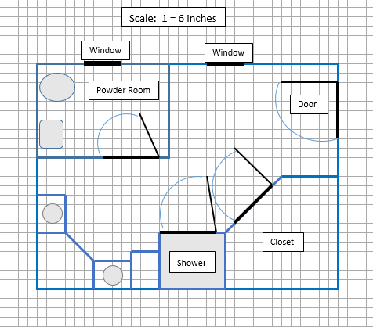

Break 1: Problem: How much carpet will be needed for the floor of the closet?

1. In the video, the man states, “We can find the area of the carpet needed by finding the area of a square and subtracting the area of a triangle.” Explain his thinking. Use the picture below to help you.

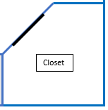 Create a square by extending the sides, the portion that was created extra is a right triangle. The triangle legs are 3 ft. long.

2. Calculate the area of the square (in square feet). Label your drawing and show your work.
6 ft x 6 ft = 36 sq. ft

Break 2: Problem: How much carpet will be needed for the floor of the closet?

3. Calculate the area of the triangle.

½ bh = ½ 3x3 = 4.5 sq. ft.

4. What is the area of the closet?

36 sq. ft – 4.5 sq. ft = 31.5 sq. ft

5. Is there a difference in how much carpet is on the floor of the closet, versus how much carpet will need to be ordered? Explain your thinking.

It depends if the customer wants the closet floor to be one solid piece of carpet (then 36 sq. ft. will need to be ordered), or if cutting and gluing carpet pieces together is acceptable.

Break 3: Problem: How much tile will be needed for the rest of the bathroom floor?

6. Calculate the solution to the problem. Show your work.

total bathroom floor area – area of closet
16 ft x 12 ft = 192 sq. ft
192 sq. ft – 31.5 sq. ft = 160.5 sq. ft

Break 4: Problem: How many gallons of paint are needed for the bathroom ceiling?

7. Calculate the solution to the problem. Show your work.

Ceiling of bathroom = 192 sq. ft
192 x 2 for two coats = 384 sq. ft
384 sq. ft divided by 250 sq. ft per gallon = 1.54 gallons
2 gallons will need to be purchased

Break 5: Problem: How many gallons of paint are needed for the POWDER ROOM walls?

8. Calculate the solution to the problem. Show your work.

2 walls x 7ft long x 8 ft tall = 112 sq. ft
2 walls x 5ft long x 8 ft tall = 80 sq. ft
192 sq. ft of wall space x 2 coats of paint = 384 sq. ft
384 sq. ft divided by 250 sq. ft per gallon = 1.54 gallons
2 gallons will need to be purchased

EXTRA DIAGRAMS

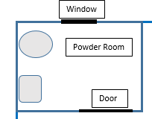

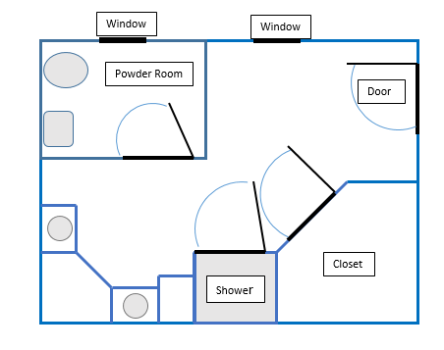

Student Handout - What does a Bathroom Remodel have to do with math?
Name(s):
Pre-Video Discussion: Notes on important background information, vocabulary and measurements on the diagram below.

Break 1: Problem: How much carpet will be needed for the floor of the closet?

1. In the video, the man states, “We can find the area of the carpet need by finding the area of a square and subtracting the area of a triangle.” Explain his thinking. Use the picture below to help you.

2. Calculate the area of the square (in square feet). Label your drawing and show your work.

Break 2: Problem: How much carpet will be needed for the floor of the closet?

3. Calculate the area of the triangle.

4. What is the area of the closet?

5. Is there a difference in how much carpet is on the floor of the closet, versus how much carpet will need to be ordered? Explain your thinking.

Break 3: Problem: How much tile will be needed for the rest of the bathroom floor?
6. Calculate the solution to the problem. Show your work.

Break 4: Problem: How many gallons of paint are needed for the bathroom ceiling?

7. Calculate the solution to the problem. Show your work.

Break 5: Problem: How many gallons of paint are needed for the POWDER ROOM walls?

8. Calculate the solution to the problem. Show your work.

