What does math have to do with a Military Vehicle?
Video: https://youtu.be/pkhwaIiDk1Q
Lesson Plan
Teacher Note: Please preview the entire video and pre-work the solutions in order to anticipate students’ needs, misconceptions and materials unique to your classroom.
You will also need to determine the background knowledge of your students regarding the following topics and decide the best method for providing that background in order to support the conceptual understanding of the mathematics shown in the video.
- Force and (free body) diagrams
- Right triangle trigonometry
- Torque

Common Core Mathematical Content Standards
  - G.SRT.8 Use Trigonometric ratios and the Pythagorean Theorem to solve right triangles in applied problems.
  - High School Math Modeling standard

Common Core Mathematical Practice Standards
1. Make sense of problems and persevere in solving them.
2. Reason abstractly and quantitatively.
3. Model with mathematics.
4. Use appropriate tools strategically.

Company Information
At Oshkosh Defense, we stand behind those who dedicate their lives to protecting others. As a tactical vehicle manufacturer, every day we strive to meet or exceed our customers’ ever-changing needs with next-generation defense technologies and advanced systems. We operate with unparalleled commitment to those who depend on our products and services worldwide to perform their missions and return home safely.
Summary
Mathematics and Physics combine to make this Get Real Math video double trouble for the employees on the video. They want to be certain that the military vehicle they are designing has both maximum capabilities and maximum safety. Can you help them?
Pre-Activity Discussion:
- Vocabulary
  - Wheelbase
  - Center of gravity
  - Grade of terrain
  - Static equilibrium equation - to be in static equilibrium the forces (or moments) have to add to 0.
  - Magnitude is distance without direction (positive)
  - Moment (torque)
    - Sum of force (pounds or Newtons) * distance (feet or meters) when force is perpendicular to distance
    - The center of gravity will be used for the axis for rotation.
    - A clockwise rotation about the axis is considered a positive direction and a counterclockwise rotation is considered a negative direction.
Differentiation:
- The questions on the student handout are scaffolded to meet the needs of students who may need extra support.
- Eliminating some of the added questions, and just posing the questions from the video would be a possible differentiation strategy for students who do not need the extra support.
- Students may also benefit by working with others as part of a partner/group investigation.

Part 1: (0:00 – 1:35)
BREAK 1
- Problem posed: What information will be needed in order to calculate how much weight sits on the rear tires at a given grade (steepness)?
- Have students use part one of student handout to document their brainstorming.
- Before showing Part 2, have students share their ideas.

Part 2: (1:36 – 2:14)
BREAK 2
- Problem posed: How much weight would be on the vehicles rear tires as the vehicle is driving up the incline?
- Information needed or given
  - JLTV vehicle weights 17,000 lb.
  - Assume the front and rear wheels produce the same forward thrust
  - JLTV Wheelbase is 11 feet.
  - Center of gravity is 5 feet behind the front tires.
  - Center of gravity height is 6 feet.
  - Grade of the terrain is 30 percent
- Students are asked to answer the question on the student handout.

- Answer:
0 = (Fxf * C.G.y) + (Fxr * C.G.y) + (Fyf * C.G.x) – ( Fyr * (11 – C.G.x))

0 = (Fxf+ Fxr) * 6ft + (16283 – Fyr)lb. * 5ft – (Fyr lb. * 6ft)

0 = 4885lb * 6ft + 81415 ftlb - 5Fyr - 6Fyr

11ft * Fyr lb = 110725ftlb

Fyr = 10066 lb.

- Before showing Part 3 have students share their answers and problem solving methods.

Part 3: (2:18 –3:07)
- Discuss the solution from Part 2 and any calculation errors or misconceptions.
- Extension problem posed: How does the incline impact the braking capabilities of the JLTV?

Extension:
- See above.
- If the vehicle is driving down the incline, will that change to set up of the problem and its solution?

Student Handout - What does a Military Vehicle have to do with Math?
Name(s):
Pre-Video Discussion: Notes on important background information.

Break 1: Problem: What information would you need to know in order to calculate how much weight sits on the rear tires at a given grade (steepness)?
1.
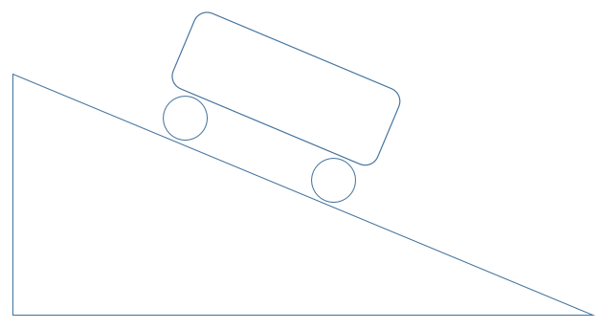

Break 2: Problem: How much weight would be on the vehicle’s rear tires?

2. Use the information from #1 above and the information that was given to you to calculate a solution to the problem.

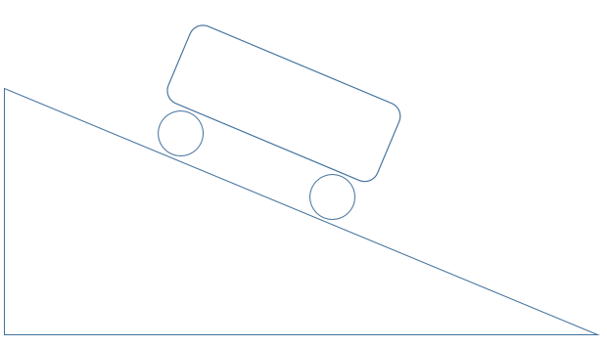

Answer Key What does a Military Vehicle have to do with math?

Problem: How much weight would be on the vehicle’s rear tires?

- Information needed or given
  - JLTV vehicle weights 17,000 lb.
  - Assume the front and rear wheels produce the same forward thrust
  - JLTV Wheelbase is 11 feet.
  - Center of gravity is 5 feet longitudinal behind the front tires.
  - Center of gravity has a height of 6 feet.
  - Grade of the terrain is 30 percent

tan θ = 30/100 θ= 16.7 degrees

Fxtotal / 17000 = sin 16.7
(Fxf + Fxr )/17000 = sin 16.7
(Fxf + Fxr) = 4885 lb.

Fytotal /17000 = cos 16.7
Force in lbs. in y direction
θ
(Fyf + Fyr)/17000 = cos 16.7
(Fyf + Fyr) = 16,283 lb
17000 lb
We are solving for Fyr so Fyf = (16283 – Fyr)

This drawing is to find theta

Force in lbs. in x direction
Front
θ
X

C.G.
Fxf lb

17000lb
Fy
Fxr lb
Fyf lb
Fx
30ft
Y
Fyr lb

θ
100ft

This drawing is to find the torque equation
Front
6ft
11ft
5ft
C.G.
X

Fxf lb
6 ft
Fxr lb
Fyf lb
Y
Fyf lb
30ft

θ
100ft

Front and rear torque diagrams (force * distance (magnitude) when perpendicular)
Fxf or 2442.5lb Fxr or 2442.5lb

C.G.y or 6ft C.G.y or 6ft

C.G.x or 5ft (11- C.G.x) or 6ft

Fyf or (16283 – Fyr) Fyr

- To find equilibrium, set the torque equation equal to zero and solve for Fyr
- The longitudinal force (Fx) causes all four wheels to rotate around the C.G. axis in the same direction.
- The vertical force (Fy) causes the front wheels and rear wheels to rotate around the C.G. axis in opposite directions.

0 = (Fxf * C.G.y) + (Fxr * C.G.y) + (Fyf * C.G.x) – ( Fyr * (11 – C.G.x))

0 = (Fxf+ Fxr) * 6ft + (16283 – Fyr)lb. * 5ft – (Fyr lb. * 6ft)

0 = 4885lb * 6ft + 81415 ftlb - 5Fyr - 6Fyr

11ft * Fyr lb = 110725ftlb

Fyr = 10066 lb

