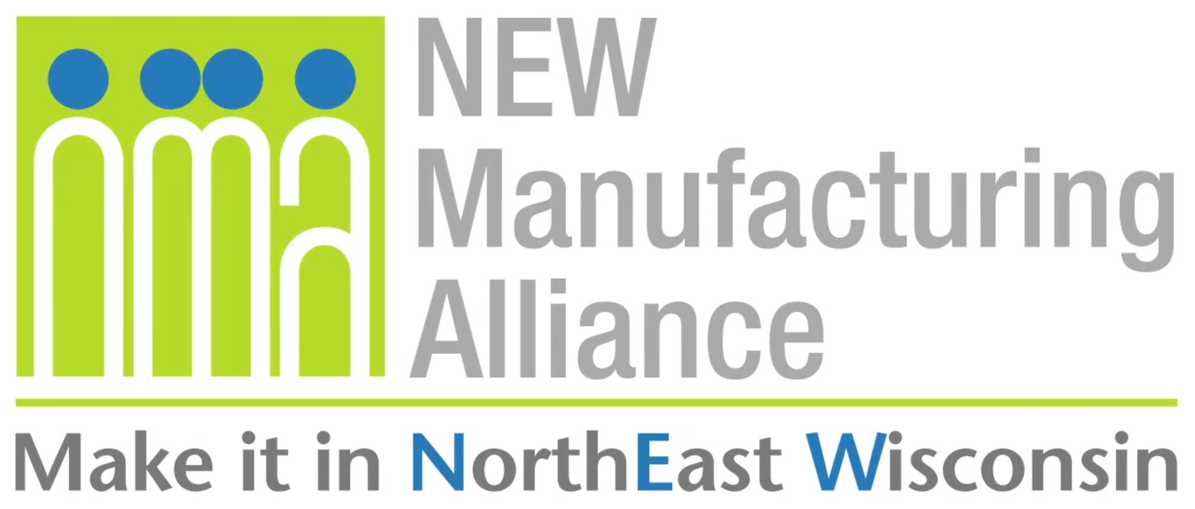

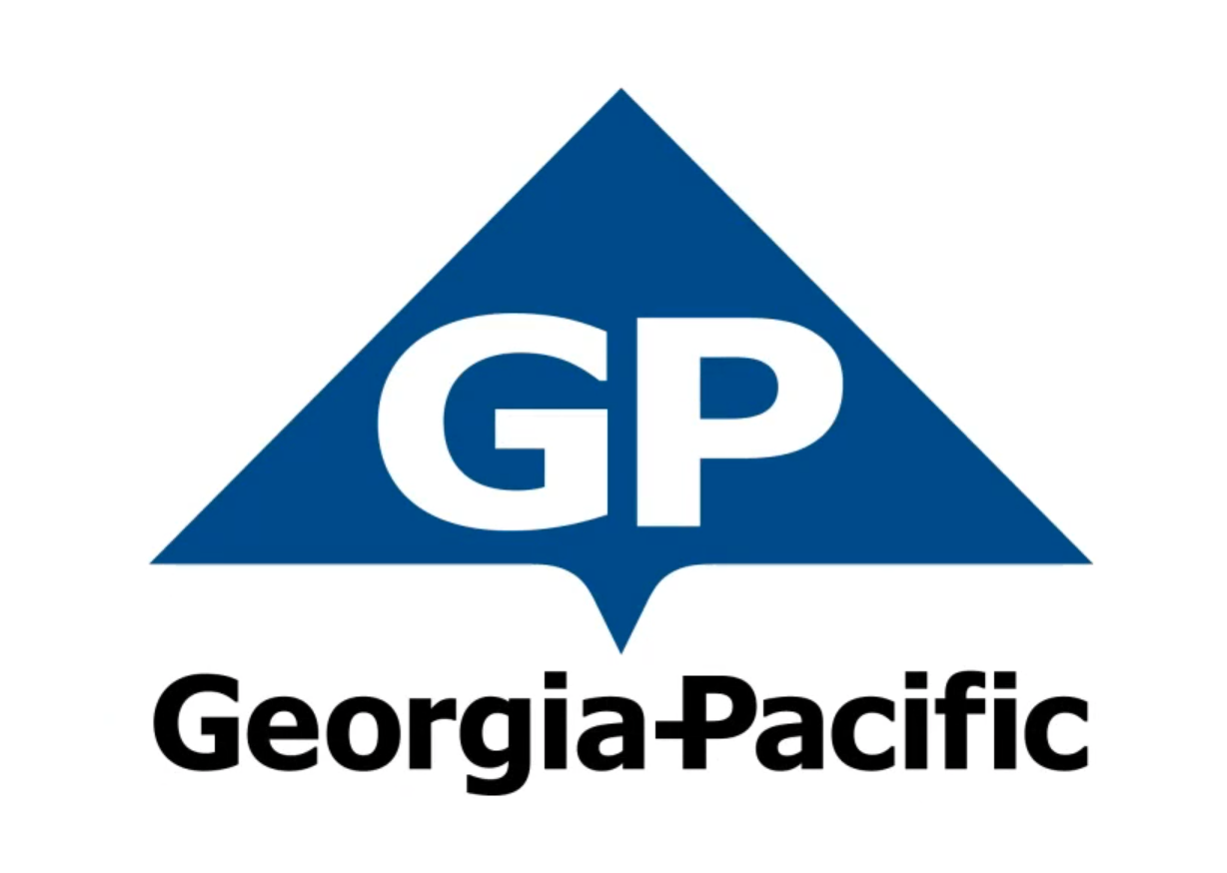
Company Background
With approximately 300 facilities across North America, South America and Europe, Georgia-Pacific is one of the world's leading manufacturers and marketers of bath tissue, paper towels and napkins, tableware, paper-based packaging, office papers, cellulose, specialty fibers, nonwoven fabrics, building products and related chemicals. In Northeastern Wisconsin, its Green Bay facilities make nationally-known products (Quilted Northern®, Angel Soft® and Compact® bath tissue; enMotion® and SofPul® paper towels; and Vanity Fair® and Mardi Gras® napkins) and packaging is produced in Sheboygan and Oshkosh. Each year, GP's Ecosourceä facility in Green Bay recycles nearly 100,000 tons of wastepaper - equal to 1.7 million trees - and saves 5 million cubic feet of landfill space. In addition, its Neenah-based research and development laboratory, iNNOVATION institute®, constantly develops creative and innovative products, and tests them in Green Bay using the latest technology available. For more information, visit: gp.com.

Get Real Science Video Link: https://youtu.be/muyeQC6PO8c

Teacher Note
This lesson is written to accompany the above video. It is recommended that you watch the entire video in advance. This will help you to anticipate student misconceptions and questions and prepare ways to support their sense making.

If this is the first time that you are using the system models and modeling with your students, take the time to review the Next Generation Science Appendix F section on developing and using models for appropriate grade level expectations.

Lesson Summary
In this lesson students will develop models to develop understanding of the paper recycling process and the important role that they play in conserving and recycling our natural resources.

Standards Alignment
Next Generation Science Standards Performance Expectations
5-ESS3-1 Obtain and combine information about ways individual communities use science ideas to protect
the Earth’s resources and environment.
MS-ESS3-3 Apply scientific principles to design a method for monitoring and minimizing a human impact on the
environment.
HS-ESS3-4 Evaluate or refine a technological solution that reduces impacts of human activities on natural
systems.

Science & Engineering Practices | Disciplinary Core Ideas | Crosscutting Concepts
Analyzing & Interpreting Data  Obtaining, Evaluating, & Communicating  Information  Constructing Explanations & Designing  Solutions | ESS3.C Human Impacts on Earth Systems  ETS1.B: Developing Possible Solutions | Patterns  Systems and System Models  Cause and Effect

Materials
US Municipal Solid Waste Data Charts (printed or projected)
Student Notebooks
Whiteboards or Chart Paper

Procedure
- Ask students to think about the waste that they make at home and at school. Ask them to identify the types of materials that make up that waste (food scraps, plastic bottles, paper, aluminum cans, cardboard, etc.)
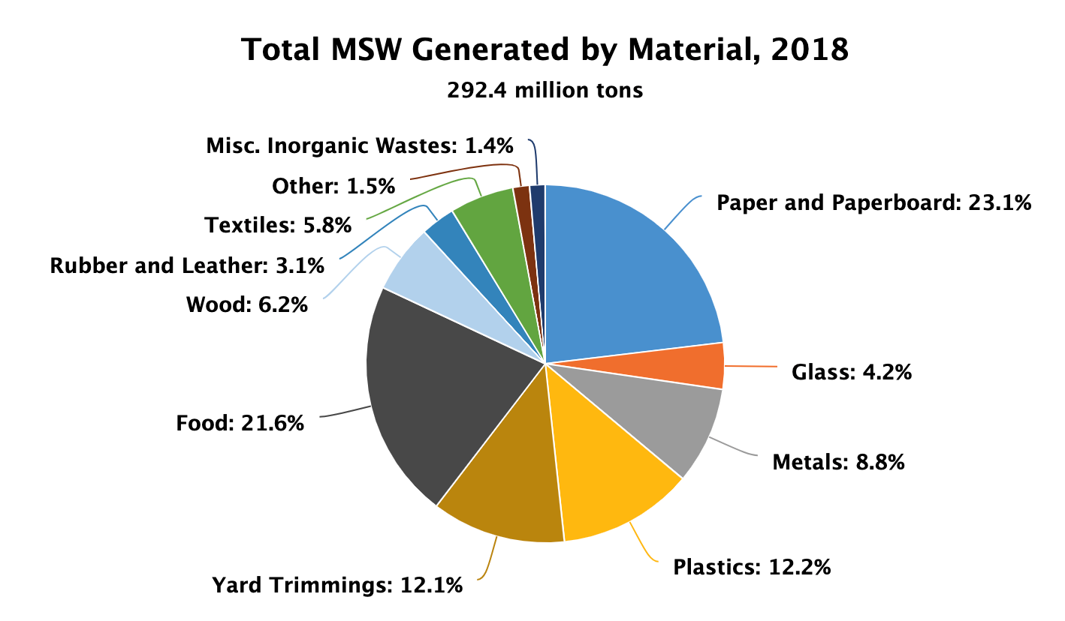
- Show students the pie graph of the US Municipal Solid Waste data from 2018 (EPA).

- Ask them to discuss with a classmate the similarities and differences they see here compared to where they think their waste generation falls. Are there categories that they did not think of? Are the amounts close or really different than what they generate?

- Ask students to consider where their waste ends up. How much of it do they recycle? Where does the rest go?

- Show the students the pie graph of the US Municipal Solid Waste Management data from 2018 (EPA).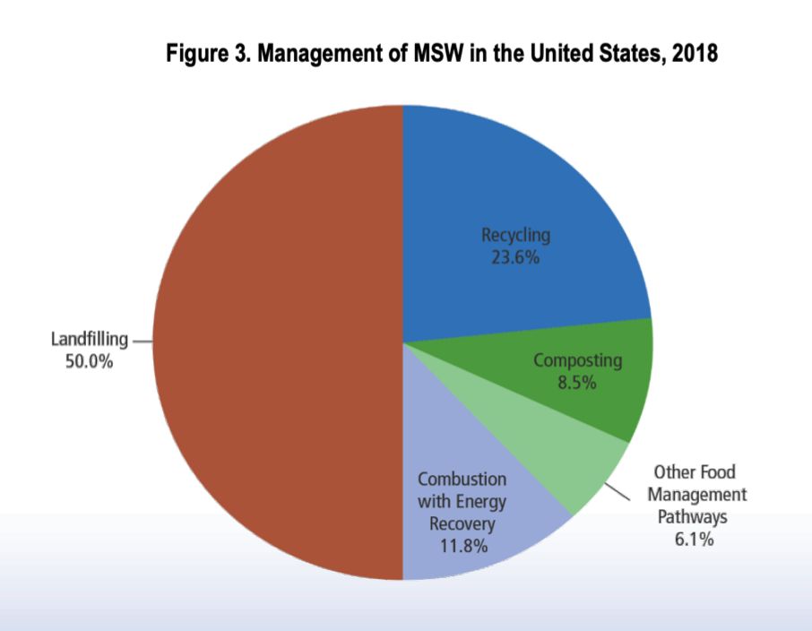

- Again ask them to discuss with a classmate. Does this data fit with what they thought was happening to it? Are there some management options that they did not consider?

- Ask students to think about the types of materials that can be recycled. Which materials do they think are recycled the most?

- Show the students the pie graph of the US Municipal Solid Waste Recycling data from 2018 (EPA).
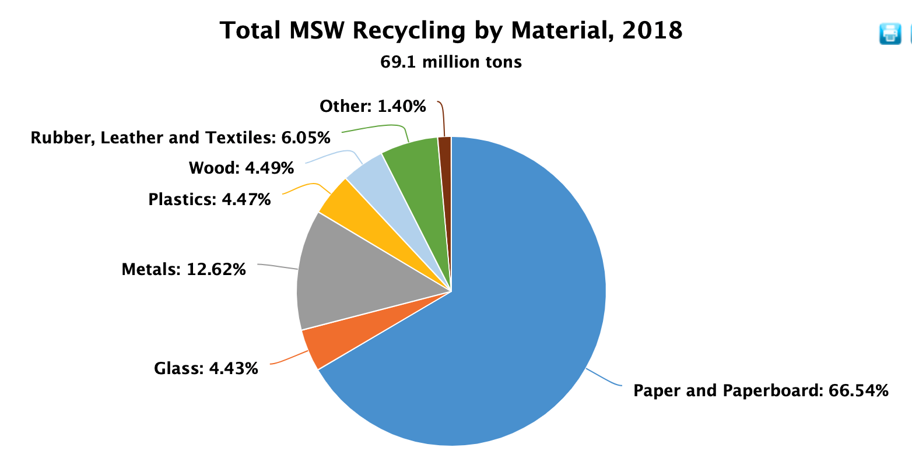

- Ask the students if any of the data are surprising to them. Have them explain both what and why it is surprising.

- Tell the students that we will be exploring the recycling process that is used by Georgia Pacific to turn our waste paper into new products. Play the Get Real Science Video: What does science have to do with recycling? Up to the first break. (0:00 - 2:37).

- In the video Chris has explained the start of the recycling process. That involves many steps of taking our waste and preparing it to be manufactured into a new paper product. To help student make sense of this process, ask them to watch the video again up to break 1 and record all of the steps that it takes to prepare a semi of waste paper and turn it into pulp that can be used once again in the paper making process.

- In small groups have students compare their lists to compile a shared, agreed upon list of the steps.

- Students should then construct a model that uses pictures, symbols, and words to show the process visually. They can do this on whiteboards or chart paper. Students should represent inputs into the system or their system model, as well as outputs of waste and the material that will be converted into new paper products.
- Now play the remainder of the video (2:37 - 5:38). Here students learn about the manufacturing of a new product from the recycled paper pulp.

- Ask students to once again identify the steps in the papermaking process by watching the video again. They should begin by listing the steps and then in their groups, create a second model that shows the process with pictures, symbols & words, also depicting the inputs and outputs.

- When the student models are complete. Have each group display their models side by side with the processing of the waste. Provide time for students to review and explore the models made by the other groups.

- At the completion of the sharing of models, ask students to identify similarities and differences between the model that they created and those made by their classmates. Allow students time to make revisions to their models if they wish.

- Finally, as a class, discuss the combination of the two models. Ask students to think about how the two parts (processing the waste paper, and making new paper products) fit together. Have the students consider the inputs and outputs of each. See if they can recall from the video any of the destinations for the other outputs. Discuss why it might be most beneficial to find uses for all of the outputs. Ask them where they would put themselves on their model. Discuss the important role of consumers in closing the loop by recycling their waste paper and purchasing products made from recycled materials.

Extension
Ask students to answer Chris’s question posed at the end of the video. Have them take another product or materials and research what it takes to recycle it and what it might be turned into. Look to see if there is a manufacturer in your community that recycles those materials. Invite them to join your class in an online discussion or possible field trip.

Data and graphs from United States Environmental Protection Agency, Advancing Sustainable Materials Management: 2018 Fact Sheet.

