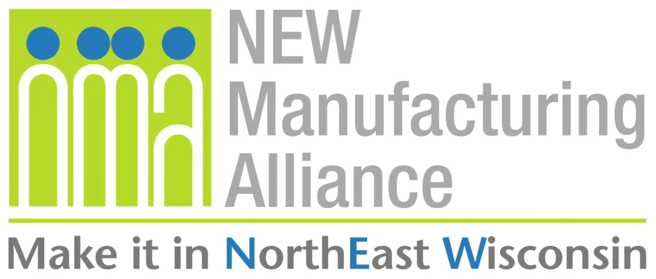
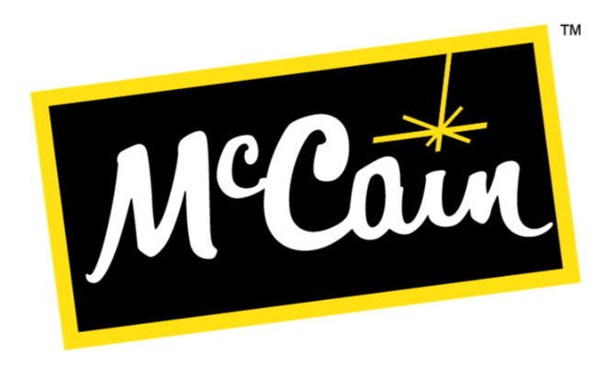
Company Background
McCain Foods is a global business that has been creating great tasting food for over 60 years! As a privately owned family company with sales in over 160 countries and a global team of 22,000 people, our values are at the heart of everything we do. Our people, product quality, and customer dedication are at the core of our business. The McCainFoods, Appleton facility makes appetizers such as mozzarella cheese sticks, jalapeno poppers, and pickle fries. This location also recycles food waste generated during production with the use of a local digester. Almost all other waste is also recycled, resulting in very minimal waste to the landfill. For more information, visit www.mccain.com.

Get Real Science Video Link: https://youtu.be/fgp3mR7tVpM

Teacher Notes
This lesson is written to accompany the above video. It is recommended that you watch the entire video in advance. This will help you to anticipate student misconceptions and questions and prepare ways to support their sense making.

If this is the first time that you are using the engineering design process with your students take the time to review the full Grades 3-5th Engineering Design NGSS Standards or MS Engineering Design NGSS Standards.

Lesson Summary
In this lesson students will develop and use models to explain the impacts of batter that is too thin or too thick in the manufacturing of McCain’s Mozzarella Cheese Sticks. They will then use the engineering design process to develop, test, and refine a method to test the viscosity batter.

Standards Alignment
Next Generation Science Standards Performance Expectations
5-PS1-3 Make observations and measurements to identify materials based on their properties.
3-5-ETS1-1 Define a simple design problem reflecting a need or a want that includes specified criteria for
success and constraints on materials, time, or cost.
3-5-ETS1-2 Generate and compare multiple possible solutions to a problem based on how well each is likely to meet
the criteria and constraints of the problem.
3-5-ETS1-3 Plan and carry out fair tests in which variables are controlled and failure points are considered to identify
aspects of a model or prototype that can be improved.
Science & Engineering Practices | Disciplinary Core Ideas | Crosscutting Concepts
Planning & Carrying Out Investigations  Asking Questions & Defining Problems  Constructing Explanations & Designing  Solutions | PS1.A Structure & Properties of Matter  ETS1.A Defining and Delimiting  Engineering Problems  ETS1.B Developing Possible Solutions  ETS1.C Optimizing the Design Solution | Cause and Effect  Scale Proportion and Quantity  Systems and System Models  Structure and Function

Materials
Student Notebooks Batter Mixtures (Flour & Water)
Whiteboard or Chart Paper Mixing bowl & whisk or fork
Wide variety of potential measuring materials (Straws, paper or plastic cups, graduated cylinders, etc.)

Batter Recipe Recommendations
Be sure to mix the batter completely using a whisk or fork to break up any lumps that may form.

Too Thick | Too Thin | Just Right
1 part water to 2 parts flour | 2 parts water to 1 part flour | 1 part water to 1 part flour

Procedure
- Ask your students if they have ever helped to make pancakes. Following the recipe is important when mixing ingredients to make sure that you do not add too much or too little of anything. Pancake batter that has too much liquid might be too runny. Too little liquid and it might be too thick. Have the students make predictions with a partner about what the pancakes might look like with too much or too little liquid.

- As a full class, have students share what they thought might happen to the pancakes.

- Explain that they will be exploring another food product and how it is made. Play the video up to the first break (0:00 - 1:34).

- Ask the students how our example of the pancakes is similar and different to the example of the mozzarella cheese sticks.

Examples of possible student responses…
Similarities | Differences
Both examples describe food | The pancakes are made at home
Both examples talk about the thickness of batter | The mozzarella sticks are make in a factory
Both examples must be cooked | The pancakes are only made of batter
When the recipes are not followed carefully the food might not cook right | The mozzarella sticks also have cheese in them

- In the video they used the word viscosity to describe the thickness of a liquid. The higher the viscosity, the thicker the liquid. The actual definition describes a fluid’s resistance to flow. It is determined by the internal friction between molecules of a liquid. Ask your students to brainstorm some examples of liquids with high and low viscosity. Students can record these examples in their notebooks.

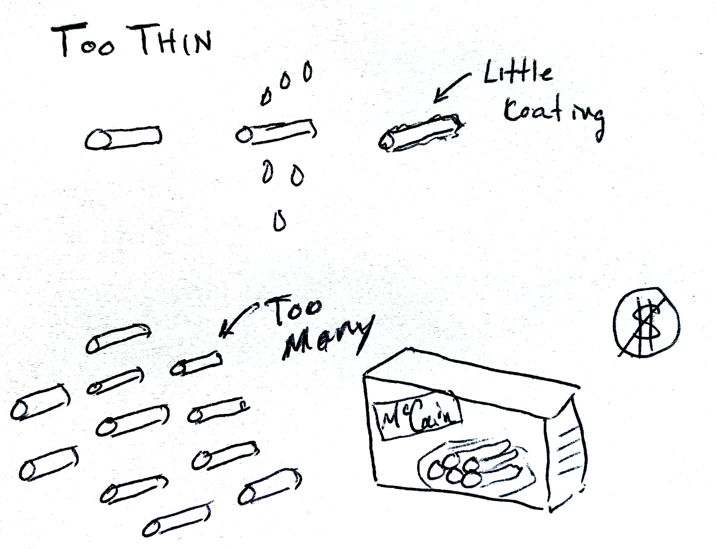
- They also described some of the negative impacts of getting the viscosity wrong; too thick or too thin. Split the class into an even number of groups. Have half of them think about the consequences of the mozzarella batter being too thick. Have the other half of the groups think about the consequences of the batter being too thin. Students may wish to rewatch the video up to the first break to catch some of the ideas that were given.

- Ask each group to select one of their consequences and draw a model to be able to explain why that consequence occurs (An example is provided below). The models are a great way to help all students to make sense of the impact of the batter being too thick or too thin. This will help them to understand why getting viscosity right is important. Student models can be initially recorded in their notebooks and then shared with the other students on whiteboards or chart paper.

- Push them to think about the impacts beyond just the quality of the mozzarella cheese stick. Ask them to consider financial impacts for the company and the customer, as well as the other environmental impacts and mechanical challenges that arise from too much or too little batter on each cheese stick.

~~ Possible break point if you are running short on time ~~

- Play the video from break 1 to break 2 (1:34 - 1:58).

- Measuring viscosity can be done in a wide variety of ways. Tell the students that they are going to use their creativity to help design a method to help get the viscosity measurement just right for coating mozzarella cheese sticks.

- Show the students the three batter solutions that you have prepared (Too Thick, Too Thin, Just Right). Prep instructions included in the materials section of the lesson.

- Explain to the students that they must come up with a way to test the viscosity of a liquid. They will use the three prepared solutions as references during their design and testing. They will then be given an unknown solution that they must determine if its viscosity is too thick, too thin, or just right.

- Show students the materials that you have available to use in their designs. It is recommended that you do not allow students to search the internet to find ways to measure viscosity. There are many different experiments, videos, and images suggesting ways to measure viscosity. Many of them come down to timing the movement of the liquid as it is poured or timing the movement of an object dropped through the liquid in a narrow container. Provide a variety of containers including plastic or paper cups that can be cut. The actual measuring cup used by McCain Foods has a hole in the center. The flow of batter from the cup is timed. Too fast and it is too thin. Too slow and it is too thick.

- In small groups, ask the students to think through their designs before starting to build and test. Using chart paper or whiteboards, they should draw sketches that show how the viscosity test will be performed.

- Before students are allowed to begin building and testing their designs, ask them to explain the test to you or another group of students. Pressing them for the explanation requires them to think it through more thoroughly.

- Provide supplies and time for students to construct and test their designs with the three reference solutions.

- After the preliminary test, ask students to refine their designs if they need to make modifications to make it work better. Students should document their changes on their original drawings.

- Provide the students with an unknown sample to test using their design. Remind students to test it multiple times and document their results to verify their tests.

- Students should make a claim about the unknown batter solution (Too Thick, Too Thin, or Just Right). Remind them to use their data as evidence to support their claim.

- Play the remainder of the video (1:58 - 2:29).

- Have each of the groups share their designs and the results of their unknown tests.

