Get Real Science Video Link: https://youtu.be/ouEKPbm3t3w

Company Background: Since 1979, Plexus has been partnering with companies to create the products that build a better world. With a team of over 19,000 individuals, they are dedicated to providing Design and Development, Supply Chain Solutions, New Product Introduction, Manufacturing and Aftermarket Services. Plexus is a global leader that specializes in serving customers in industries with highly complex products and demanding regulatory environments. Plexus delivers customer service excellence to leading companies by providing innovative, comprehensive solutions throughout a products lifecycle.

Teacher Note
This lesson is written to accompany the above video. It is recommended that you watch the entire video in advance. This will help you to anticipate student misconceptions and questions and prepare ways to support their sense making.

Lesson Summary
In this lesson students will explore an analogy that helps them to troubleshoot a problem in an electric circuit. They will then use computer simulations to reconstruct the problem and test other solutions.

Standards Alignment
Next Generation Science Standards Performance Expectations
4-PS3-2 Use evidence to construct an explanation relating the speed of an object to the energy of that
object.

4-PS3-4 Apply scientific ideas to design, test, and refine a device that converts energy from one form to
another.

3-5-ETS1-2 Generate and compare multiple possible solutions to a problem based on how well each is likely
to meet the criteria and constraints of the problem.

HS-PS3-1 Create a computational model to calculate the change in the energy of one component in a system when
the change in energy of the other component(s) and energy flows in and out of the system are known.

HS-PS3-3 Design, build, and refine a device that works within given constraints to convert one form of
energy into another form of energy.

Science & Engineering Practices | Disciplinary Core Ideas | Crosscutting Concepts
Planning & Carrying Out Investigations  Analyzing & Interpreting Data  Constructing Explanations & Designing  Solutions  Using Mathematics & Computational  Thinking | PS3.A Definitions of Energy  PS3.B: Conservation of Energy and  EnergyTransfer | Energy and Matter  Systems and System Models  Cause and Effect

Materials
Whiteboard or Chart Paper
Devices connected to the Internet

Procedure
- Play the video up to Break 1 (0:00 - 1:11)
- Ask the students to identify and record possible reasons why an LED light might not light up in a simple circuit.
- Ask students to share their reasons with another student and look for similarities and differences in their lists.
- As a class, compile all of the student’s ideas as to what might be the problem with lighting up the LED on the circuit board.
Potential answers include:
- Not connected to a power source (battery or electric outlet)
- Bad wire connections or solder joints
- The polarity is not correct (mixed up anode (+) and cathode (-))
- The bulb is faulty. (Students may say burned out, as that is what they are used to with incandescent bulbs.)
- Too much or too little voltage.
- There is a short circuit allowing an alternative path for the current.
- The resistor is not sized properly. Too large and it will limit the current too much; too small and it will allow too much current and potentially damage the LED.
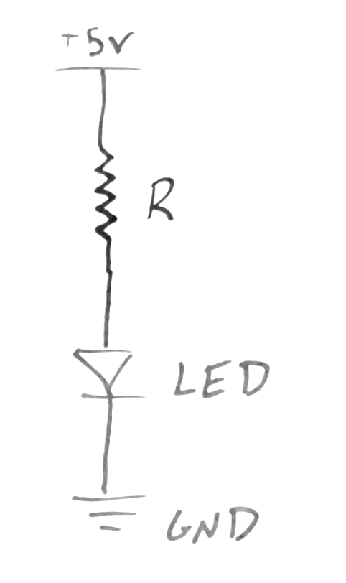
- Play the next section of the video up to break 2 (1:11 - 1:48). In this section Rachel explains how her circuit is set up by showing Ethan a diagram that includes her power supply, a resistor, the LED bulb and the ground, which completes the circuit. Ethan uses the analogy of a sprinkler.

- Remind students that if the circuit were not complete, the sprinkler at the end of the hose, like the LED at the end of the circuit, would not work.

- Ask students to identify the correlated components in this analogy. Set up a chart on the whiteboard for students to discuss and complete…

Water | Electricity
Faucet | Power Supply
Hose | Wire
Sprinkler | LED
Kink in Hose | Resistor

- Technically, the water source is the city water tower or the well pump. This is the power supply. Students may not have developed that understanding yet. But feel free to take them deeper if they are ready for it. This would make the faucet another resistor, limiting the flow of water through the hose.

- Ask them to consider the word “resistor.” Students are likely not familiar with the role of a resistor in an electric circuit. See if students can come up with the analogous feature in the water hose. In this case, rather than adding something to the hose, kinking the hose would work like a resistor limiting the water flow. In a circuit, resistors limit the current of electricity flowing through the wire. If they are not large enough, too much electricity can flow. If they are too large, not enough electricity can flow.

- Play the video up to break 3 (1:48 - 3:00).

- In this clip Rachel uses a meter to test the voltage and current. Students may have heard these words used before when discussing electricity but were not really sure what they are describing. Tell the class that we will continue with the water analogy to help them to understand how they apply to electricity.

The voltage can be thought of as the pressure of the water. In the hose analogy, the pressure comes
either from the well pump or the city’s water tower. Voltage is measured in volts and is represented in
Rachel’s equation as V.

The current in the analogy can be thought of as the volume of water flowing through the hose. The
volume is determined by the diameter of the pipes and hoses in the analogy. Electric current is
measured in Amps and is represented by the I in Rachel’s equation.

It is important to note that students are not expected to be able to calculate resistance in this equation
or even develop a deeper understanding of the vocabulary. Instead they should focus on the
applications of the concepts and the problem solving that is being used to troubleshoot the circuit.

Explain to your students that Rachel’s measurements are used to calculate the amount of resistance necessary for her current and voltage. Resistance is measured in Ohm’s. It is represented by the R in her equation. This equation is commonly referred to as Ohm’s Law. In this circuit Rachel measures the resistance of the resistor and finds out that it is too high. That means that not enough current is making it to the LED bulb

- Play the remainder of the video (3:00 - 3:40).

- Having students build circuits to simulate this situation can be a great way to deepen their understanding. If you do not have supplies there are some great online simulations that allow students to build the circuits and adjust the voltage, current, resistors, and much more. Two free resources are included below. Each has lessons and tutorials built in to help guide you and your students.
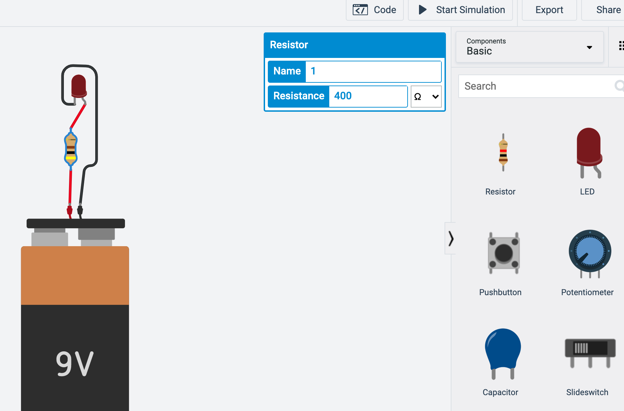

https://www.tinkercad.com/

TinkerCAD has an Ohm’s Law lesson
that opens with all of the necessary components. Students can click on the resistor to change its resistance to simulate the change made by Rachel and Ethan in the video.
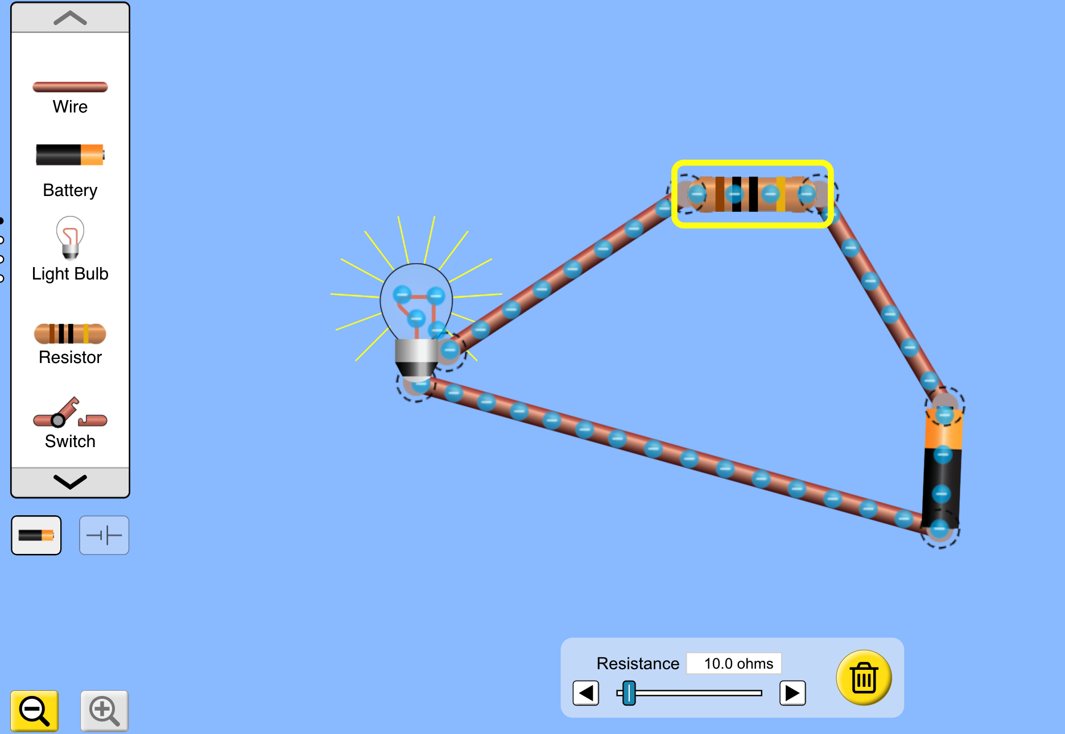

https://phet.colorado.edu/

PhET simulations has a DC Circuit Construction Kit that allows students to construct simple circuits and adjust the resistance and the voltage to experiment with the impacts.

