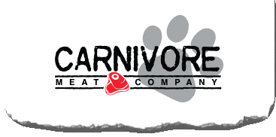
What does math have to do with the shape of dog food?
Video: https://youtu.be/UcJt_B6JtZI
Lesson Plan
Teacher Note: This video and lesson plan are a continuation of the Carnivore Meat’s Get Real Math video and lesson plan “What does math have to do with dog food?”.
Please preview the entire video and pre-work the solutions in order to anticipate students’ needs, misconceptions, and materials unique to your classroom.
You will also need to determine the background knowledge of your students regarding the following topics, and decide the best method for providing that background in order to support the conceptual understanding of the mathematics shown in the video.
  - Area of a circle
  - Area of a square
  - Volume of a cylinder
  - Volume of a prism
  - Density
  - Mass
  - pi (π)
  - Radius
  - Height
  - Inscribe
  - Order of operations
  - Solving multi-step equations

Common Core Mathematical Content Standards
- 8.NS.A Know that there are numbers that are not rational and approximate them by rational numbers.
- 7.G.4 Know the formulas for the area and circumference of a circle and use them to solve problems.
- 8.G.C Solve real-world and mathematical problems involving volume of cylinders, cones and spheres.
- G.C Understand and apply theorems about circles.
- A.CED.A.4 Rearrange formulas to highlight a quantity of interest

Common Core Mathematical Practice Standards
1. Make sense of problems and persevere in solving them.
2. Reason abstractly and quantitatively
3. Construct viable arguments and critique the reasoning of others.

Company Information
Carnivore Meat Company is an award-winning manufacturer of ultra-premium raw frozen and freeze-dried pet food and treats. The Green Bay, Wisconsin company’s rapidly growing brands include Nature’s Advantage®, Vital Essentials®, VE RAW BAR and Vital Cat®, which are distributed to over 6,000 retailers nationwide, in 14 international markets and online to Chewy.com, Amazon, PetFlow.com and others. Long considered a raw pet food pioneer, the company’s freeze-dried products division supplies private label, co-packing and ingredients to customers globally. Carnivore Meat Company is family owned and has been recognized for its growth accomplishments and manufacturing excellence with a number of awards in recent years including Wisconsin Manufacturer of the Year Award and Inc 5000 Fastest Growing Private Companies.
Summary
This video takes students through a real world problem solving process from start to finish. Students investigate the process of changing the shape of freeze-dried dog food patty from a cylinder to a square prism without changing the volume, density or weight of the patty’s materials. Will this change increase efficiency? Will this change decrease production cost?

Pre-Activity Discussion and Vocabulary:
- The company manufactures raw dog food patties that have been freeze dried
- The raw material is extruded, sliced and laid flat on a production tray to be freeze dried.
- The equipment needed for the extrusion and slicing has to be cut out and built or “machined”
- Extrusion is a process used to create objects of a specific shape by pushing material through a metal or plastic cut out.
- Machining is a process in which material (metal or plastic) is cut out so that it can produce the desired dimensions and surface finish.
- Freeze drying works by freezing the material, then reducing the pressure and adding heat to allow the frozen water in the material to change directly to a vapor.
- The patties dry on a rectangular tray that is 24 inches by 16 inches.
- The dried patties are then packaged in a re-sealable bag (as seen in the background of the video).
- Patty Data:
  - Density = 0.547 oz. /cu. Inch
  - Final wet weight (mass) = 2 ounces
  - Final volume = 3.656 cubic inches
- The cylindrical patty dimensions
  - Thickness (height) = 0.566 inches
  - Diameter = 2.868 inches
- Discuss why efficiency in manufacturing is important to both the business and the customer, and the different ways a business can be efficient (i.e. space, time, materials, cost etc.)

Differentiation:
- You may want students to make accurate physical copies of a tray, a circle, a square, and a rounded square as manipulatives.
- The questions on the student handout are scaffolded to meet the needs of students who may need extra support.
- Eliminating some of the added questions, and just posing the questions from the video would be a possible differentiation strategy for students who do not need the extra support.
- Students may also benefit by working with others as part of a partner/group investigation.

Part 1: (0:00 – 0:32)
BREAK 1
- Have students use part 1 of the student handout to document their answers to the following questions:
  - What would be the disadvantage of making the dog food patty in a cylindrical shape?
  - What would be advantages of a cylindrical shaped patty?
  - What would be the disadvantage of making the dog food patty in a square prism shape?
  - What would be advantages of a square prism shaped patty?
- Share ideas whole group before showing part 2 of the video.

Part 2: (0:36 – 1:28)
BREAK 2
- Have students use part 2 of the student handout to answer the question posed in part two of the video: What would be the height of the new square prism patty?
- Numbers to know
  - The square base of the prism should have a side measurement of 2.468 inches
  - Volume remains the same as the previous cylindrical patty (3.656 cubic inches)
  - The formula for a rectangular prism is given in the video: v = lwh
- Before showing part 3 have students share their answers and solving methods.
Part 3: (1:30 – 1:50)
BREAK 3
- Have students use part 3 of the student handout to document their answers to the following question:
  - Why would it be more challenging to extrude the dog food through a square shaped template compared to a round shape?
- Share ideas whole group before showing part 4 of the video.

Part 4: (1:55 – 2:42)
BREAK 4
- Have students use part 4 of the student handout to answer the question posed in this part of the video: What is the height of the new square patty with the rounded corners?
- Numbers to know
  - The side measurements (length and width) remain 2.468 inches
  - Volume remains the same as the previous cylindrical patty (3.656 cubic inches)
  - The corners now have a radius of 0.250 inches
  - Formula for volume of any prism: Area of a Base x Height of the prism
- Before showing Part 5 have students share their answers and problems solving methods.

Part 5: (2:45 – 3:23)
BREAK 5
- One method for finding the new height is shared in this part of the video.
  - Formula given in video: height = diameter² – π x radius²
- Ask students to use part 5 of the handout to find the height using the formula given.
- Have students discuss how the formula in the video was derived.
- Have students compare and contrast their method for finding the height with the one presented in the video.
- The solution will be shared in Part 6 of the video

Part 6: (3:27 – 4:27)
BREAK 6
- Have students use part 6 of the handout to document their solutions to the following question
  - If a tray is 16 inches by 24 inches, how many round patties are able to fit on one drying tray?
  - How many square (or with rounded corners) patties are able to fit on one drying tray?
- You may want students to make accurate physical copies of a tray, a circle and a rounded square to test out placement.
- Before showing Part 7 have students share their answers and problems solving methods.

Part 7: (4:31 – 4:47)
BREAK 7
- Have students use part 7 of the handout to document their solutions to the following question
  - If the maximum amount of patties that can fit on a drying try is 45 round patties OR 54 square patties, how much more efficient is it to produce the square shape?
- Before showing Part 8 have students share their answers and problems solving methods

Part 8: (4:51 – 5:53)
- Solution is shown

Extensions:
- Convert the measurements to metric units in order to produce and/or sell the product in other countries.
- Investigate this same process with patties of different shapes. (bone, heart, tree etc.)

Drawings from video
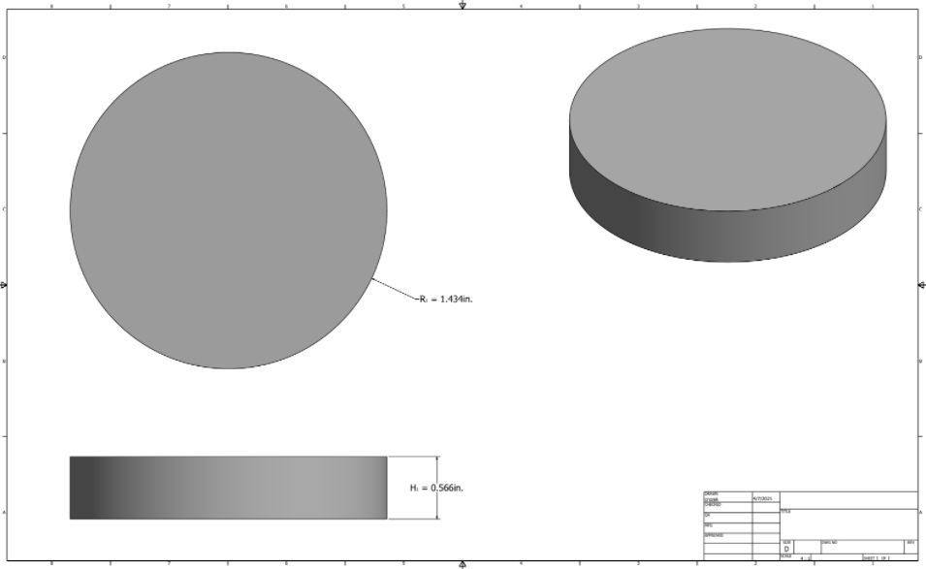

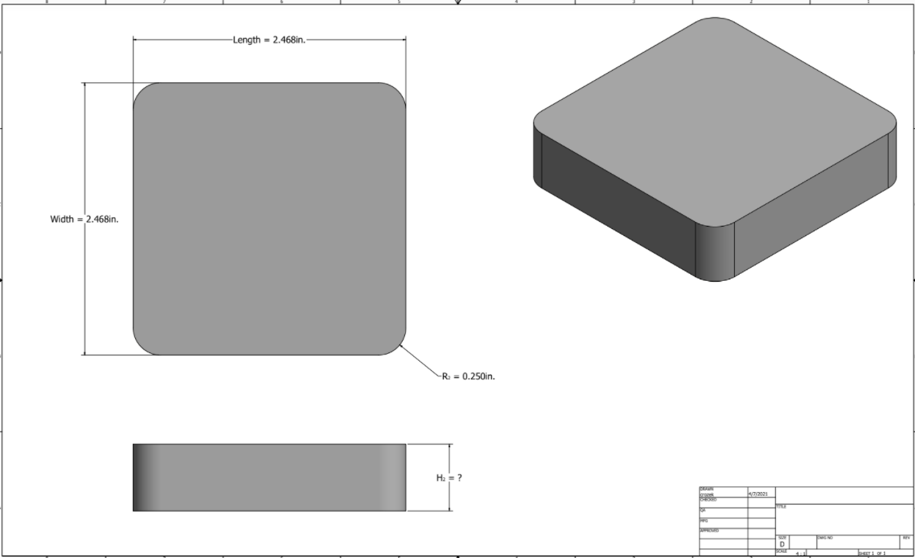

Student Handout - What does math have to do with the shape of dog food? Name(s):
Pre-Video Discussion: Notes on important background information.

Break 1:

- What would be the disadvantage of making the dog food patty in a cylindrical shape?

- What would be advantages of a cylindrical shaped patty?

- What would be the disadvantage of making the dog food patty in a square prism shape?

- What would be advantages of a square prism shaped patty?

Break 2:
- Numbers to know
  - The square base of the prism should have a side measurement of 2.468 inches
  - Volume remains the same as the previous cylindrical patty (3.656 cubic inches)
  - The formula for a rectangular prism is given in the video: v = lwh
5. What is the height of the new square prism patty? Show your thinking.

Break 3:
6. Why would it be more challenging to extrude the dog food through a square shaped template compared to a round shape?

Break 4:
- Numbers to know
  - The side measurements (length and width) remain 2.468 inches
  - Volume remains the same as the previous cylindrical patty (3.656 cubic inches)
  - The corners now have a radius of 0.250 inches
  - Formula for volume of any prism: Area of a Base x Height of the prism

7. Why is it important for the volume of the patty to stay constant while different shaped patties are tested?

8. What is the height of the new square patty with the rounded corners? Show your thinking.
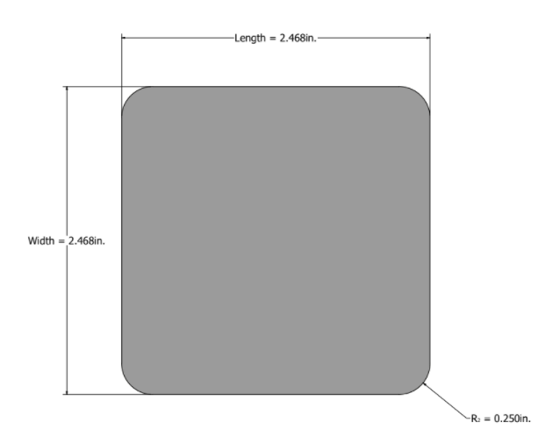

.
9. The volume of the patty stayed the same, but changing the patty from one with right angle corners, to one with rounded corners, caused the height of the patty to _____________ (increase or decrease?) by _______inches.

Break 5:
10. Use the formula given in the video to calculate the height of the patty. Show your work

11. Compare and contrast your solution method in number 7 above to your solution from number 10.

Break 6:
12. If the dimensions of a drying tray are 16 inches by 24 inches, how many round patties are able to fit on one drying tray? Draw to show your thinking.

13. How many square (or with rounded corners) patties are able to fit on one drying tray? Show your thinking.

Break 7:
14. Which shape is more efficient to manufacture?

15. How much is the increase in efficiency?

Answer Key

#1 through #4. Answers Vary

#5
V = l x w x h
3.656 cu inches = 2.468 in x 2.468 in x h
3.656 cu in = 6.091 sq in x h
3.656 cu in / 6.091 sq in = h
0.600 inches = height

#6 & #7 Answers vary

#8 The solution method below uses subtraction of areas to find the area of the base of the prism which is a square with rounded corners.

The square patty’s base is 2.468 in X 2.468 in and had an area of 6.091 sq inches.

The rounded corner patty has the same area minus the four of the corners shown by the arrow above.

Zoomed in area of the small square and inscribed circle above

0.25 in
0.5 in

0.5 in

Area of small square – area of inscribed circle = The four corner areas between the circle and square

(0.5 x 0.5) sq in – 3.1415 (0.25 ² ) sq in = The four corner areas between the circle and square

0.25 sq in – 0.1963 sq in = The four corner areas between the circle and square
0.0537 sq in = The four corner areas between the circle and square

The four corner areas between the circle and square have the same area as the four corners cut off the rounded square …so no need to divide by 4

Area of square – area of the four corners that will be cut off = area of rounded square

6.091 sq in – 0.0537 sq in = area of the rounded square

6.0373 sq in = area of the rounded square (or base of the prism)

Lastly, use formula for area of a prism and solve for the height

Volume of the patty (prism) = area of the base x height

3.656 cu in = 6.0373 sq in x height

0.606 in = height of the patty

#9 increased by 0.006 inches

#10 Diameter ² - pi x radius ²
0.5 x 0.5 - 3.1415 (0.25²) Which is the corner area to subtract from the area of the 2.468 x 2.468 square. The rest of the steps would be the same as above

#11 Answers vary

#12 Tray is 16 in by 24 in. Circle with radius of 1.43 in. has diameter 2.86 in. 24 /2.86 = 8.4 patties horizontally and 16/2.86 = 5.6 patties vertically Estimate: <47

#13 24 in / 2.468 in = 9.7 patties horizontally and 16/2.468 = 6.5 patties vertically Estimate <62 patties

Carnivore Meats uses 45 round & 54 rounded square on each tray

#14 Rounded square

#15 Find percent increase = (rounded square per tray – round per tray) / round per tray
(54 – 45)/ 45 = 0.2 or 20%

