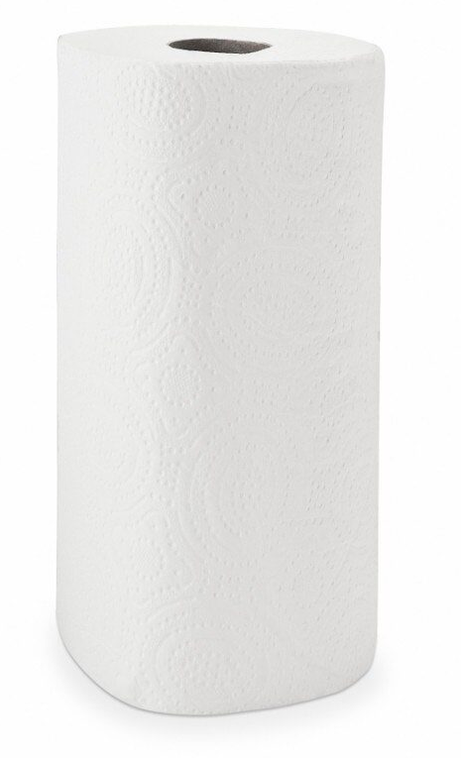
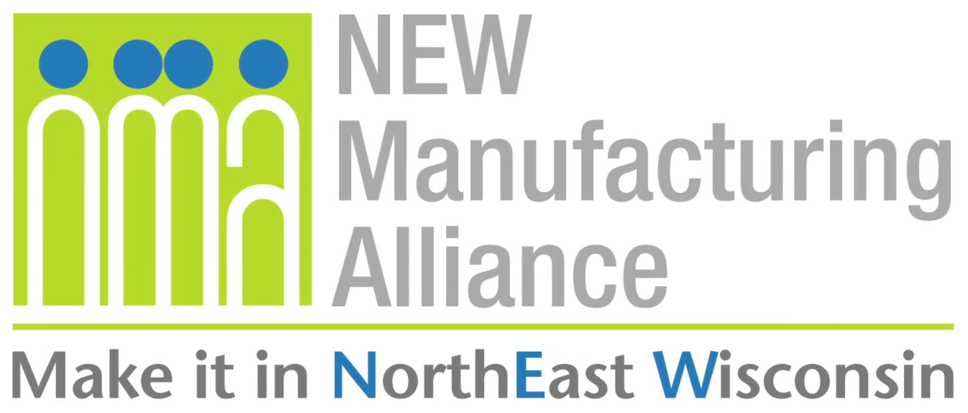

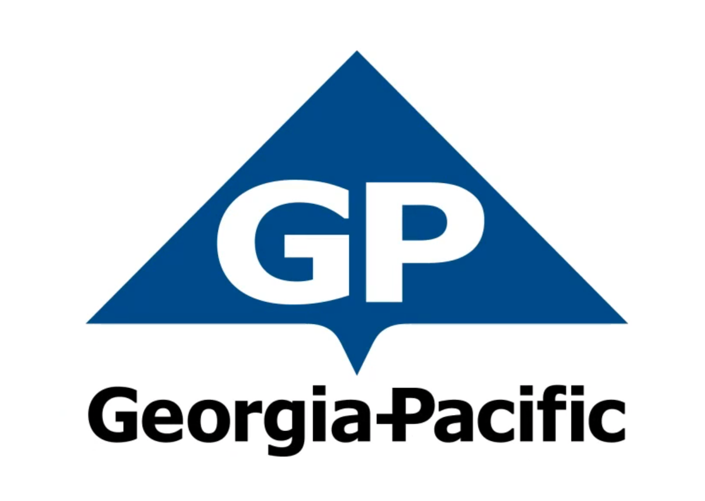
Company Background
With approximately 300 facilities across North America, South America and Europe, Georgia-Pacific is one of the world's leading manufacturers and marketers of bath tissue, paper towels and napkins, tableware, paper-based packaging, office papers, cellulose, specialty fibers, nonwoven fabrics, building products and related chemicals. In Northeastern Wisconsin, its Green Bay facilities make nationally-known products (Quilted Northern®, Angel Soft® and Compact® bath tissue; enMotion® and SofPul® paper towels; and Vanity Fair® and Mardi Gras® napkins) and packaging is produced in Sheboygan and Oshkosh. Each year, GP's Ecosourceä facility in Green Bay recycles nearly 100,000 tons of wastepaper - equal to 1.7 million trees - and saves 5 million cubic feet of landfill space. In addition, its Neenah-based research and development laboratory, iNNOVATION institute®, constantly develops creative and innovative products, and tests them in Green Bay using the latest technology available. For more information, visit: gp.com.

Get Real Science Video Link: https://youtu.be/N0YL9b-fnDQ

Teacher Notes
This lesson is written to accompany the above video. It is recommended that you watch the entire video in advance. This will help you to anticipate student misconceptions and questions and prepare ways to support their sense making.

If this is the first time that you are using the investigation design process with your students, take the time to review the recommendations from the Next Generation Science Standards. Appendix F, page 7 contains grade level specific details regarding designing and conducting investigations.

Lesson Summary
In this lesson students will learn about the different properties of paper towels and design a method for testing paper towel absorbency and strength.

Standards Alignment
Next Generation Science Standards Performance Expectations
3-5-ETS1-1 Define a simple problem reflecting a need or a want that includes specified criteria for success and
constraints on materials, time, or cost.

3-5-ETS1-2 Generate and compare multiple solutions to a problem based on how well each is likely to meet the
criteria and constraints of the problem.

3-5-ETS1-3 Plan and carry out fair tests in which variables are controlled and failure points are considered to identify
aspects of a model or prototype that can be improved.

MS-ETS1-2 Evaluate competing design solutions using a systematic process to determine how well they meet the
criteria and constraints of the problem.

MS-ETS1-3 Analyze data from tests to determine similarities and differences among several design solutions to
identify the best characteristics of each that can be combined into a new solution to better meet the criteria for success.

MS-ETS1-4 Develop a model to generate data for iterative testing and modification of a proposed object, tool, or
process such that an optimal design can be achieved.

Science & Engineering Practices | Disciplinary Core Ideas | Crosscutting Concepts
Asking Questions & Defining Problems  Developing & Using Models  Planning & Carrying Out Investigations  Analyzing & Interpreting Data  Constructing Explanations & Designing  Solutions  Obtaining, Evaluating, & Communicating  Information | ETS1.A: Defining and Delimiting Engineering  Problems  ETS1.B: Developing Possible Solutions  ETS1.C: Optimizing the Design Solution | Systems and System Models  Cause and Effect  Structure & Function

Materials
Student Notebooks
Chart Paper or Whiteboards
Different styles and types of paper towels or other paper products
Various lab supplies for conducting the investigations
Stopwatch or timers

Procedure
- Play the video up to the first break (0:00 - 0:49). Ask your students to independently jot down a few ideas about what makes some paper more absorbent than others. After a few minutes have them turn & share ideas with a neighbor.

- Play the video up to the second break. (0:53 - 3:13). In this section students will learn about 2 of the processes in the making of paper towels that help them to be absorbent: creping and embossing.

- Divide students into groups of 3-4. Each group will develop their own unique method for testing paper towel absorbency. If this is one of the first times that your students have designed their own investigation, you may wish to review with them ideas surrounding asking questions that can be investigated, writing hypotheses, identifying and controlling experimental variables, etc. Ask students to complete the experimental design in a student notebook or on chart paper.

- Have students share their designs with the rest of the class before allowing them to carry out the investigation. This will give them an opportunity to get feedback about their investigation design and make any necessary modification to ensure a fair test. Try to avoid having students scrap their original ideas and use another group’s design. It is important that they try a variety of methods to see if they yield the same results.

~~ Possible break point if you are running short on time ~~

- Provide students with a variety of paper towels or other paper products to test. Provide them with the other materials that they need to complete the investigation. Encourage students to run more than one trial with each paper to ensure accurate results.

- At the conclusion of the tests it is important to provide students with ample opportunity to make sense out of their results. All students should be pressed to use Claim - Evidence - Reasoning to report their conclusions. The claim will indicate which paper was most absorbent. The evidence will be the data that supports that claim. The reasoning should provide the explanation of why one might be more absorbent. Students might need to go back to the video to explain creping and embossing and why it makes a paper product absorbent.
- Play the video up to break 3 (3:18 - 4:12). You may need to help students understand how the lab technician knows when to start and stop the timer as the sheen is not visible in the video.

- Depending on the time available to you, you could once again use the investigation design process to come up with a way to test the wet-strength of a paper towel. If ample time is available, regroup the students and have them run through the entire design process and investigations. You could also just complete the experimental design process and skip the investigations. This could also be done as a class to review the process. You could then conduct the investigation as a demonstration.

- Play the video to the end (4:17 - 5:07). Students will notice that the lab uses a pretty sophisticated piece of equipment to conduct their wet-strength test. This machine has meters built in to measure how much force it takes to break the towel. This is called Tensile Strength.Take this opportunity to discuss equipment like this can help to make repetitive tests like this more accurate and easier to conduct.

