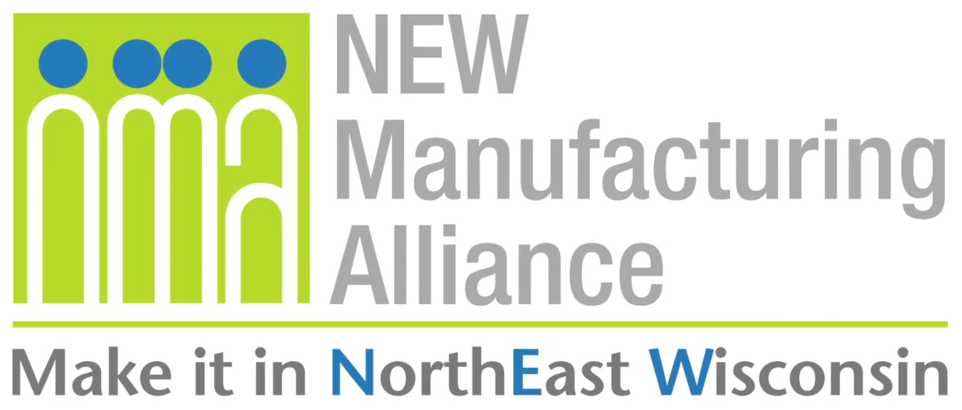
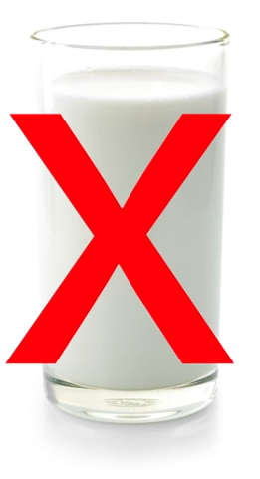
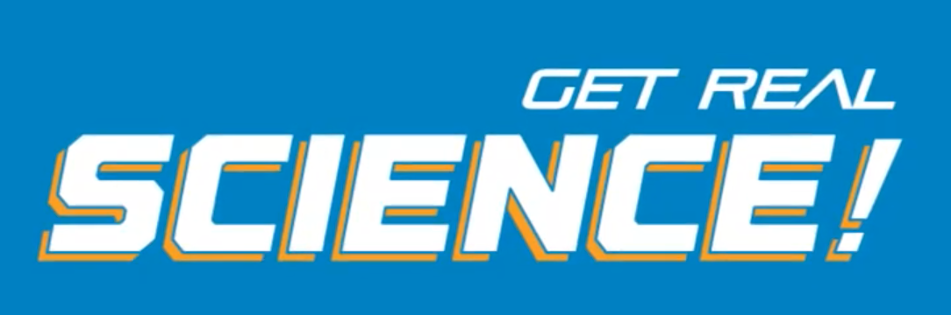

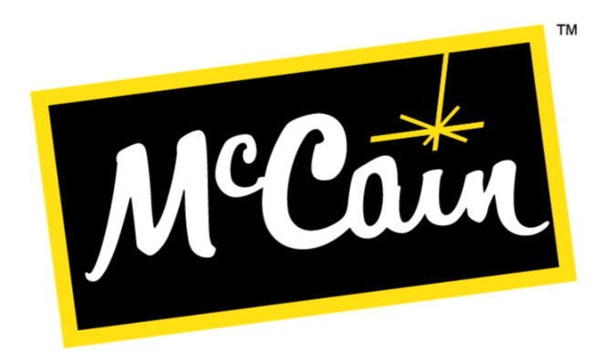
Company Background
McCain Foods is a global business that has been creating great tasting food for over 60 years! As a privately owned family company with sales in over 160 countries and a global team of 22,000 people, our values are at the heart of everything we do. Our people, product quality, and customer dedication are at the core of our business. The McCain Foods, Appleton facility makes appetizers such as mozzarella cheese sticks, jalapeno poppers, and pickle fries. This location also recycles food waste generated during production with the use of a local digester. Almost all other waste is also recycled, resulting in very minimal waste to the landfill. For more information, visit www.mccain.com.

Get Real Science Video Link: https://youtu.be/1tUWvx1vQss

Teacher Notes
This lesson is written to accompany the above video. It is recommended that you watch the entire video in advance. This will help you to anticipate student misconceptions and questions and prepare ways to support their sense making.

As you begin to discuss food allergies it is really important that you do not intentionally call out or discuss any students’ personal experience with allergies unless they volunteer the information and willingly share it with the class. Unfortunately, like many other circumstances, food allergies can be a stigmatizing topic that can have adverse effects on a student’s social and emotional health. We need to use this opportunity to learn about the science of allergies and raise awareness about the challenges they present to some individuals. Like many other topics, awareness leads to better understanding and helps to erase the stigma. Be sure to consult school counselors if any students seem stressed or uncomfortable when discussing this topic.

Lesson Summary
In this lesson students will learn about food allergies and how food manufacturing companies, like McCain Foods, work hard to properly label foods and protect against cross contamination. Students will analyze data from allergen testing and make recommendations to improve cleaning procedures.

Standards Alignment
Next Generation Science Standards Performance Expectations
MS-LS1-2 Develop and use a model to describe the function of a cell as a whole and ways parts of cells contribute
to the function.

Science & Engineering Practices | Disciplinary Core Ideas | Crosscutting Concepts
Analyzing and Interpreting Data  Constructing Explanations & Designing  Solutions  Obtaining Evaluating & Communicating Information | LS1.A Structure & Function  ETS1.B Developing Possible Solutions | Patterns  Cause and Effect  Systems and System Models  Structure and Function

Materials
Student Notebooks Copies of Allergy Scenarios A B C D
Whiteboard or Chart Paper

Procedure
- Play the video up to the first break (0:00 - 1:29). Ask the students to try to come up with the list of the top 8 foods that cause allergies.

- Play the video up to the second break (1:33 - 3:24). See if your students can identify some of the other ways that food producers can help to avoid cross contamination and prevent accidental exposure to allergens. If they cannot come up with more, play the video up to (3:37) to hear what practices are used at McCain Foods.

- Divide your students into 5 groups. Assign each group one of the following good manufacturing practices just mentioned. (Cleaning the manufacturing line, Scheduling, Proper Storage Practices, Personal Protective Equipment, Labeling Verification). Ask each group to discuss how their assigned practice could prevent contamination of foods with allergens if done well and how it could cause contamination if not done or done poorly. Each group could draw a diagram to explain their practice. Display these with a document camera.

- Play the video up to the 3rd break (3:38 - 3:53). Show the students the table below. This is a sample of the type of data that a validation test might produce. This test uses quantitative data to indicate how much of the allergen is present. In this case it is measured in parts per million (ppm). Ask the students the following questions…
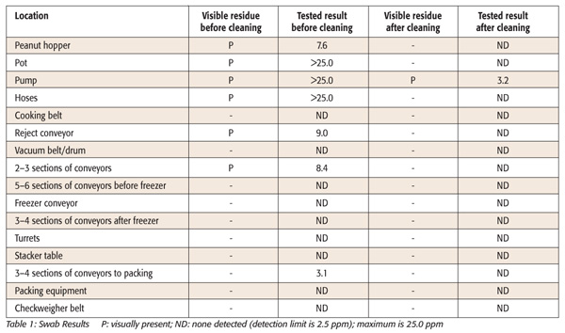

  - How many locations were tested in this sample?
(16)
  - How many tests were conducted?
(32; 16 before cleaning and 16 after cleaning)

Source: Food Safety Magazine: https://www.food-safety.com/articles/3812-allergen-validation-analytical-methods-and-scientific-support-for-a-visually-clean-standard

  - According to these validation test results, is the cleaning process working to remove the potential allergens from the manufacturing equipment?
(No - There is still visible residue and 3.2 ppm peanut residue in the pump)
  - What would you recommend to the sanitation team responsible for cleaning the equipment?
(Answers will vary: Look for ways to get the pump cleaner. Wash it longer. Wash it with more cleaning solution. Maybe see if you can take it apart to get it cleaner.)
  - What pattern do you notice in the data before cleaning? Why do you think that happened that way?
(Answers will vary: There is more residue earlier in the manufacturing process. Maybe
once the product is made there is less of a chance that the peanuts can contaminate the surfaces because they are inside of the product or inside of a package.)

- Play the remainder of the video (3:55 - 5:02). This clip shows the process of conducting verification testing that is done more frequently after cleaning is completed. It only produces qualitative data, indicating if egg or soy is still present after cleaning. Have students discuss with a partner what would happen if they did not remove them before manufacturing another product that does not declare them on the label. Remind students that this is why most food recalls are due to undeclared allergens and why manufacturers make food quality and safety a top priority.

Extensions
- Many students are going to wonder how exactly an allergic reaction happens. We can use models of the immune response to help them to see and understand what is happening inside of the body. The biochemistry is likely beyond what most kids can understand at the grade level. Because of that wwe have left out the technical vocabulary.

Share the following models with your students. Tell them that each represents a different scenario. List
the four possibilities on the board. Ask them to try to figure out which is which. Push them to explain why they think the way that they do.

Scenario A | Scenario B | Scenario C | Scenario D
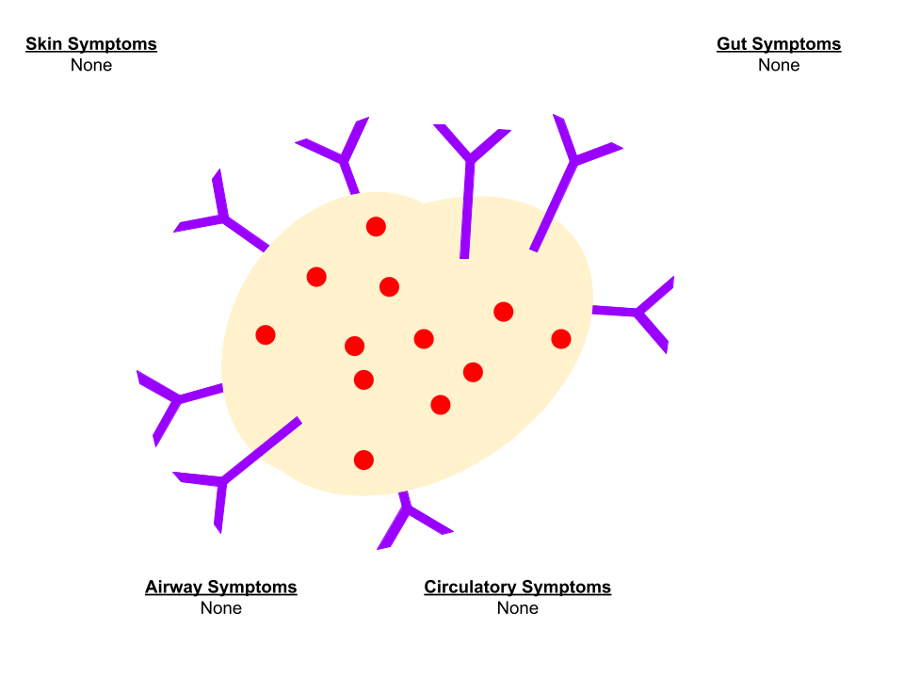 | 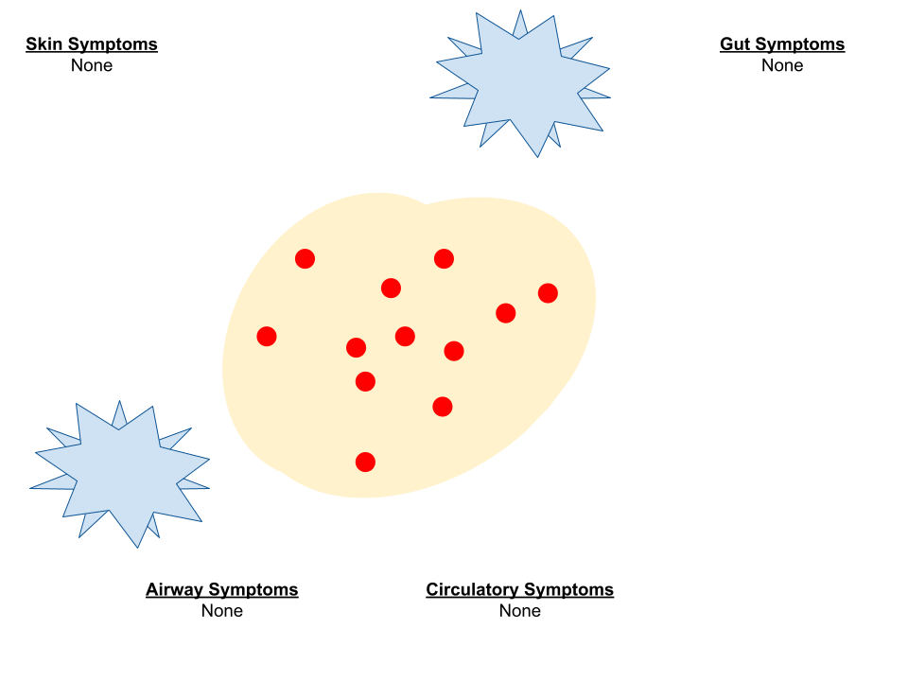 | 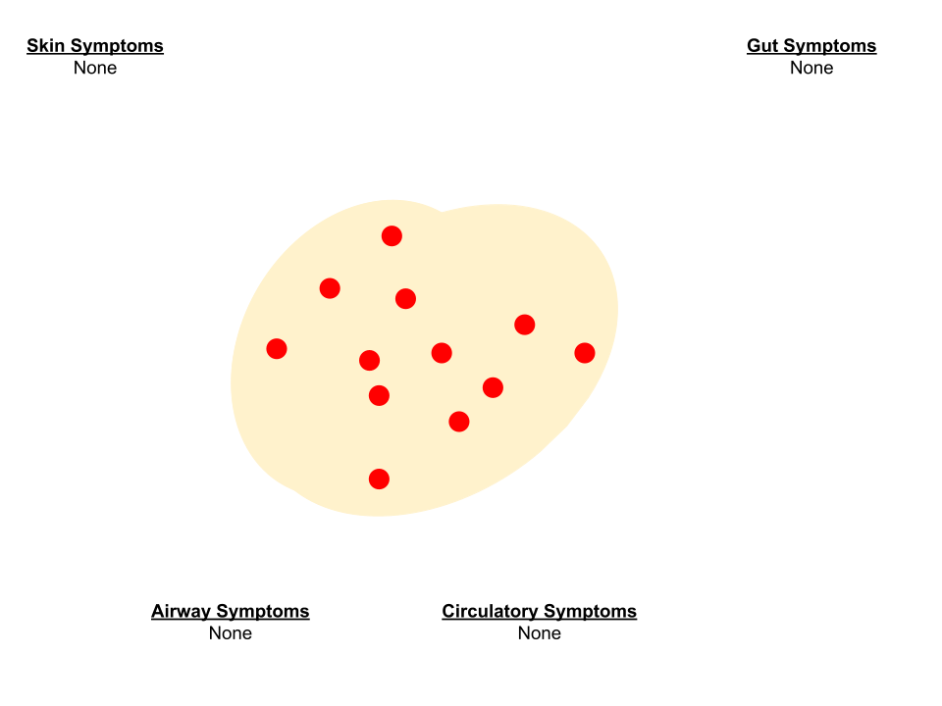 | 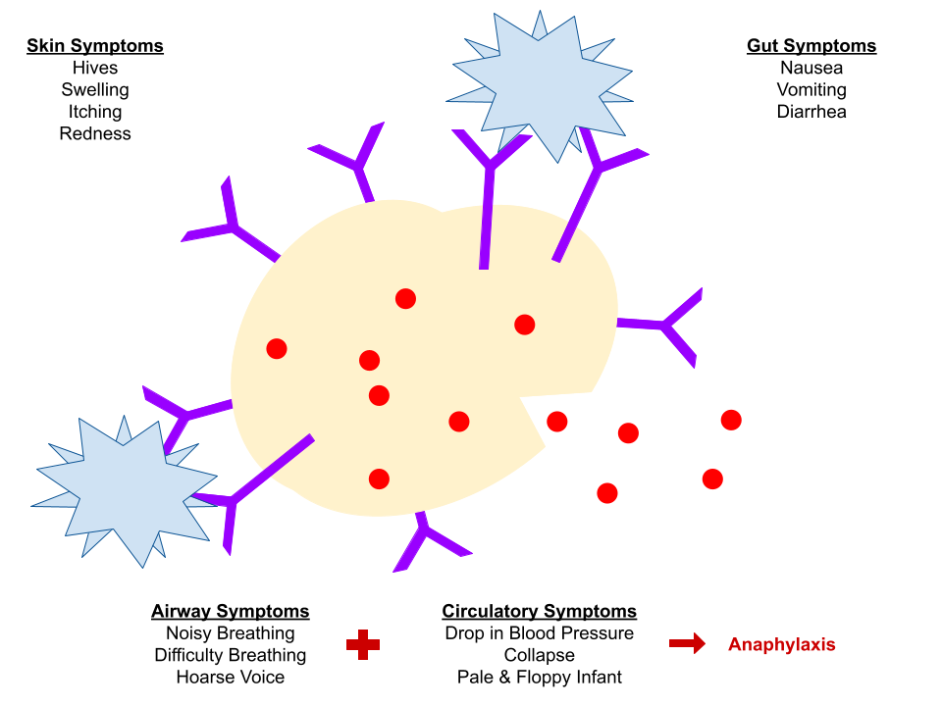
Answers - Do Not Share With Students Until They Have Discussed
Person with soy allergy - did not eat soy | Person without soy allergy - did eat soy | Person without soy allergy - did not eat soy | Person with soy allergy - did eat soy

Key - Share as needed when kids start using some of the terms or come up with their own names.
Allergen (Soy Protein) Histamine Immune Cell (Mast Cell) Antibody

- BSCS developed a free online curriculum supplement called Allergies and Scientific Inquiry. The supplement addresses many of the disciplinary core ideas, crosscutting concepts, and science practices contained in the Next Generation Science Standards. It is integrated with other subjects, drawing most heavily from science, social science, mathematics, and health. It is web-based and includes student and teacher videos, interactive activities, and tutorials.

Access this supplement here: https://allergies.bscs.org/

