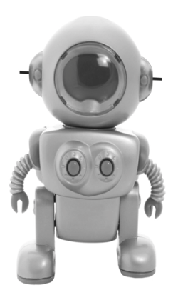
Company Background
Since 1979, Plexus has been partnering with companies to create the products that build a better world. With a team of over 19,000 individuals, they are dedicated to providing Design and
Development, Supply Chain Solutions, New Product Introduction,
Manufacturing and Aftermarket Services. Plexus is a global leader
that specializes in serving customers in industries with highly
complex products and demanding regulatory environments. Plexus
delivers customer service excellence to leading companies by
providing innovative, comprehensive solutions throughout a
product's lifecycle.

Get Real Science Video Link: https://youtu.be/VFmBakwsoLs

Teacher Note
This lesson is written to accompany the above video. It is recommended that you watch the entire video in advance. This will help you to anticipate student misconceptions and questions and prepare ways to support their sense making.

Lesson Summary
In this lesson students will consider what it means to be a robot. They will also learn how programmers control robots to complete tasks and solve problems.

Standards Alignment
Next Generation Science Standards Performance Expectations
K-2-ETS1-1 Ask questions, make observations, and gather information about a situation people want to change to
define a simple problem that can be solved through the development of a new or improved object or tool.

K-2-ETS1-2 Develop a simple sketch, drawing, or physical model to illustrate how the shape of an object helps it
function as needed to solve a given problem.

3-5-ETS1-1 Define a simple problem reflecting a need or a want that includes specified criteria for success and
constraints on materials, time, or cost.

3-5-ETS1-2 Generate and compare multiple solutions to a problem based on how well each is likely to meet the
criteria and constraints of the problem.

Science & Engineering Practices | Disciplinary Core Ideas | Crosscutting Concepts
Asking Questions & Defining Problems  Developing & Using Models  Constructing Explanations & Designing  Solutions | ETS1.A Defining & Delimiting  Engineering Problems  ETS1.B Developing Possible Solutions | Systems and System Models  Structure and Function

Materials
Student Notebooks Various building toys (Legos, blocks, etc.)
Whiteboard or Chart Paper Copies of the Robot Frayer Model

Procedure
- Ask your students if any of them have robots at home? This question is intended to puzzle them because we may not all have a shared understanding of what a robot is. Listen to their responses and look for common examples.

- Place students in groups of 3 or 4 and ask them to complete a Frayer Model for a robot. A Frayer Model is a good technique to arrive at a shared definition. Suggest that they work on writing a definition last. Once they agree on characteristics, examples, and non-examples it will be easier to write the definition. Have students share their models with others and look for similarities and differences.
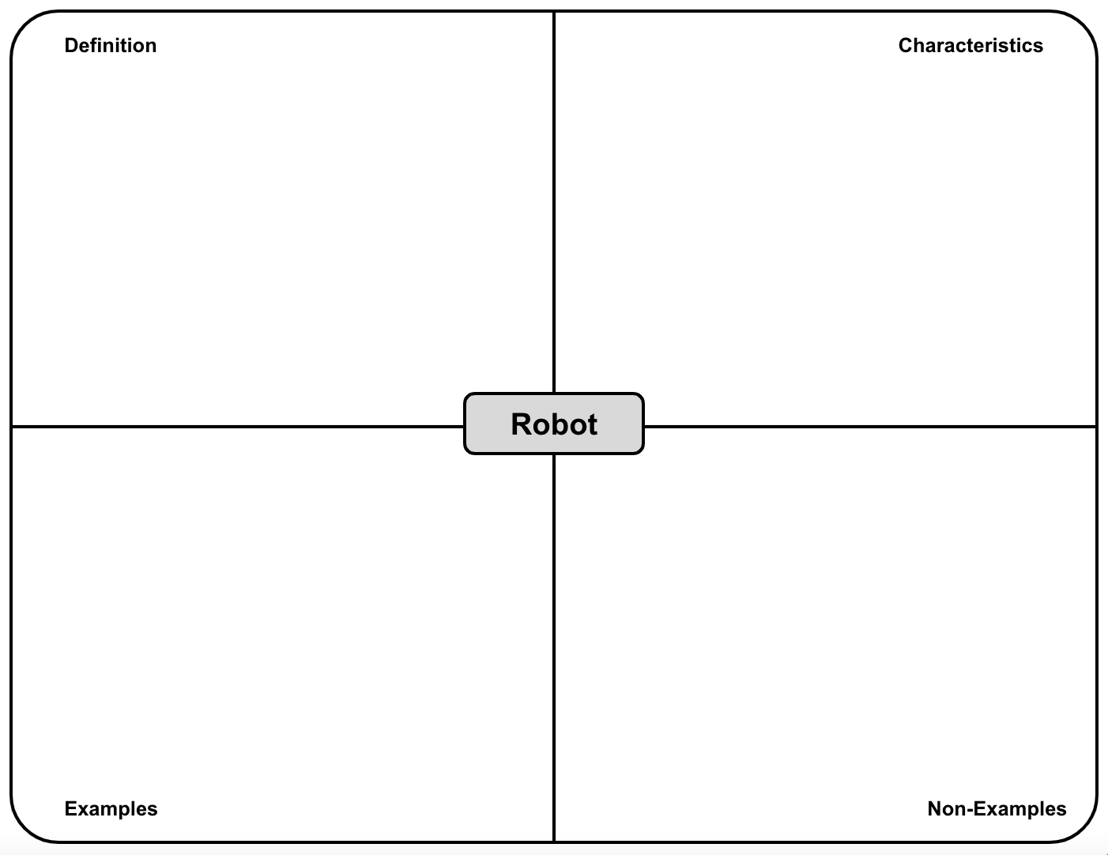
- Play the video up to the first break (0:00 - 1:08). Ask the students what similarities and differences they noticed about Carl’s explanation of the robotic system.

- Explain that the robot featured in the video is a robotic arm that can be used in manufacturing. One of the characteristics of all robots is that they can help us to complete complex or repetitive tasks.

- The next segment of video (1:08 - 2:16) shows the robot assembling the Plexus logo out of tiles randomly placed in a tray. In the remainder of the video Carl will explain how we can control the robot and how it interacts with materials in its environment. Play the remainder of the video.

- Discuss how the engineers use programming to write a sequence of instructions for the robot to complete on its own, autonomously. Explain that writing this set of instructions is important to accomplishing the task safely and without errors.

- Divide students into groups of 2. These students should sit back to back to avoid seeing what the other is doing. (blindfolds would also work).Provide each group 2 sets of simple toys (legos, blocks, puzzle pieces, etc.). One student will be the programmer and the other will be the robot. The programmer should build something with the toys and then provide a series of steps for the robot to make the same assembly. If it is easier, you can provide the object to build and have the programmer write out the steps to build it and then provide thoss steps to the robot. When students complete the task they should switch roles.

- Discuss with the whole class the similarities and differences between what they did and what real programmers and robots do.

Extensions
- Identify problems that could be solved using a robotic arm. Ask students to look around their school, home or community, and dream up robotic solutions to some of the problems that they see. For example, if a student dislikes drying dishes, how could a robot complete that task and put away the dishes? Ask students to sketch out their ideas in a science notebook or on chart paper to share with the rest of the class.

- Design tools for the end of the arm that can be used for completing different tasks. This time ask students to come up with ideas for the tools that can be attached to the end of the robotic arm. You may wish to first explore some of the options that already exist by looking for pictures or videos online. Then ask students to sketch out their ideas in a science notebook or on chart paper to share with the rest of the class.

