What does math have to do with Balanced Breaks?

Video Link: https://youtu.be/5-X3c0iB6IA

Lesson Plan

Teacher Note: Please preview the entire video and pre-work the questions in order to anticipate students’ needs, misconceptions, and materials unique to your classroom.

You will also need to determine the background knowledge of your students regarding the following topics and decide the best method for providing that background in order to support the conceptual understanding of the mathematics shown in the video.

- Tell the difference between permutations and combinations
- Use factorial in calculations
- Calculate the number of combinations of n objects taken r at a time.

Common Core Mathematical Content Standards

- HSS.CPB.9 Use permutations and combinations to compute probabilities of compound events and solve problems.

Common Core Mathematical Practice Standards

1. Make sense of problems and persevere in solving them.
2. Reason abstractly and quantitatively.
3. Construct viable arguments and critique the reasoning of others.
4. Attend to precision.

Company Information

Sargento Foods Inc. is a family-owned company comprising four business divisions: Consumer Products, Food Service, Food Ingredients and Culinary Solutions. The company employs more than 1,500 people at four Wisconsin facilities. The Consumer Products Division is a leading national packager and marketer of natural shredded, sliced, snack and specialty cheeses sold under the Sargento brand.

Summary

Manufacturing companies that package food, such as Sargento, must consider many variables to create and package their product. In addition to maintaining a clean environment, the production process is often analyzed to determine how to increase efficiency as well as product produced. Frequently the addition of automated systems can help them achieve their goals with the help of engineers and technicians who determine how to use the equipment in an optimal way. This video shows how an automated system of scales is used to make sure that each package contains the proper amount of product.

Differentiation

- The questions on the student handout are scaffolded to meet the needs of students who may need extra support.
- Students who struggle may need additional examples before the lesson to prepare them for the calculations required in the video.

Pre-Activity Discussion

- This video opens with a member of the product support team explaining how a system of scales is used to distribute product into containers in the proper portions. The scales are constantly determining the optimal combination of buckets required to fill the containers. Additionally, an electrical controls engineer discusses the importance of keeping equipment operating and how it affects the output of product.
- Discuss with students that products like Balanced Breaks have to get put together somehow. It may be good to have students list some of the ways that they can think of that the product might get to and into the containers.
- Discuss with students that a company is always trying to put out as much product to sell as they can and do it in as little time as possible. It may be good to talk about things that can affect profits.
- Discuss the vocabulary related to the problem.
- It may be necessary to discuss the difference between permutations and combinations as well as to review formulas for calculating.

- Vocabulary
- Production Line – The system in which product is formed, transported, and packaged.
- Permutation – Represents the number of ordered arrangements of elements in a set.
- Combination – Represents the number of groups of elements that can be created from a set.

Information Needed to Solve:

- The number of buckets in the scale system is 16 for the initial problem.
- In practice not all 16 buckets are used to fill the trays. There is an optimum average number of buckets.
- The scales work in such a way that if one bucket does not work an entire pair of buckets will not work.
- When all buckets are available, 200 packages of Balanced Breaks are produced each minute.
- If the line loses two buckets, the number of packages produced decreases by 1 package per minute.
- The formula for calculating the number of combinations of n objects taken r at a time is:

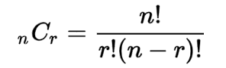

Part 1 (0:00 – 2:54)

BREAK 1

- Prior to answering the question, small groups of students should list as many variables as possible that could affect the production of the balanced breaks.

- Have the small groups calculate the number of combinations there are for 16 buckets assuming that any number of buckets may be used. The provided table may be helpful for students to organize their work.

Part 2 (3:00 – 3:57)

BREAK 2

- Have students look at all combinations from ₁₆C₀ all the way to ₁₆C₁₆ to decide which gives the most available combinations.

Part 3 (4:04 – 4:51)

BREAK 3

- Have students make a prediction of how much losing two buckets will affect the total number of combinations. They can do this on their own or with a partner. Once they have made their prediction have them calculate what the new optimum number of buckets will be.

Part 4 (4:52 – 5:45)

- Have students calculate how many fewer packages will be completed in the shift if we go down to 14 buckets.

Extension

- Students can create a bar graph for each situation and describe the distribution of the combinations.
- Students can explore the connection between Pascal’s Triangle and the numbers of combinations that they found in their calculations.

Student Handout – What does math have to do with Balanced Breaks?

Names:_________________________________

Pre-Activity Discussion: Notes on necessary background information.

Problem: Determine the number of combinations possible in a 16 bucket scale and analyze the effects of a bucket dropping out of service.

Break 1

- Before finding the number of possible combinations your group needs to list as many different variables as possible that could affect the production of these balanced breaks. Your teacher may ask you to share some of these with the class.

- As a group calculate the number of combinations of buckets that can be used if there are 16 buckets. Assume that any number of buckets can be chosen from the 16. It may help to use the provided table to organize your work.

Break 2

- Look through your results from the previous problem. What is the number of buckets chosen that will give you the most combinations?

Break 3

- Predict how the number of combinations available will change if the system goes from 16 to 14 buckets. Your prediction does not involve calculations. Just an estimate.

- Determine the number of buckets that will give the most combinations when we only have 14 buckets available. How many combinations is this? How does it compare to your estimate?

Break 4

- Knowing that dropping from 16 to 14 buckets means that the company will lose 1 tray per minute, how many trays will they lose during an 8 hour production run?

- Explain how you think the company is affected if they produce much fewer trays during the run?

Extension

- Create a bar graph for each situation and describe the distribution of the combinations.

- Research and explore the connection between Pascal’s Triangle and the numbers of combinations that you found in your calculations

Answer Key – What does math have to do with Balanced Breaks?

Pre-Activity Discussion: Notes on necessary background information.

Problem: Determine the number of combinations possible in a 16 bucket scale and analyze the effects of a bucket dropping out of service.

Break 1

- Before finding the number of possible combinations your group needs to list as many different variables as possible that could affect the production of these balanced breaks. Your teacher may ask you to share some of these with the class.

Answers will vary.

Sample: Time available, temperature, number of workers, number of machines running, time spent fixing machines, incorrect setup, lines running too fast or too slow etc.

- As a group calculate the number of combinations of buckets that can be used if there are 16 buckets. Assume that any number of buckets can be chosen from the 16. It may help to use the provided table to organize your work.

Solution:

₁₆C₁ + ₁₆C₂ + ₁₆C₃ + ₁₆C₄ + ₁₆C₅ + ₁₆C₆ + ₁₆C₇ + ₁₆C₈ + ₁₆C₉ + ₁₆C₁₀ + ₁₆C₁₁ + ₁₆C₁₂ +
+ ₁₆C₁₃ + ₁₆C₁₄ + ₁₆C₁₅ + ₁₆C₁₆ = 65,535 possible combinations

It is up to the discretion of the teacher as to whether students calculate all of these by hand or use a statistics package on a calculator. A sample solution by hand would use the formula for calculating combinations:

_{n}C_{r} = $\frac{n!}{r!\left(n-r\right)!}$ Ex. ₁₆C₃ = $\frac{16!}{3!\left(16-3\right)!}$ = $\frac{16!}{3!13!}$ = $\frac{16*15*14}{3*2*1}$ = 560

It is also reasonable to consider creating a spreadsheet for the data as was done in the video.

Break 2

- Look through your results from the previous problem. What is the number of buckets chosen that will give you the most combinations?

Solution: By looking at the list of possibilities in the chart below we can see that ₁₆C₈ = 12,870
gives the largest number of possibilities. Sargento tries to hit an average of 8 buckets.
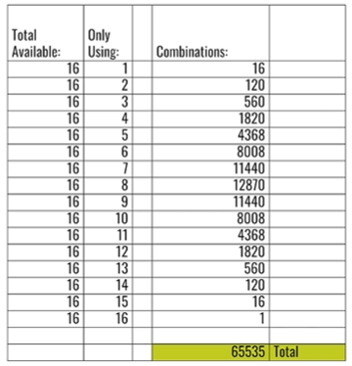

Break 3

- Predict how the number of combinations available will change if the system goes from 16 to 14 buckets. Your prediction does not involve calculations. Just an estimate.

Answers will vary.

- Determine the number of buckets that will give the most combinations when we only have 14 buckets available. How many combinations is this? How does it compare to your estimate?

Solution:

₁₄C₁ + ₁₄C₂ + ₁₄C₃ + ₁₄C₄ + ₁₄C₅ + ₁₄C₆ + ₁₄C₇ + ₁₄C₈ + ₁₄C₉ + ₁₄C₁₀ + ₁₄C₁₁ + ₁₄C₁₂ +
+ ₁₄C₁₃ + ₁₄C₁₄ = 16,383 possible combinations

Notice that ₁₄C₇ = $\frac{14!}{7!\left(14-7\right)!}$ = $\frac{14!}{7!7!}$ = $\frac{14*13*12*11*10*9*8}{7*6*5*4*3*2*1}$ = 3,432

is the largest possible value and occurs at 7 buckets. See the chart that
follows to verify.

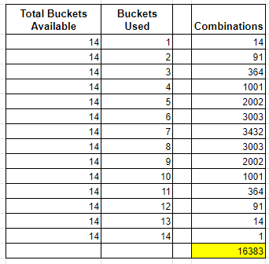

Break 4

- Knowing that dropping from 16 to 14 buckets means that the company will lose 1 tray per minute, how many trays will they lose during an 8 hour production run?

Solution: $1 \frac{Tray}{Minute}*8 Hours*60 \frac{Minutes}{Hour}=480 Trays$

- Explain how you think the company is affected if they produce much fewer trays during the run?

Answers vary. Points to look for might be that the company is still paying for the workers, utilities, and machines, but putting out less product to sell. This means that they cannot make as much money or could lose money.

Extension

- Students can create a bar graph for each situation and describe the distribution of the combinations.

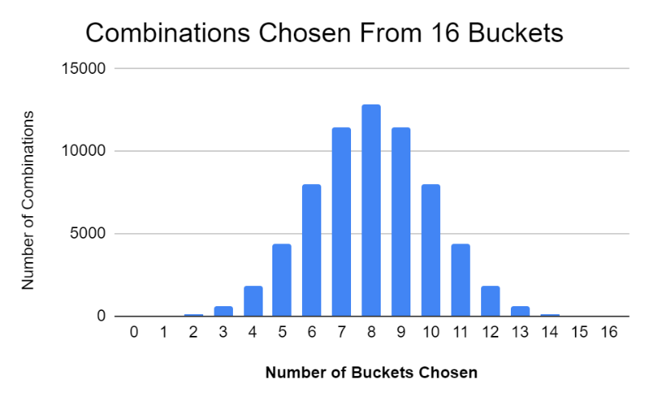
A possible sample might look like this.
Students can describe the shape of the data
and the distribution etc.

- Students can explore the connection between Pascal’s Triangle and the numbers of combinations that they found in their calculations
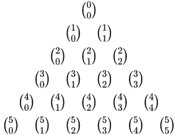

The values that students calculated can be
found in Pascal’s Triangle. If they extend each
row of combinations to the 17th row they will see
all of the values they had calculated.

Student Work Page

Use this space to organize your work
for breaks 1 and 2 if needed.

Use this space to organize your work
for break 3 if needed.

