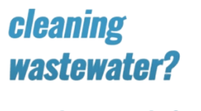

Company Background
With approximately 300 facilities across North America, South America and Europe, Georgia-Pacific is one of the world's leading manufacturers and marketers of bath tissue, paper towels and napkins, tableware, paper-based packaging, office papers, cellulose, specialty fibers, nonwoven fabrics, building products and related chemicals. In Northeastern Wisconsin, its Green Bay facilities make nationally-known products (Quilted Northern®, Angel Soft® and Compact® bath tissue; enMotion® and SofPul® paper towels; and Vanity Fair® and Mardi Gras® napkins) and packaging is produced in Sheboygan and Oshkosh. Each year, GP's Ecosourceä facility in Green Bay recycles nearly 100,000 tons of wastepaper - equal to 1.7 million trees - and saves 5 million cubic feet of landfill space. In addition, its Neenah-based research and development laboratory, iNNOVATION institute®, constantly develops creative and innovative products, and tests them in Green Bay using the latest technology available. For more information, visit: gp.com.

Get Real Science Video Link: https://drive.google.com/file/d/1ogre-LccYF3WXeRybwoi_4rEyEDkRtMh/view?usp=sharing

YouTube Video link: https://youtu.be/xC2_sIWK9A0

Teacher Note
This lesson is written to accompany the above video. It is recommended that you watch the entire video in advance. This will help you to anticipate student misconceptions and questions and prepare ways to support their sense making.

If this is the first time that you are using the system models and modeling with your students, take the time to review the Next Generation Science Appendix F section on developing and using models for appropriate grade level expectations.

Lesson Summary
In this lesson students will develop models to develop understanding of the paper recycling process and the important role that they play in conserving and recycling our natural resources.
Standards Alignment
Next Generation Science Standards Performance Expectations
5-ESS3-1 Obtain and combine information about ways individual communities use science ideas to protect
the Earth’s resources and environment.
MS-ESS3-3 Apply scientific principles to design a method for monitoring and minimizing a human impact on the
environment.
HS-ESS3-4 Evaluate or refine a technological solution that reduces impacts of human activities on natural
systems.

Cross Cutting Concept: Systems and System Models
In grades 6-8, students can understand that systems may interact with other systems; they may have sub-systems and be a part of larger complex systems. They can use models to represent systems and their interactions—such as inputs, processes, and outputs—and energy, matter, and information flows within systems. They can also learn that models are limited in that they only represent certain aspects of the system under study.
Science & Engineering Practices | Disciplinary Core Ideas | Crosscutting Concepts
Analyzing & Interpreting Data  Obtaining, Evaluating, & Communicating  Information  Constructing Explanations & Designing  Solutions | ESS3.C Human Impacts on Earth Systems  ETS1.B: Developing Possible Solutions | Patterns  Systems and System Models  Cause and Effect

Background Information: Please visit https://www.coleparmer.com/tech-article/eight-stages-of-wastewater-treatment-process to review the steps of the wastewater treatment process.

Materials
Whiteboards or Chart Paper
Scissors

Procedure
- Show students the Get Real Science video: What does science have to do with cleaning wastewater?
  - Break 1: How does gravity help clean the water? Have students discuss this question.
    - Setup a quick demonstration. Use an empty water bottle. Fill the bottle up ¾ with water. Add one spoon of coffee grounds and three squares of toilet paper. Shake up the bottle for 30 seconds. Allow to sit out until the following day. This demonstration shows the concept of solids settling due to gravity.
  - Break 2: Have you ever heard of a good bacteria? Ask students if they know of any bacteria that is helpful.
  - Break 3: What can they do with the sludge? Have students brainstorm for what they might use the sludge.
- Tell students: “Today we will take a closer look at how cleaning wastewater and making paper is a system.” Ask students to list examples of systems that they know. Write these ideas down on the board. (Ex: human body systems, water cycle, vehicles, etc.).
- Explain to students that each system has an input and output. Explain what the inputs and outputs are of the respiratory system. (Input = oxygen, output = carbon dioxide, purpose = to supply oxygen to your blood and remove carbon dioxide).
- Ask students: What are the inputs and outputs at a paper mill? Have students work in groups to create a diagram on a whiteboard or chart paper. If students struggle you could show the video again. Inputs = recycled fiber, water from the Fox River, output = sludge, water, tissue paper and paper
- Tell students that they will be looking closer at each step of the system.
- Hand out “Cleaning Wastewater” worksheet to each student.
- Students will list the inputs and outputs of the wastewater treatment system. One student from each group should visit other groups to see what they identified as the inputs and outputs of the system. Have a class discussion to correctly identify the inputs (water from the Fox River, recycled paper waste) and outputs (water to be sent to the Fox River, tissue or paper, wastewater sludge).
- Hand out one copy of the Cleaning Wastewater Diagram and Steps to each group. Students should cut out the cards on page 2. If it is possible to print the diagram on larger paper that would be helpful. Tell students that there might be more than one card for each step.
- Once students think they have the order of cards accurate, have one student visit other groups to compare their results and share back with their group. Review the steps of the process as a large group once the groups are all complete. See the attached answer key to help you.
- Have students complete the conclusion questions. Ask students to share their story of a water molecule when complete.

Name ___________________________ Date _______________

Get Real Science
Cleaning Wastewater

Directions: Use this worksheet with the Get Real Science video and procedure: What Does Science have to do with cleaning wastewater?

- Today your class will be taking a closer look at how paper mills clean the water they use to make paper. The wastewater treatment diagram below shows a system. With your group, try to identify the inputs and outputs of this system.

Inputs: ___________________________________________________________________

Outputs: __________________________________________________________________

- Send one group member to visit each group in the classroom and compare the inputs and outputs they identified.
- Your group will now organize steps of the wastewater treatment process. Cut out the steps and place on the larger diagram where you think they occur.

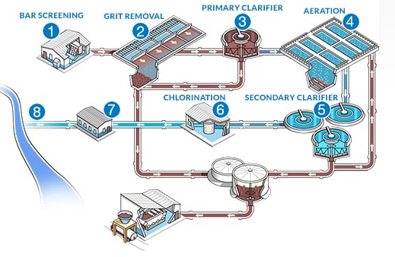
Conclusion Questions
- Write a story pretending you are a drop of water in the Fox River that is just about to enter the paper mill. The audience for your story is a group of first graders.

________________________________________________________________________________________________________________________________________________________________________________________________________________________________________________________________________
________________________________________________________________________________________________________________________________________________________________________________________________________________________________________________________________________
________________________________________________________________________________________________________________________________________________________________________________________________________________________________________________________________________
________________________________________________________________________________________________________________________________________________________________________________________________________________________________________________________________________
________________________________________________________________________________________________________________________________________________________________________________________________________________________________________________________________________
________________________________________________________________________________________________________________________________________________________________________________________________________________________________________________________________________

- Below is a graph showing relationships between different substances that are present during the wastewater treatment process.

Substances in Wastewater Treatment
oxygen
bacteria
Paper fibers/
Organic matter
time
amount
Oxygen demand
- Place a star where you think the process adds oxygen to the process. Explain why the process adds oxygen to the water. ______________________________________________________
___________________________________________________________________________ ___________________________________________________________________________
- The oxygen demand ___________________ as the paper fibers ___________________. This is called a direct/indirect relationship.
- Make a prediction: If the amount of paper fibers increase, what will happen to the oxygen demand? How do you know? ____________________________________________________ ____________________________________________________________________________ ____________________________________________________________________________
- If the process did not add any oxygen to the process, what would happen to the levels of paper fibers? Explain your answer using evidence from the activity or graph. ____________________________________________________________________________ ____________________________________________________________________________ ____________________________________________________________________________

- Why is it important to you that paper mills clean the water before releasing it back into the Fox River? List three reasons.

- ____________________________________________________________________________________________________________________________________________________________________________________________________________________________________
- ____________________________________________________________________________________________________________________________________________________________________________________________________________________________________
- ____________________________________________________________________________________________________________________________________________________________________________________________________________________________________

Cleaning Wastewater Diagram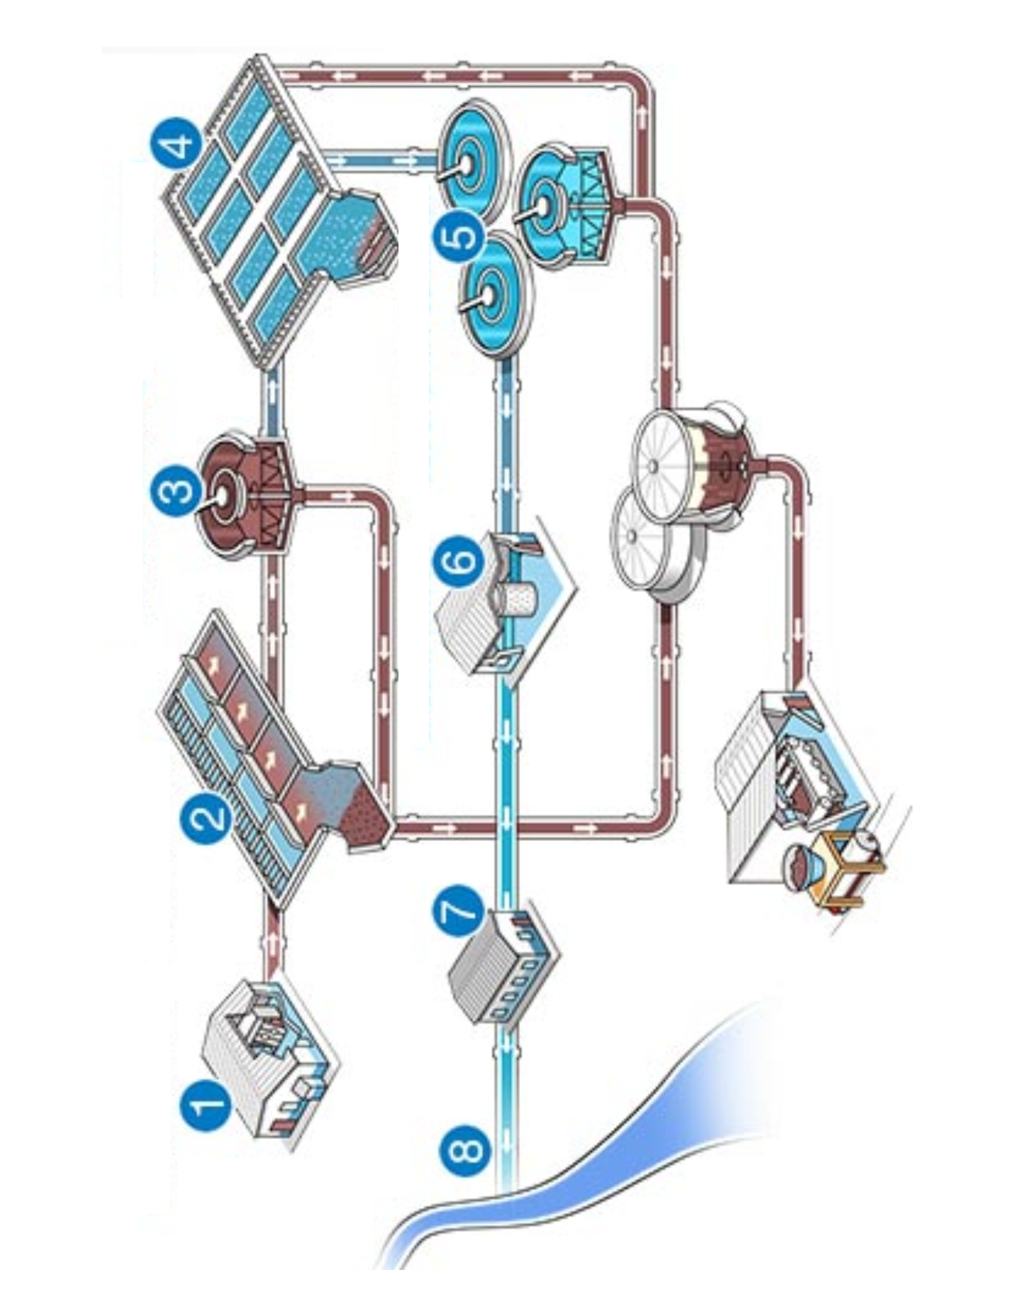
Cleaning Wastewater Diagram - Answer Key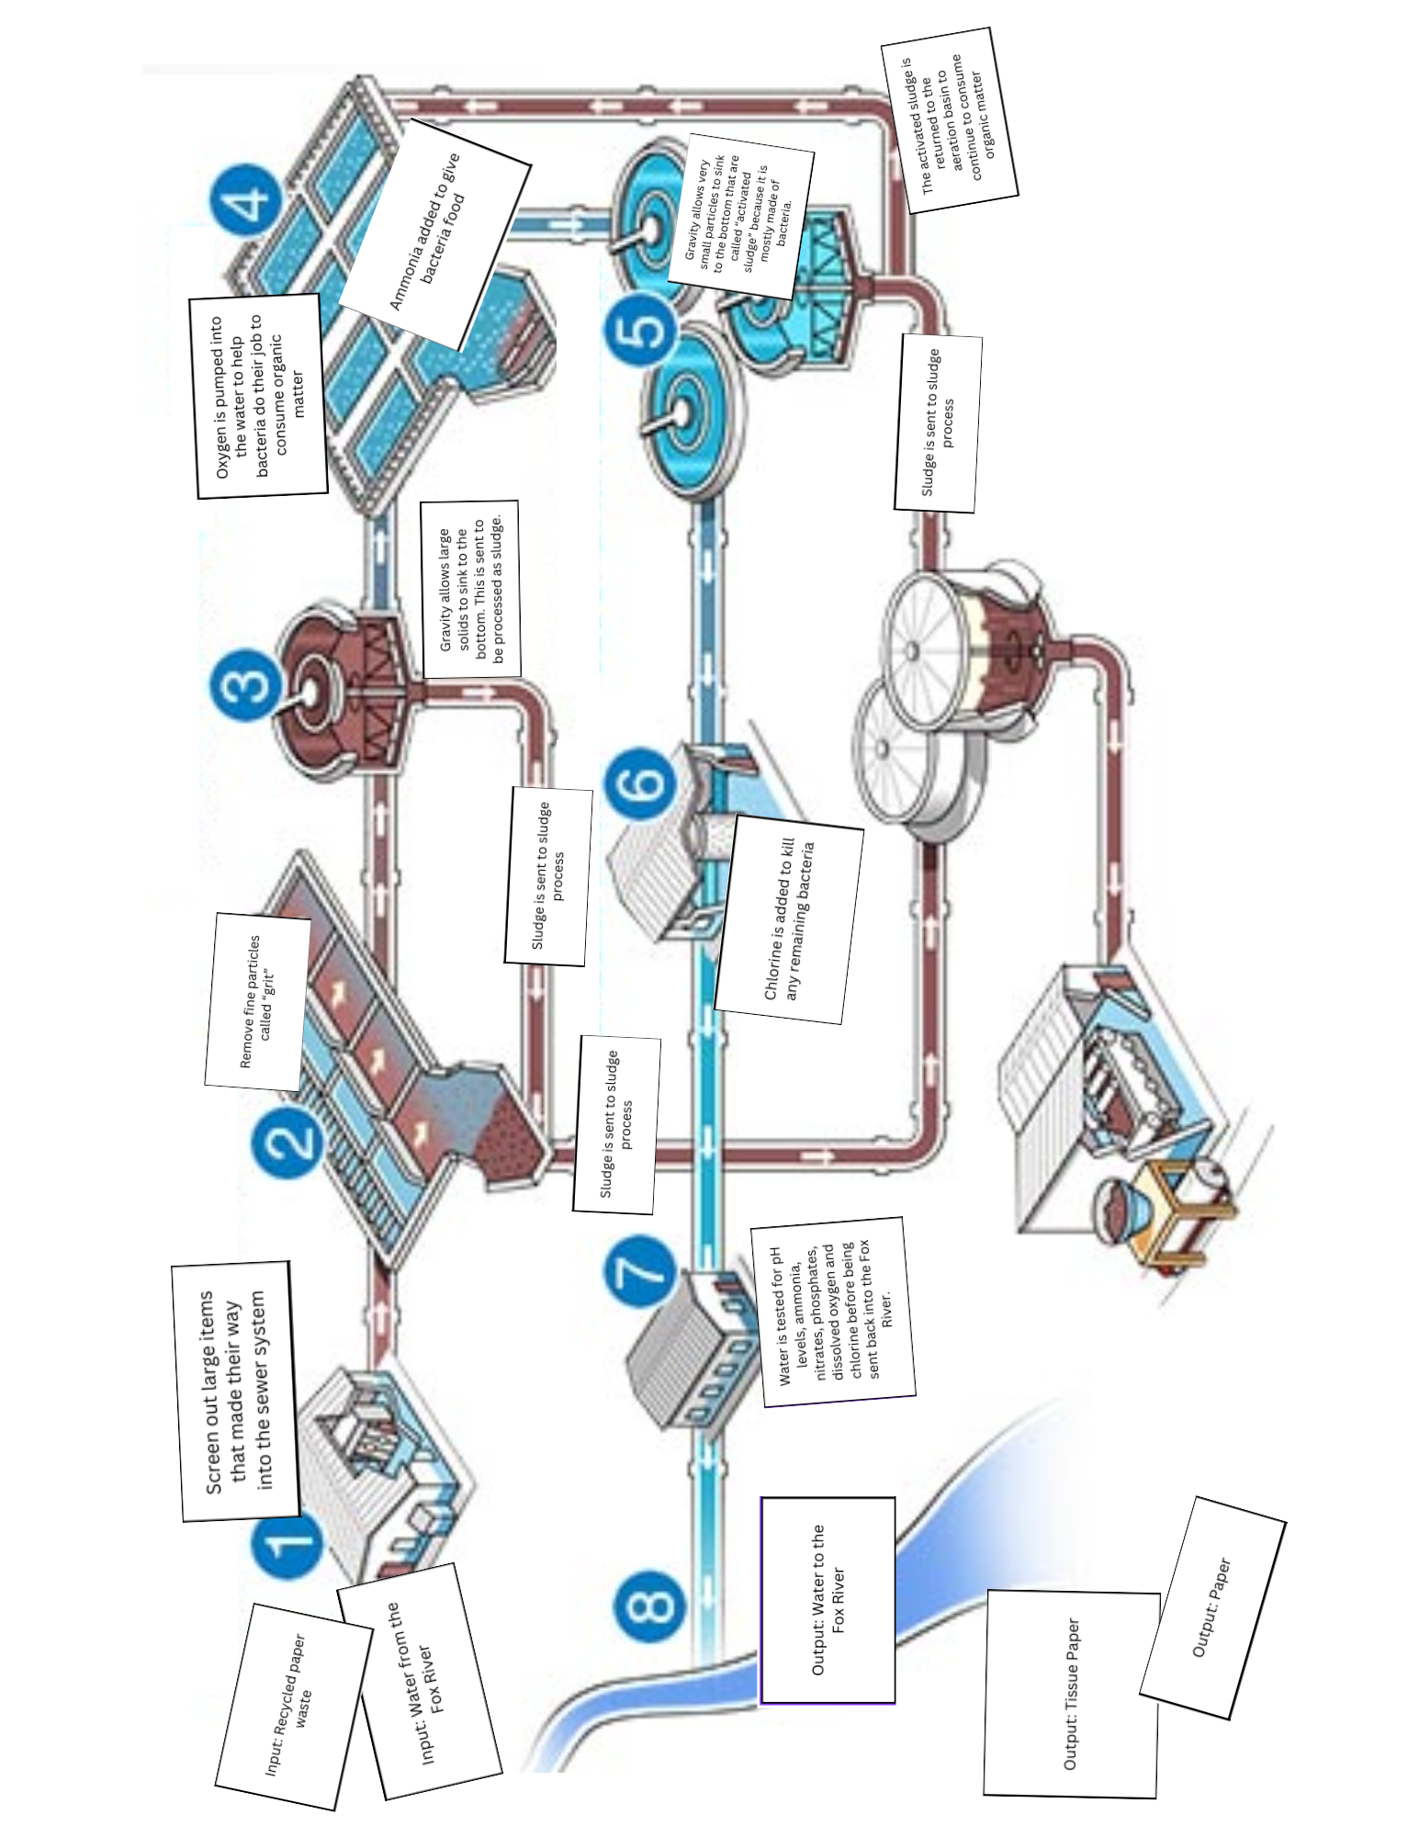
Cleaning Wastewater Steps

Output: Water to the Fox River | Oxygen is pumped into the water to help bacteria do their job to consume organic matter | Chlorine is added to kill any remaining bacteria
Water is tested for pH levels, ammonia, nitrates, phosphates, dissolved oxygen, and chlorine before being sent back into the Fox River. | Gravity allows very small particles to sink to the bottom that are called “activated sludge” because it is mostly made of bacteria. | Output: Tissue Paper
Remove fine particles called “grit” | Input: Water from the Fox River | Gravity allows large solids to sink to the bottom. This is sent to be processed as sludge.
Output: Paper | Screen out large items that made their way into the sewer system | Sludge is sent to sludge process
The activated sludge is returned to the aeration basin to continue to consume organic matter | Ammonia added to give bacteria food | Input: Recycled paper waste

