Contract Converting Breaks Ground on New Expansion Project

(July 20, 2023) GREENVILLE, WI – Contract Converting LLC, a local custom slitting & rewinding Converter, broke ground on Wednesday to celebrate the beginning of construction on their Plant 2 expansion. The expansion will provide the business with an additional 20,000 square feet of space, which they will use for warehousing and production.

“This expansion is an important part of our growth initiative moving forward,” mentioned Bob Saari, the president of Contract Converting. “It’s important for our dedicated staff members to have expanded space to be able to perform their daily tasks without the irritation of a congested work environment.” The expansion will increase efficiencies, improve safety, and improve overall quality.

Contract Converting has always emphasized a “premium service platform” as a value proposition for all their customers. The expansion will allow the company to continue growing while still carrying out this important vision.

Consolidated Construction Co., Inc. designed the addition and will be the contractor for the project. Consolidated is a long-time preferred partner of Contract Converting, “We’ve been very fortunate to be a preferred partner of Contract Converting and have worked alongside their team on several projects over the years, which is something we are very proud of,” mentioned Jason Pettitt, VP of Construction with Consolidated. “It’s an honor to be here today representing Consolidated Construction and very much appreciate the opportunity to serve Contract Converting on another great project.”

About Consolidated Construction
Consolidated Construction Co., Inc. is based locally in Appleton, WI. and serves customers in the industrial, manufacturing, education, commercial, retail, multi-family, and healthcare markets. Our project delivery model has resulted in national awards for design/build ingenuity and cost reduction. Project information and company history can be viewed at 1call2build.com.

###

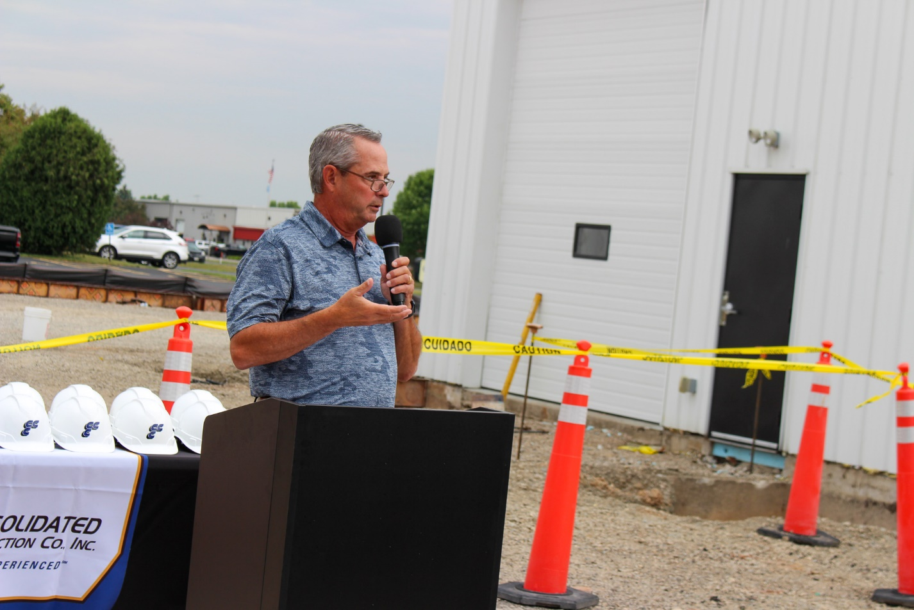

Figure 1 Contract Converting president Bob Saari delivers remarks during the groundbreaking ceremony for
the company's Plant 2 expansion on Wednesday, July 19th

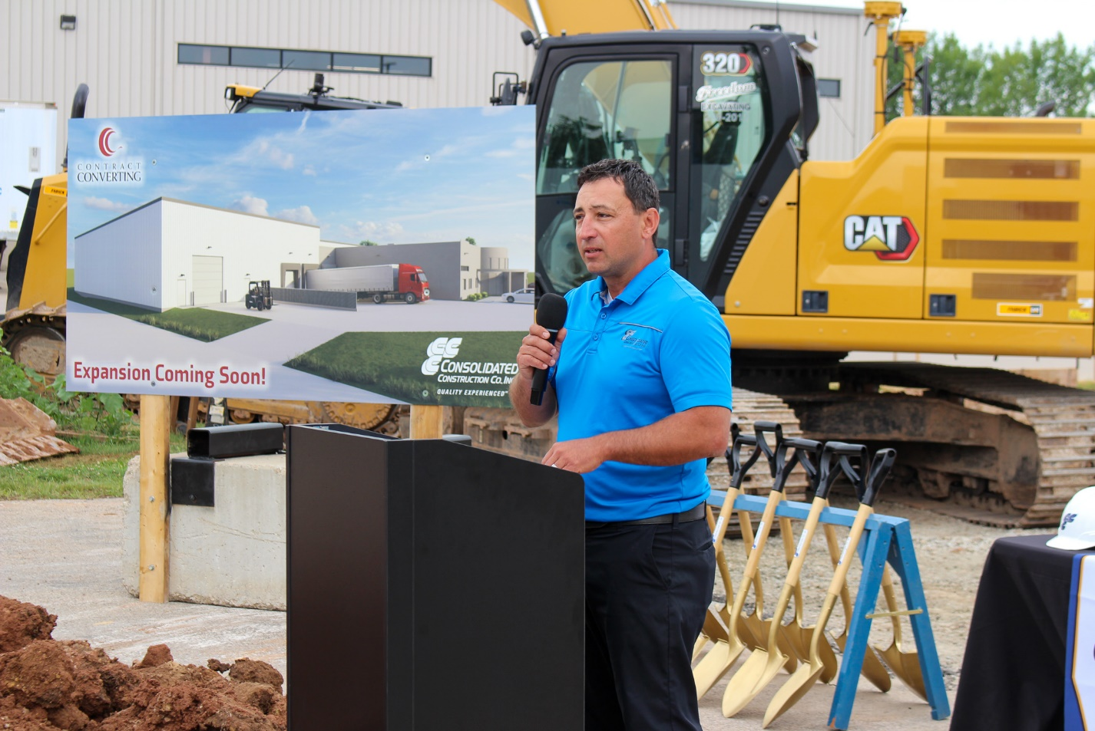
Figure 2 Jason Pettitt, VP of Construction with Consolidated Construction, provides
details about the expansion and about experiences shared with the Contract Converting team

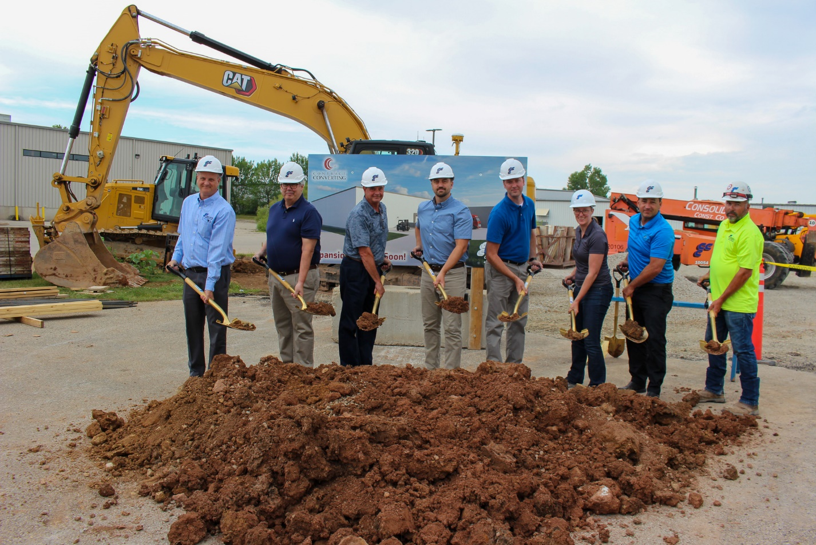
Figure 3 Representatives of Contract Converting and Consolidated Construction posing as they break ground on the new addition.

